

TrimGap
SECS/GEM

User manual

1.0.0.3

2023/02/17

大量科技股份有限公司 TALIANG TECHNOLOGY
桃園市八德區友聯街49號 No. 49, Youlian St., Bade Dist., Taoyuan City 334009, Taiwan
TEL : (03)3686368 / FAX : (03)3685811

SECS/GEM Driver & Dongle Install - 4 -
SECS/GEM Interface - State - 5 -
SECS/GEM Interface – Default Substate - 9 -
SECS/GEM Interface – Manual SV,DV,EC - 10 -
SECS/GEM Interface – Alarm - 13 -
SECS/GEM Interface – Event - 14 -
SECS/GEM Interface – Spooling - 15 -
SECS/GEM Interface – Terminal - 16 -
SECS/GEM Interface – PP - 17 -
Config Interface - 18 -
System SV - 20 -
System DV - 22 -
System EC - 23 -
System Event - 25 -
Equpiment SV - 26 -
Equpiment DV - 27 -
Equpiment Event - 31 -
Event Report Link - 33 -
Equpiment Alarm - 34 -
SECS-II Message List (H -> E) - 107 -
SECS-II Message List (E -> H) - 108 -
SECS-II Message Example - 109 -
(Host perspective) - 109 -
S1F1 : Are You There (H -> E) - 109 -
S1F2 : On-Line Data (E -> H) - 109 -
S1F3 : Selected Status Request (H -> E) - 110 -
S1F4 : Selected Status Data (E -> H) - 110 -
S1F11 : Status Variable NamelistRequest (H -> E) - 111 -
S1F12 : Status Variable Namelist Reply (E -> H) - 111 -
S1F13 : Establish Communication Request (H -> E) - 112 -
S1F14 : Establish Communication Request Acknowledge (E -> H) - 112 -
S1F15 : Request Off-Line (H -> E) - 113 -
S1F16 : Off-Line Acknowledge (E -> H) - 113 -
S1F17 : Request On-Line (H -> E) - 114 -
S1F18 : On-Line Acknowledge (E -> H) - 114 -
S2F13 : Equipment Constant Request (H -> E) - 115 -
S2F14 : Equipment Constant Data (E -> H) - 115 -
S2F15 : New Equipment Constant Send (H -> E) - 116 -
S2F16 : Equipment Constant Send Acknowledge (E -> H) - 117 -
S2F17 : Date and Time Request (H -> E) - 117 -
S2F18 : Date and Time Data (E -> H) - 118 -
S2F23 : Trace Initialize Send (H -> E) - 118 -
S2F24 : Trace Initialize Acknowledge (E -> H) - 119 -
S2F25 : Diagnostic Loopback Request (H -> E) - 119 -
S2F26 Diagnostic Loopback Data (E -> H) - 120 -
S2F29 Equipment Constant Namelist Request (H -> E) - 120 -
S2F30 : Equipment Constant Namelist Reply (E -> H) - 121 -
S2F31 : Date and Time Send (H -> E) - 122 -
S2F32 Date and Time Acknowledge (E -> H) - 122 -
S2F33 Define Report (H -> E) - 123 -
S2F34 Define Report Acknowledge (E -> H) - 123 -
S2F35 : Link Event Report (H -> E) - 124 -
S2F36 Link Event Report Acknowledge (E -> H) - 124 -
S2F37 : Enable/Disable Event Report (H -> E) - 125 -
S2F38 : Enable/Disable Event Report Acknowledge (E -> H) - 126 -
S2F41 : Remote Command Send (H -> E) - 127 -
S2F42 : Remote Command Acknowledge (E -> H) - 128 -
S5F1 : Alarm Report (E -> H) - 129 -
S5F2 : Alarm Acknowledge (H -> E) - 129 -
S5F3 Enable/Disable Alarm Send (H -> E) - 130 -
S5F4 Enable/Disable Alarm Acknowledge (E -> H) - 131 -
S5F5 : List Alarms Request (H -> E) - 131 -
S5F6 : List Alarm Data (E -> H) - 132 -
S5F7 : List Enabled Alarms Request (H -> E) - 132 -
S5F8 : List Enabled Alarm Data (E -> H) - 133 -
S6F1 : Trace Data Send (E -> H) - 134 -
S6F2 : Trace Data Acknowledge (H -> E) - 134 -
S6F11 : Event Report Send (E -> H) - 135 -
S6F12 : Event Report Acknowledge (H -> E) - 135 -
S6F15 : Event Report Request (H -> E) - 136 -
S6F16 : Event Report Data (E -> H) - 137 -
S6F19 : Individual Report Request (H -> E) - 137 -
S6F20 : Individual Report Data Event Report Data (E -> H) - 138 -
S7F1 : Process Program Load Inquire (H -> E) - 139 -
S7F2 : Process Program Load Grant (E -> H) - 140 -
S7F5 : Process Program Request (H -> E) - 140 -
S7F6 : Process Program Data (E -> H) - 141 -
S7F19 : Process Program Dir. Request (H -> E) - 141 -
S7F20 : Current Process Program Data (E -> H) - 142 -
S7F25 : Formatted Process Program Request (H -> E) - 143 -
S7F26 : Formatted Process Program Data (E -> H) - 144 -
S9F7 : Invalid Data - 145 -
S9F9 : Transaction Timer Timeout - 145 -
S10F1 : Terminal Request - 146 -
S10F2 : Terminal Request Acknowledge - 146 -
S10F3 : Terminal Display, Single (H -> E) - 147 -
S10F4 : Terminal Request Acknowledge (E -> H) - 148 -
S2F41 Action Format And Simulate Log - 149 -
GO-REMOTE - 149 -
GO-LOCAL - 150 -
ACCESSMODE-ASK - 151 -
PORT-TRANSFERSTATUS-ASK - 152 -
PP-SELECT - 153 -
ACCESSMODE-CHANGE(Manual) - 154 -
ACCESSMODE-CHANGE(Auto) - 155 -
SLOTMAP-L&C - 156 -
SLOTMAP-L - 158 -
MEASURE-L&C - 160 -
MEASURE-L - 162 -
RELEASE-L&C - 164 -
RELEASE-L - 166 -
CANCEL-L&C - 168 -
CANCEL-L - 170 -
MACHINE START - 172 -
MACHINE STOP - 173 -

SECS/GEM Driver & Dongle Install

STEP1 :  Install HASPUserSetup.exe | 
STEP2 :  Insert SECS/GEM Dongle to Computer’s USB port | 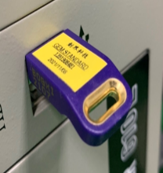

※If the installation fails or the USB cannot be read, the message box will pop up as shown below.

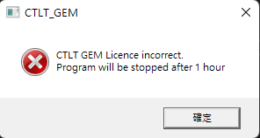

SECS/GEM Interface - State
SECS Connection state
Communicating state
Enable/Disable Comm
Display of current control status
Status toggle field
Messagebox

GEM Initial result show

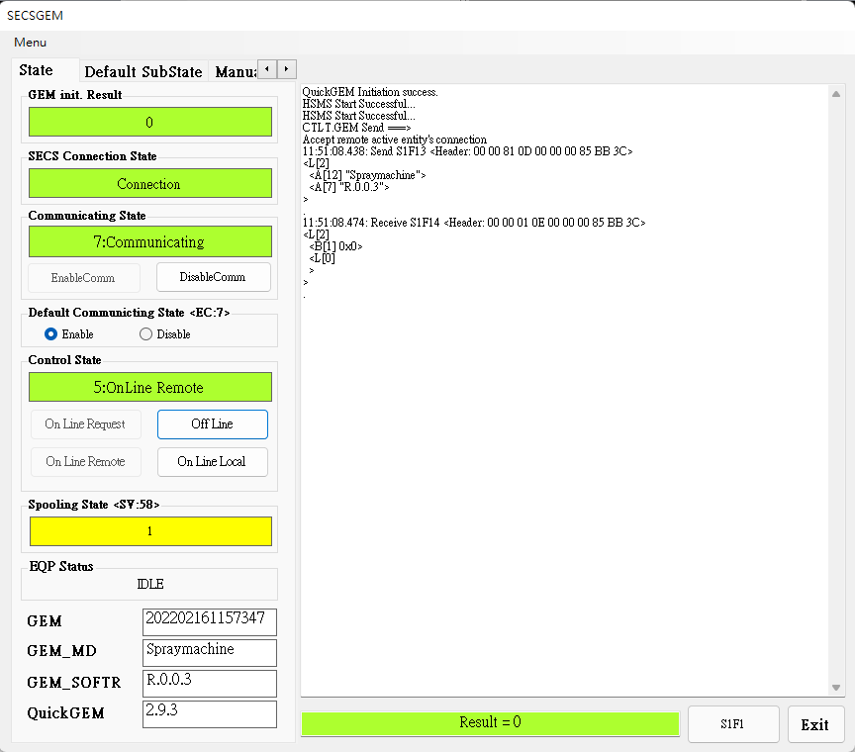
GEM Clock
GEM MODEL Name
GEM Software Version
QuickGEM Software Version

EQ Status show
Spooling State show
Are you there command
Last command result

EnableComm : Start Communication
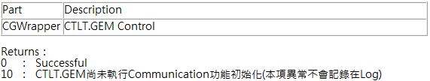
####################################################
DisableComm : Stop Communication
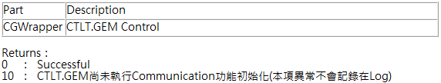
####################################################
On Line Request : Send the request to connect with the remote On Line
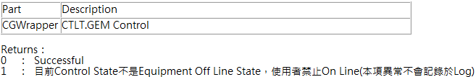
####################################################
Off Line : Send the request to disconnect with the remote On Line
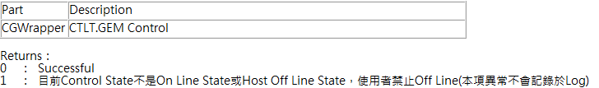
####################################################

On Line Remote : Switch to remote control status
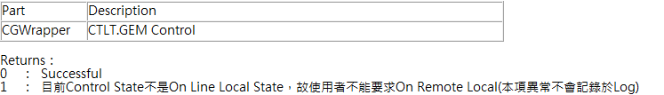
####################################################
On Line Local : Switch to local control status
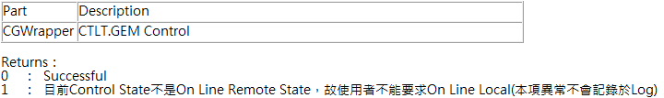
####################################################

SECS/GEM Interface – Default Substate
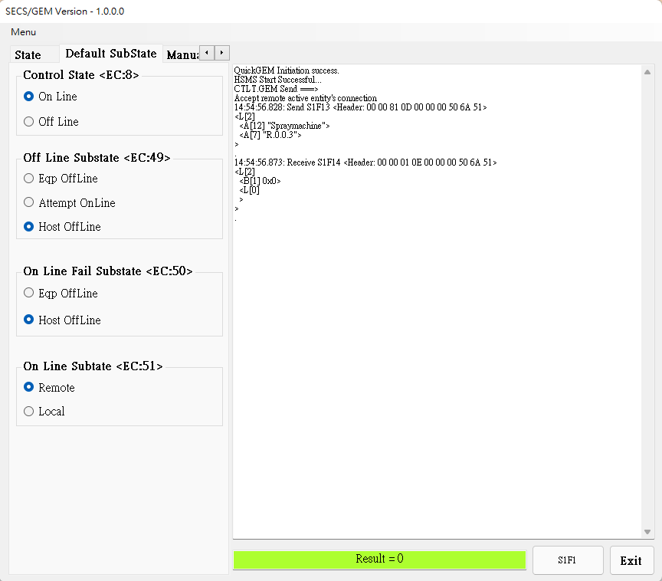
Switch EC:8, EC:49, EC:50, EC:51 ‘s sub state, See [System EC page (p.23) ] for details

SECS/GEM Interface – Manual SV,DV,EC
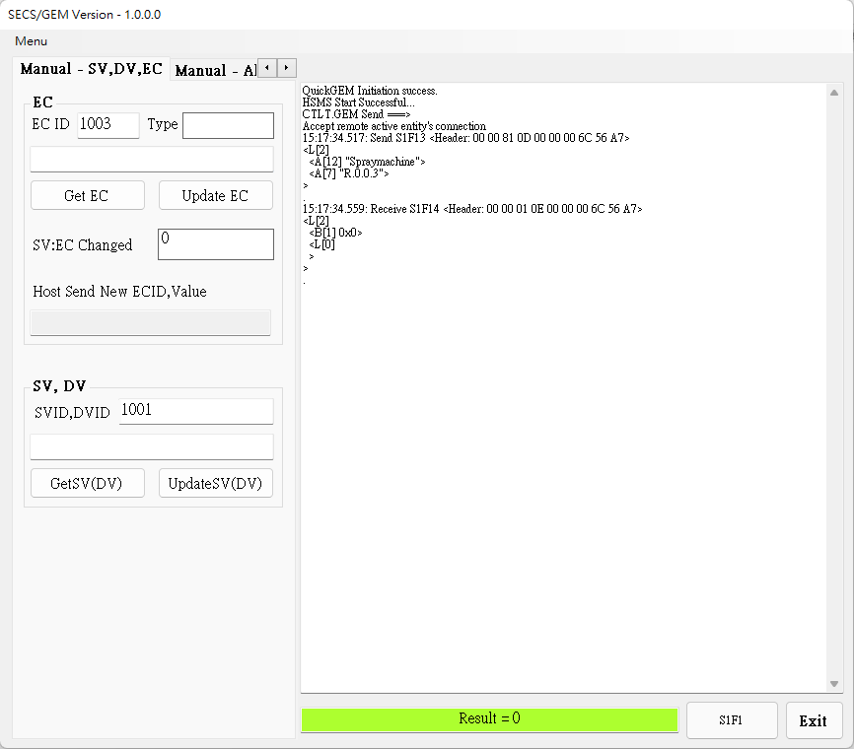
Update EC : Update specified Equipment Constant(EC) value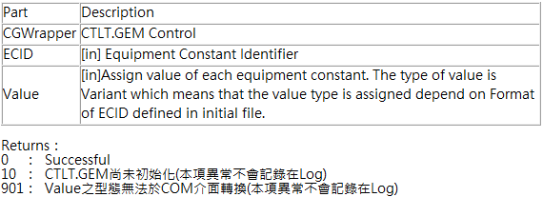
####################################################
Update SV(DV) : Update specified Status Variable(SV) and Data Value(DV) value
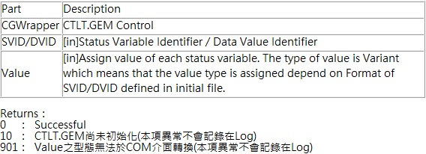
####################################################
GetEC : Load specified Equipment Constant value
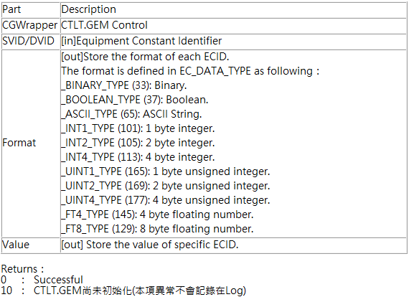
####################################################

GetSV(DV) : Load specified Status Variable(SV) and Data Value(DV) value
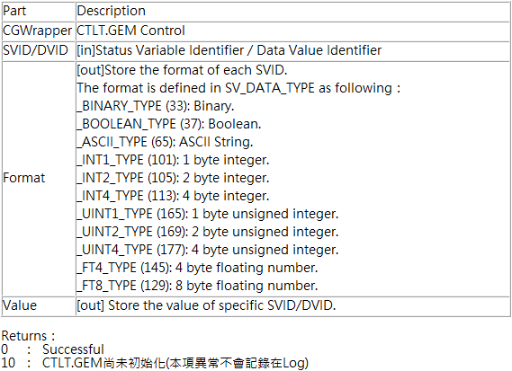
####################################################

SECS/GEM Interface – Alarm
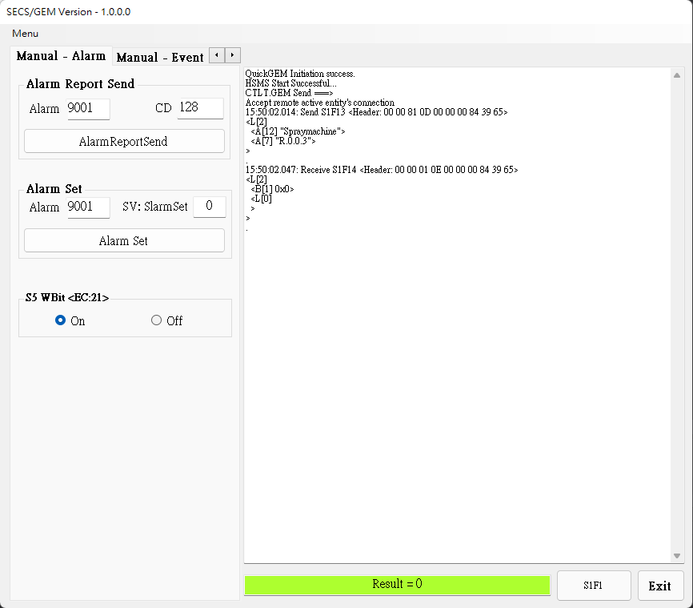
AlarmReportSend : Based on specified Alarm ID send alarm message
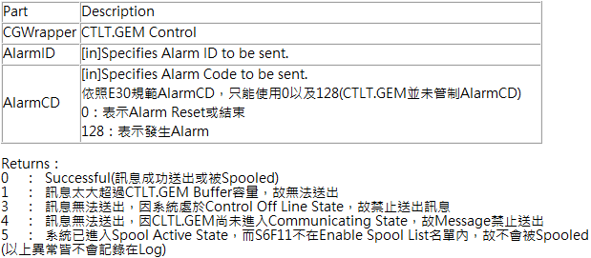
S5 WBit <EC:21> :check [System EC] for details

SECS/GEM Interface – Event
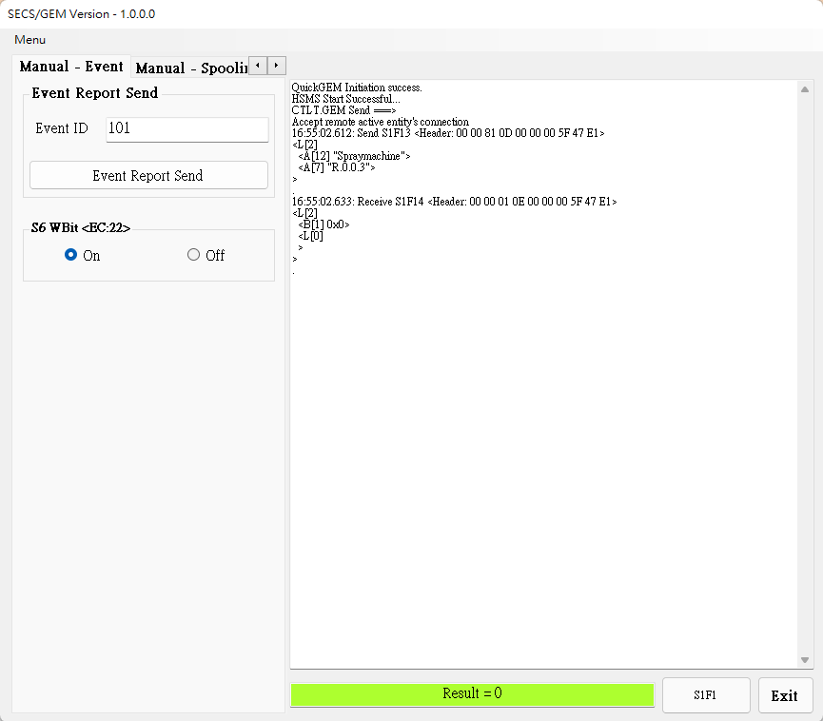
EventReportSend : Based on specified Event ID send event message
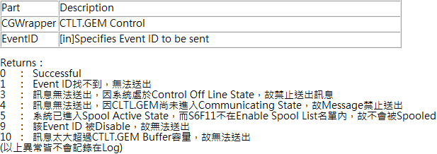
S6 WBit <EC:22> : Check [System EC] for details

SECS/GEM Interface – Spooling
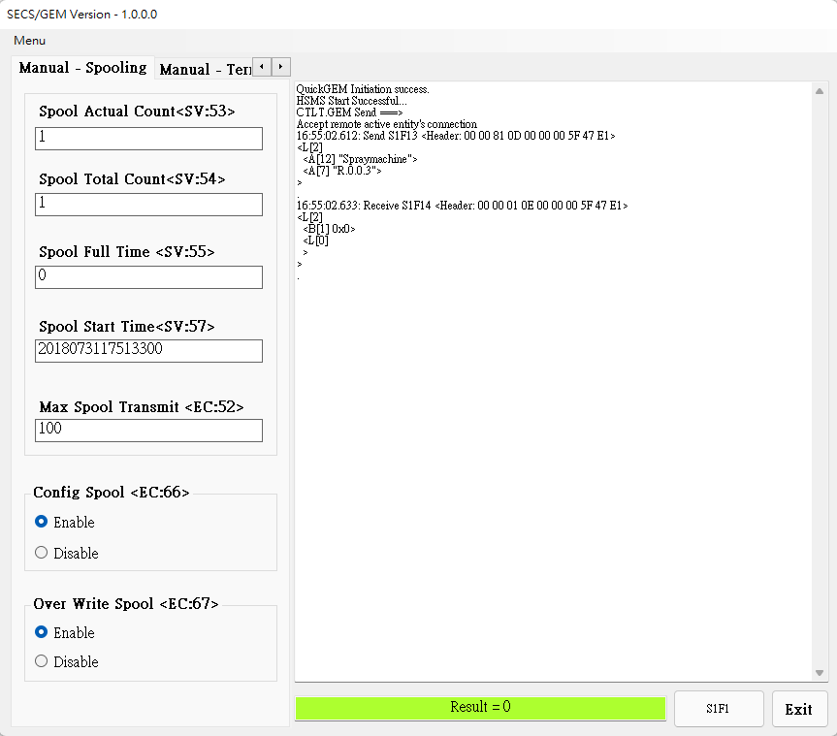
Display SV:53, SV:54, SV:55, SV:57 current value, check [System SV ] for details

Display EC:52current value, check [System EC ] for details

Open/Close EC66, EC67 enable state, check [System EC ] for details

SECS/GEM Interface – Terminal
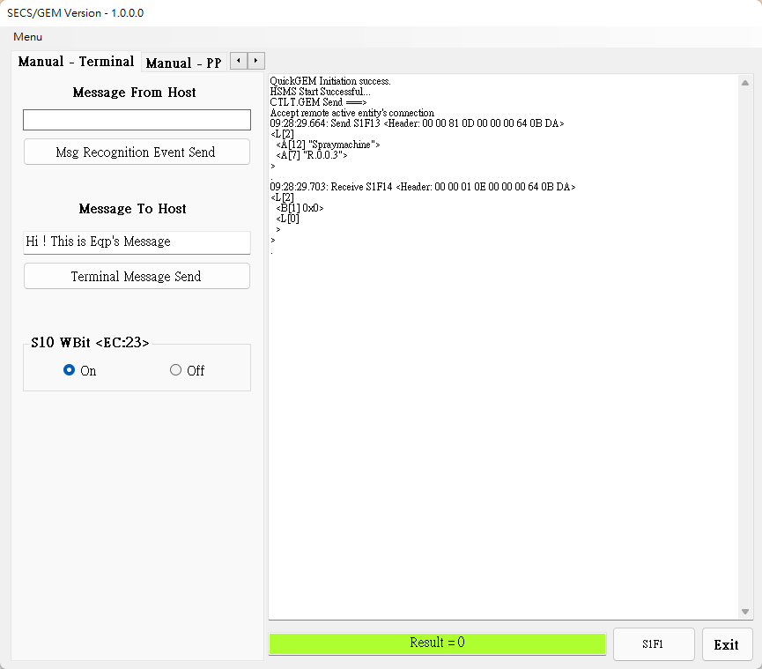
Msg Recognition Event Send: Send terminal message
Terminal Message Send: Send terminal message
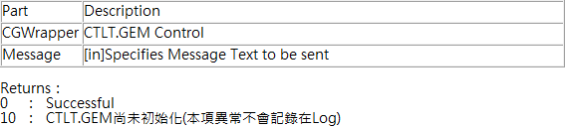
S10 WBit <EC:23> : Check [System EC ] for details

SECS/GEM Interface – PP
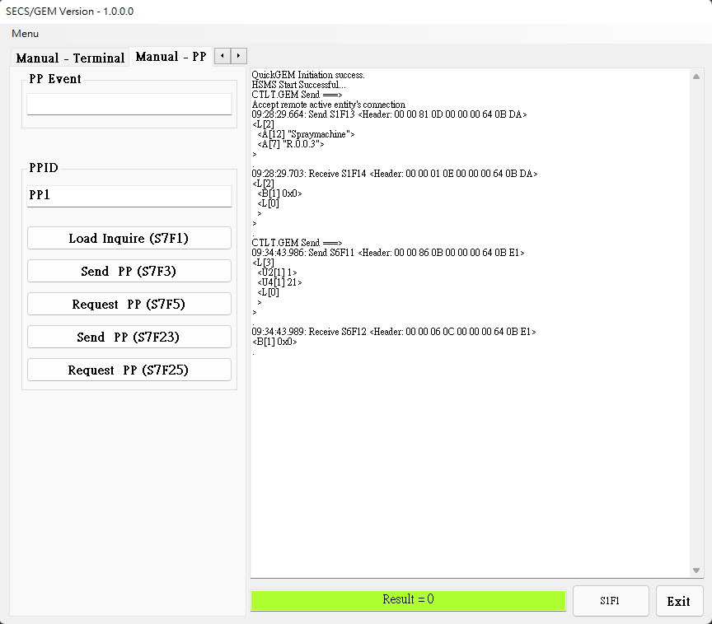
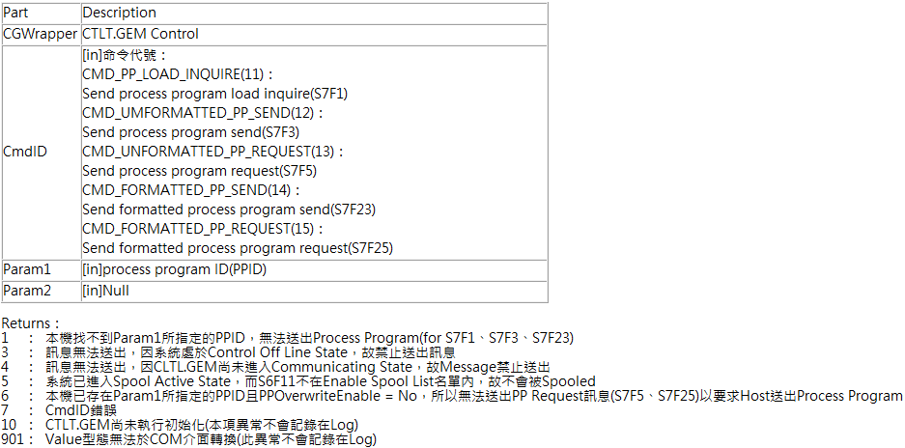

Config Interface
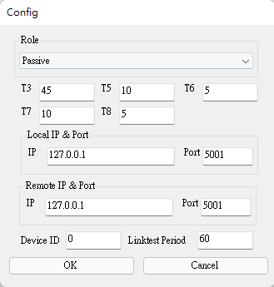
Role : Set the machine as the active side (Host) or the passive side (Equipment)
T3 : Set the time for the sender to wait for the receiver to return a message after sending the data message
T5 : After the TCP/IP connection is set to fail, the active side needs to wait for T5 time before reconnecting
T6 : Set the time for the sender to wait for the receiver to return a message after sending a control message
T7 : Set the time to wait to enter Selected Stats after entering Connected Stats
T8 : Set the maximum time interval allowed between characters in the message when the receiver receives the message
Local IP & Port : Set local IP & Port
Remote IP & Port : Set remote IP & Port
Device ID : Set Device ID
Linktest Period : Set the interval for sending test messages periodically (limited by T6)

System SV

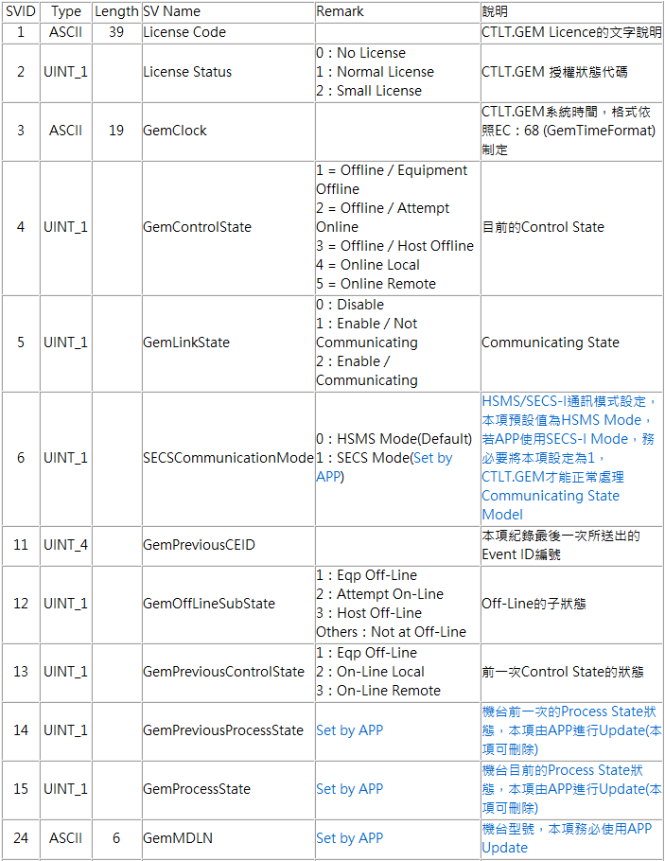

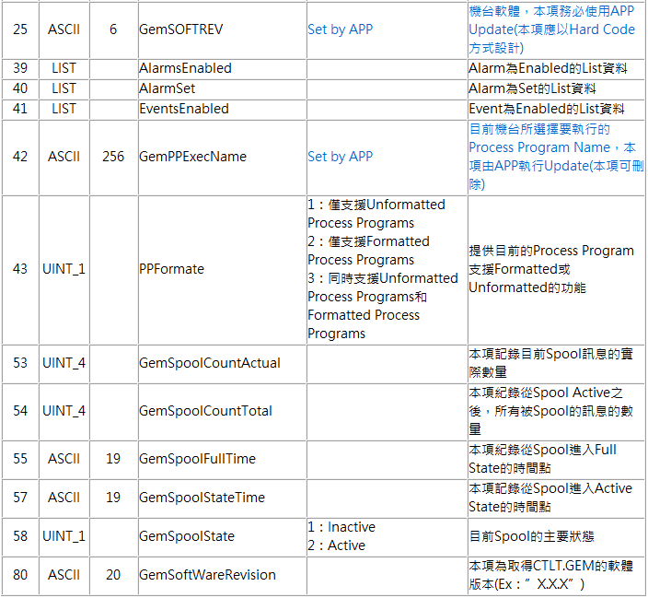

System DV

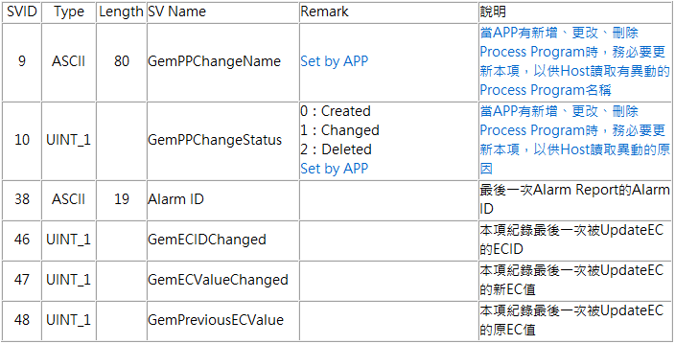

System EC

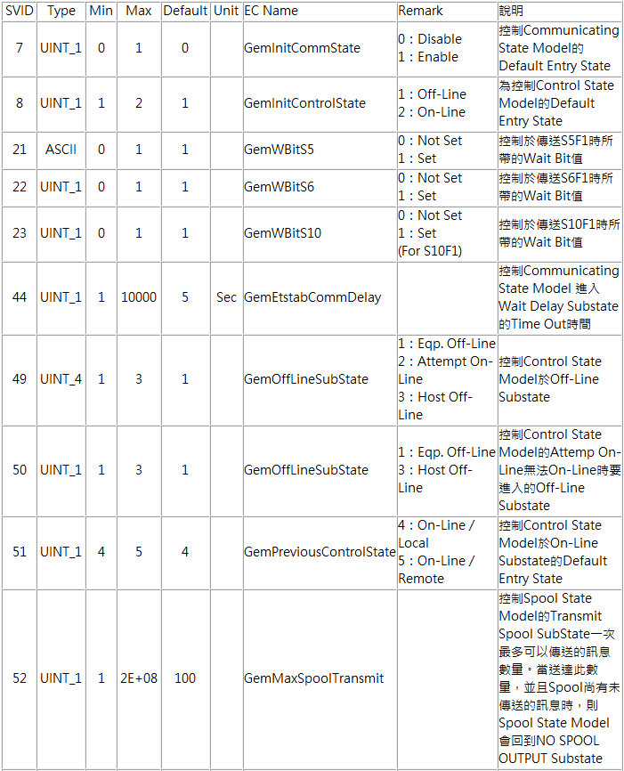

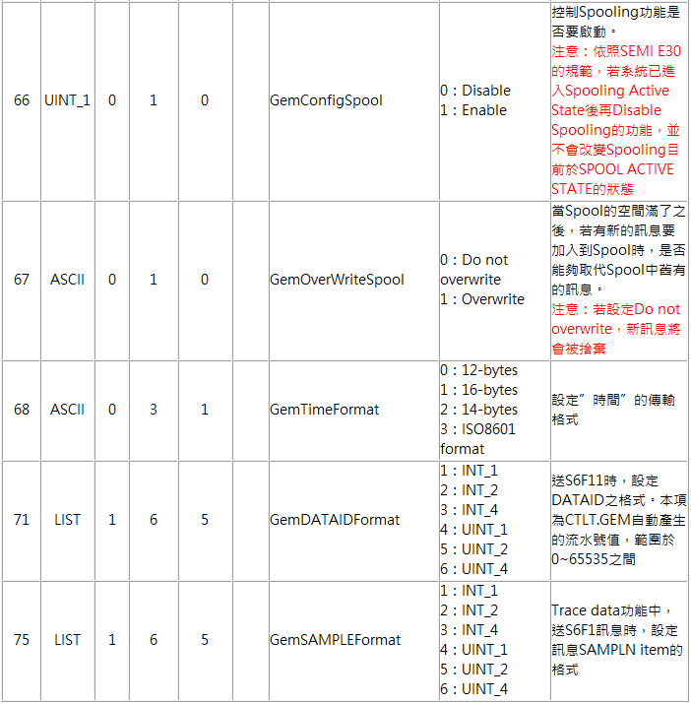

System Event

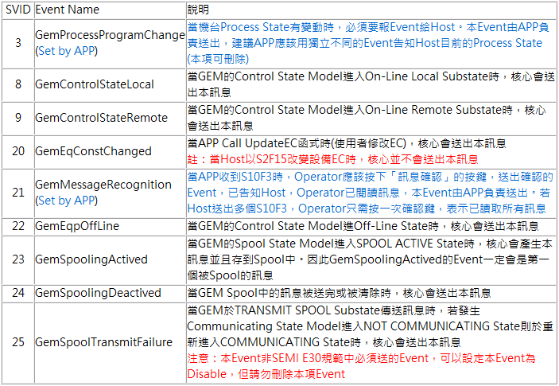

Equpiment SV

ID | TYPE | Lenght | NAME | Definition

Equpiment DV

ID | TYPE | Length | NAME | Definition
1998 | UINT_1 | 1000 | EquipmentStatus | Identifier for the equipment status
1999 | ASCII | 1000 | RecipeID | Identifier for the recipe ID
2000 | ASCII | 1000 | CarrierID | Identifier for the carrier
2001 | UINT_1 | 1000 | PortID | Identifier for the load port
2002 | UINT_1 | 1000 | AccessMode | The access mode of the load port
2003 | UINT_1 | 1000 | SlotMapStatus | Slotmap status of the carrier
2005 | UINT_1 | 1000 | PortTransferState | The current transfer state of load port
2006 | UINT_1 | 1000 | Loadport1_AccessMode | The access mode of the load port 1
2007 | UINT_1 | 1000 | Loadport2_AccessMode | The access mode of the load port 2
2008 | UINT_1 | 1000 | Loadport1_PortTransferState | The current transfer state of load port 1
2009 | UINT_1 | 1000 | Loadport2_PortTransferState | The current transfer state of load port 2
2010 | LIST | 1000 | SlotMap_List | The slotmap of a carrier
2013 | UINT_1 | 1000 | Reason | slotmap verification result
2014 | ASCII | 1000 | Loadport1_Recipe | The recipe of the load port 1
2015 | ASCII | 1000 | Loadport2_Recipe | The recipe of the load port 2
3001 | UINT_1 | 1000 | SlotMap_1 | Slot Map1
3002 | UINT_1 | 1000 | SlotMap_2 | Slot Map2
3003 | UINT_1 | 1000 | SlotMap_3 | Slot Map3
3004 | UINT_1 | 1000 | SlotMap_4 | Slot Map4
3005 | UINT_1 | 1000 | SlotMap_5 | Slot Map5
3006 | UINT_1 | 1000 | SlotMap_6 | Slot Map6
3007 | UINT_1 | 1000 | SlotMap_7 | Slot Map7
3008 | UINT_1 | 1000 | SlotMap_8 | Slot Map8
3009 | UINT_1 | 1000 | SlotMap_9 | Slot Map9
3010 | UINT_1 | 1000 | SlotMap_10 | Slot Map10
3011 | UINT_1 | 1000 | SlotMap_11 | Slot Map11
3012 | UINT_1 | 1000 | SlotMap_12 | Slot Map12
3013 | UINT_1 | 1000 | SlotMap_13 | Slot Map13
3014 | UINT_1 | 1000 | SlotMap_14 | Slot Map14
3015 | UINT_1 | 1000 | SlotMap_15 | Slot Map15
3016 | UINT_1 | 1000 | SlotMap_16 | Slot Map16
3017 | UINT_1 | 1000 | SlotMap_17 | Slot Map17
3018 | UINT_1 | 1000 | SlotMap_18 | Slot Map18
3019 | UINT_1 | 1000 | SlotMap_19 | Slot Map19
3020 | UINT_1 | 1000 | SlotMap_20 | Slot Map20
3021 | UINT_1 | 1000 | SlotMap_21 | Slot Map21
3022 | UINT_1 | 1000 | SlotMap_22 | Slot Map22
3023 | UINT_1 | 1000 | SlotMap_23 | Slot Map23
3024 | UINT_1 | 1000 | SlotMap_24 | Slot Map24
3025 | UINT_1 | 1000 | SlotMap_25 | Slot Map25
4001 | ASCII | 1000 | Slot1_Info | Slot1 Info
4002 | ASCII | 1000 | Slot2_Info | Slot2 Info
4003 | ASCII | 1000 | Slot3_Info | Slot3 Info
4004 | ASCII | 1000 | Slot4_Info | Slot4 Info
4005 | ASCII | 1000 | Slot5_Info | Slot5 Info
4006 | ASCII | 1000 | Slot6_Info | Slot6 Info
4007 | ASCII | 1000 | Slot7_Info | Slot7 Info
4008 | ASCII | 1000 | Slot8_Info | Slot8 Info
4009 | ASCII | 1000 | Slot9_Info | Slot9 Info
4010 | ASCII | 1000 | Slot10_Info | Slot10 Info
4011 | ASCII | 1000 | Slot11_Info | Slot11 Info
4012 | ASCII | 1000 | Slot12_Info | Slot12 Info
4013 | ASCII | 1000 | Slot13_Info | Slot13 Info
4014 | ASCII | 1000 | Slot14_Info | Slot14 Info
4015 | ASCII | 1000 | Slot15_Info | Slot15 Info
4016 | ASCII | 1000 | Slot16_Info | Slot16 Info
4017 | ASCII | 1000 | Slot17_Info | Slot17 Info
4018 | ASCII | 1000 | Slot18_Info | Slot18 Info
4019 | ASCII | 1000 | Slot19_Info | Slot19 Info
4020 | ASCII | 1000 | Slot20_Info | Slot20 Info
4021 | ASCII | 1000 | Slot21_Info | Slot21 Info
4022 | ASCII | 1000 | Slot22_Info | Slot22 Info
4023 | ASCII | 1000 | Slot23_Info | Slot23 Info
4024 | ASCII | 1000 | Slot24_Info | Slot24 Info
4025 | ASCII | 1000 | Slot25_Info | Slot25 Info

Equpiment Event

ID | NAME | Definition
100 | MaterialReceived | Foup Placed, Report Load Complete.
101 | MaterialRemove | Foup Removed, Report Unload Complete.
1000 | CarrierIDRead | Carrier ID has been read
1001 | CarrierIDReadFail | Carrier ID reading has failed
1002 | AccessModeAuto | Load port access mode has changed from MANUAL to AUTO
1003 | AccessModeManu | Load port access mode has changed from AUTO to MANUAL
1004 | ReadyToLoad | Load port transfer state has changed to READY TO LOAD
1005 | ReadyToUnload | Load port transfer state has changed to READY TO UNLOAD
1006 | CarrierClamped | Carrier has been clamped at a load port
1007 | CarrierUnclamped | Carrier has been unclamped at a load port
1008 | AccessModeReply | Reply loadport x access mode.
1009 | CarrierDoorOpened | Carrier has been opened
1010 | CarrierDoorClosed | Carrier has been closed
1011 | LP1_CarrierMapStarted | Carrier mapping has been started at Load Port 1.
1012 | LP1_CarrierMapped | Carrier map completed at Load Port 1.
1013 | SlotMap | Carrier slotmap status has changed to Completed
1014 | MachineRunning | Machine running
1015 | MachineStop | Machine stop
1016 | PortTransferStatusAsk | Reply loadport x transfer status.
2011 | LP2_CarrierMapStarted | Carrier mapping has been started at Load Port 2.
2012 | LP2_CarrierMapped | Carrier map completed at Load Port 2.
5115 | CarrierDock | Carrier completed docking.
5116 | CarrierUnDock | Carrier completed undocking.
5999 | ProcessStart | Process start event
6000 | MeasureResultSend | Measure Result Send

Event Report Link

EventID | RPTID | VIDs
1000 | 11 | 2000, 2001
1001 | 22 | 2001
1002 | 33 | 2001, 2002
1004, 1005 | 44 | 2001, 2005
1006, 1007, 1009, 1010 | 55 | 2000, 2001
1013 | 66 | 2000, 2001, 2013, 2003, 2010
1008 | 33 | 2001, 2002
1016 | 44 | 2001, 2005
100, 101, 5115, 5116 | 88 | 2001, 2000
6000 | 99 | 2001, 2000, 4001, 4002, 4003, 4004, 4005, 4006, 4007, 4008, 4009, 4010, 4011, 4012, 4013, 4014, 4015, 4016, 4017, 4018, 4019, 4020, 4021, 4022, 4023, 4024, 4025

Equpiment Alarm

ID | NAME | Definition
10001 | EQP-DDMotorError | EQP-DDMotorError
10002 | EQP-CDAError | EQP-CDAError
10003 | EQP-EMO | EQP-EMO
10004 | EQP-StageVacuumError | EQP-StageVacuumError
10005 | EQP-CylinderUpError | EQP-CylinderUpError
10006 | EQP-CylinderDownError | EQP-CylinderDownError
10007 | EQP-DoorOpen | EQP-DoorOpen
10008 | EQP-AxleCardError | EQP-AxleCardError
10009 | EQP-IOCardError | EQP-IOCardError
20001 | EFEM-GetVersionError | EFEM-GetVersionError
20002 | EFEM-RemoteControlError | EFEM-RemoteControlError
20003 | EFEM-LocalControlError | Carrier has been opened
20004 | EFEM-GetCurrentModeError | EFEM-GetCurrentModeError
20005 | EFEM-GetStatusError | EFEM-GetStatusError
20006 | EFEM-All_HomeError | EFEM-All_HomeError
20007 | EFEM-All_ResetError | EFEM-All_ResetError
20008 | EFEM-Stage1_HomeError | EFEM-Stage1_HomeError
30001 | EFEM-Loadport_P1_GetStatusError | EFEM-Loadport_P1_GetStatusError
30002 | EFEM-Loadport_P2_GetStatusError | EFEM-Loadport_P2_GetStatusError
30003 | EFEM-Loadport_P1_HomeError | EFEM-Loadport_P1_HomeError
30004 | EFEM-Loadport_P2_HomeError | EFEM-Loadport_P2_HomeError
30005 | EFEM-Loadport_P1_ResetError | EFEM-Loadport_P1_ResetError
30006 | EFEM-Loadport_P2_ResetError | EFEM-Loadport_P2_ResetError
30007 | EFEM-Loadport_P1_ResetComPortError | EFEM-Loadport_P1_ResetComPortError
30008 | EFEM-Loadport_P2_ResetComPortError | EFEM-Loadport_P2_ResetComPortError
30009 | EFEM-Loadport_P1_ReadFoupIDError | EFEM-Loadport_P1_ReadFoupIDError
30010 | EFEM-Loadport_P2_ReadFoupIDError | EFEM-Loadport_P2_ReadFoupIDError
30011 | EFEM-Loadport_P1_ClampError | EFEM-Loadport_P1_ClampError
30012 | EFEM-Loadport_P2_ClampError | EFEM-Loadport_P2_ClampError
30013 | EFEM-Loadport_P1_LoadError | EFEM-Loadport_P1_LoadError
30014 | EFEM-Loadport_P2_LoadError | EFEM-Loadport_P2_LoadError
30015 | EFEM-Loadport_P1_UnloadError | EFEM-Loadport_P1_UnloadError
30016 | EFEM-Loadport_P2_UnloadError | EFEM-Loadport_P2_UnloadError
30017 | EFEM-Loadport_P1_MapError | EFEM-Loadport_P1_MapError
30018 | EFEM-Loadport_P2_MapError | EFEM-Loadport_P2_MapError
30019 | EFEM-Loadport_P1_StopError | EFEM-Loadport_P1_StopError
30020 | EFEM-Loadport_P2_StopError | EFEM-Loadport_P2_StopError
30021 | EFEM-Loadport_P1_GetWaferSlotError | EFEM-Loadport_P1_GetWaferSlotError
30022 | EFEM-Loadport_P2_GetWaferSlotError | EFEM-Loadport_P2_GetWaferSlotError
30023 | EFEM-Loadport_P1_GetWaferSlot2Error | EFEM-Loadport_P1_GetWaferSlot2Error
30024 | EFEM-Loadport_P2_GetWaferSlot2Error | EFEM-Loadport_P2_GetWaferSlot2Error
30025 | EFEM-Loadport_P1_GetWaferThicknessError | EFEM-Loadport_P1_GetWaferThicknessError
30026 | EFEM-Loadport_P2_GetWaferThicknessError | EFEM-Loadport_P2_GetWaferThicknessError
30027 | EFEM-Loadport_P1_LEDLoadOnError | EFEM-Loadport_P1_LEDLoadOnError
30028 | EFEM-Loadport_P1_LEDLoadOffError | EFEM-Loadport_P1_LEDLoadOffError
30029 | EFEM-Loadport_P1_LEDLoadFlashError | EFEM-Loadport_P1_LEDLoadFlashError
30030 | EFEM-Loadport_P2_LEDLoadOnError | EFEM-Loadport_P2_LEDLoadOnError
30031 | EFEM-Loadport_P2_LEDLoadOffError | EFEM-Loadport_P2_LEDLoadOffError
30032 | EFEM-Loadport_P2_LEDLoadFlashError | EFEM-Loadport_P2_LEDLoadFlashError
30033 | EFEM-Loadport_P1_LEDUnLoadOnError | EFEM-Loadport_P1_LEDUnLoadOnError
30034 | EFEM-Loadport_P1_LEDUnLoadOffError | EFEM-Loadport_P1_LEDUnLoadOffError
30035 | EFEM-Loadport_P1_LEDUnLoadFlashError | EFEM-Loadport_P1_LEDUnLoadFlashError
30036 | EFEM-Loadport_P2_LEDUnLoadOnError | EFEM-Loadport_P2_LEDUnLoadOnError
30037 | EFEM-Loadport_P2_LEDUnLoadOffError | EFEM-Loadport_P2_LEDUnLoadOffError
30038 | EFEM-Loadport_P2_LEDUnLoadFlashError | EFEM-Loadport_P2_LEDUnLoadFlashError
30039 | EFEM-Loadport_P1_LEDStatus1OnError | EFEM-Loadport_P1_LEDStatus1OnError
30040 | EFEM-Loadport_P1_LEDStatus1OffError | EFEM-Loadport_P1_LEDStatus1OffError
30041 | EFEM-Loadport_P1_LEDStatus1FlashError | EFEM-Loadport_P1_LEDStatus1FlashError
30042 | EFEM-Loadport_P2_LEDStatus1OnError | EFEM-Loadport_P2_LEDStatus1OnError
30043 | EFEM-Loadport_P2_LEDStatus1OffError | EFEM-Loadport_P2_LEDStatus1OffError
30044 | EFEM-Loadport_P2_LEDStatus1FlashError | EFEM-Loadport_P2_LEDStatus1FlashError
30045 | EFEM-Loadport_P1_LEDStatus2OnError | EFEM-Loadport_P1_LEDStatus2OnError
30046 | EFEM-Loadport_P1_LEDStatus2OffError | EFEM-Loadport_P1_LEDStatus2OffError
30047 | EFEM-Loadport_P1_LEDStatus2FlashError | EFEM-Loadport_P1_LEDStatus2FlashError
30048 | EFEM-Loadport_P2_LEDStatus2OnError | EFEM-Loadport_P2_LEDStatus2OnError
30049 | EFEM-Loadport_P2_LEDStatus2OffError | EFEM-Loadport_P2_LEDStatus2OffError
30050 | EFEM-Loadport_P2_LEDStatus2FlashError | EFEM-Loadport_P2_LEDStatus2FlashError
30051 | EFEM-Loadport_P1_GetLEDStatusError | EFEM-Loadport_P1_GetLEDStatusError
30052 | EFEM-Loadport_P2_GetLEDStatusError | EFEM-Loadport_P2_GetLEDStatusError
30053 | EFEM-Loadport_P1_SetOperatorAccessButtonOnError | EFEM-Loadport_P1_SetOperatorAccessButtonOnError
30054 | EFEM-Loadport_P1_SetOperatorAccessButtonOffError | EFEM-Loadport_P1_SetOperatorAccessButtonOffError
30055 | EFEM-Loadport_P1_SetOperatorAccessButtonFlashError | EFEM-Loadport_P1_SetOperatorAccessButtonFlashError
30056 | EFEM-Loadport_P2_SetOperatorAccessButtonOnError | EFEM-Loadport_P2_SetOperatorAccessButtonOnError
30057 | EFEM-Loadport_P2_SetOperatorAccessButtonOffError | EFEM-Loadport_P2_SetOperatorAccessButtonOffError
30058 | EFEM-Loadport_P2_SetOperatorAccessButtonFlashError | EFEM-Loadport_P2_SetOperatorAccessButtonFlashError
30059 | EFEM-Loadport_P1_GetZAxisPosError | EFEM-Loadport_P1_GetZAxisPosError
30060 | EFEM-Loadport_P2_GetZAxisPosError | EFEM-Loadport_P2_GetZAxisPosError
40001 | EFEM-Robot_GetStatusError | EFEM-Robot_GetStatusError
40002 | EFEM-Robot_StopError | EFEM-Robot_StopError
40003 | EFEM-Robot_ReStartError | EFEM-Robot_ReStartError
40004 | EFEM-Robot_SetRobotSpeedError | EFEM-Robot_SetRobotSpeedError
40005 | EFEM-Robot_ReadPositionError | EFEM-Robot_ReadPositionError
40006 | EFEM-Robot_WaferGetError(LowerArm-P1-Slot1) | EFEM-Robot_WaferGetError(LowerArm-P1-Slot1)
40007 | EFEM-Robot_WaferGetError(LowerArm-P1-Slot2) | EFEM-Robot_WaferGetError(LowerArm-P1-Slot2)
40008 | EFEM-Robot_WaferGetError(LowerArm-P1-Slot3) | EFEM-Robot_WaferGetError(LowerArm-P1-Slot3)
40009 | EFEM-Robot_WaferGetError(LowerArm-P1-Slot4) | EFEM-Robot_WaferGetError(LowerArm-P1-Slot4)
40010 | EFEM-Robot_WaferGetError(LowerArm-P1-Slot5) | EFEM-Robot_WaferGetError(LowerArm-P1-Slot5)
40011 | EFEM-Robot_WaferGetError(LowerArm-P1-Slot6) | EFEM-Robot_WaferGetError(LowerArm-P1-Slot6)
40012 | EFEM-Robot_WaferGetError(LowerArm-P1-Slot7) | EFEM-Robot_WaferGetError(LowerArm-P1-Slot7)
40013 | EFEM-Robot_WaferGetError(LowerArm-P1-Slot8) | EFEM-Robot_WaferGetError(LowerArm-P1-Slot8)
40014 | EFEM-Robot_WaferGetError(LowerArm-P1-Slot9) | EFEM-Robot_WaferGetError(LowerArm-P1-Slot9)
40015 | EFEM-Robot_WaferGetError(LowerArm-P1-Slot10) | EFEM-Robot_WaferGetError(LowerArm-P1-Slot10)
40016 | EFEM-Robot_WaferGetError(LowerArm-P1-Slot11) | EFEM-Robot_WaferGetError(LowerArm-P1-Slot11)
40017 | EFEM-Robot_WaferGetError(LowerArm-P1-Slot12) | EFEM-Robot_WaferGetError(LowerArm-P1-Slot12)
40018 | EFEM-Robot_WaferGetError(LowerArm-P1-Slot13) | EFEM-Robot_WaferGetError(LowerArm-P1-Slot13)
40019 | EFEM-Robot_WaferGetError(LowerArm-P1-Slot14) | EFEM-Robot_WaferGetError(LowerArm-P1-Slot14)
40020 | EFEM-Robot_WaferGetError(LowerArm-P1-Slot15) | EFEM-Robot_WaferGetError(LowerArm-P1-Slot15)
40021 | EFEM-Robot_WaferGetError(LowerArm-P1-Slot16) | EFEM-Robot_WaferGetError(LowerArm-P1-Slot16)
40022 | EFEM-Robot_WaferGetError(LowerArm-P1-Slot17) | EFEM-Robot_WaferGetError(LowerArm-P1-Slot17)
40023 | EFEM-Robot_WaferGetError(LowerArm-P1-Slot18) | EFEM-Robot_WaferGetError(LowerArm-P1-Slot18)
40024 | EFEM-Robot_WaferGetError(LowerArm-P1-Slot19) | EFEM-Robot_WaferGetError(LowerArm-P1-Slot19)
40025 | EFEM-Robot_WaferGetError(LowerArm-P1-Slot20) | EFEM-Robot_WaferGetError(LowerArm-P1-Slot20)
40026 | EFEM-Robot_WaferGetError(LowerArm-P1-Slot21) | EFEM-Robot_WaferGetError(LowerArm-P1-Slot21)
40027 | EFEM-Robot_WaferGetError(LowerArm-P1-Slot22) | EFEM-Robot_WaferGetError(LowerArm-P1-Slot22)
40028 | EFEM-Robot_WaferGetError(LowerArm-P1-Slot23) | EFEM-Robot_WaferGetError(LowerArm-P1-Slot23)
40029 | EFEM-Robot_WaferGetError(LowerArm-P1-Slot24) | EFEM-Robot_WaferGetError(LowerArm-P1-Slot24)
40030 | EFEM-Robot_WaferGetError(LowerArm-P1-Slot25) | EFEM-Robot_WaferGetError(LowerArm-P1-Slot25)
40031 | EFEM-Robot_WaferGetError(UpperArm-P1-Slot1) | EFEM-Robot_WaferGetError(UpperArm-P1-Slot1)
40032 | EFEM-Robot_WaferGetError(UpperArm-P1-Slot2) | EFEM-Robot_WaferGetError(UpperArm-P1-Slot2)
40033 | EFEM-Robot_WaferGetError(UpperArm-P1-Slot3) | EFEM-Robot_WaferGetError(UpperArm-P1-Slot3)
40034 | EFEM-Robot_WaferGetError(UpperArm-P1-Slot4) | EFEM-Robot_WaferGetError(UpperArm-P1-Slot4)
40035 | EFEM-Robot_WaferGetError(UpperArm-P1-Slot5) | EFEM-Robot_WaferGetError(UpperArm-P1-Slot5)
40036 | EFEM-Robot_WaferGetError(UpperArm-P1-Slot6) | EFEM-Robot_WaferGetError(UpperArm-P1-Slot6)
40037 | EFEM-Robot_WaferGetError(UpperArm-P1-Slot7) | EFEM-Robot_WaferGetError(UpperArm-P1-Slot7)
40038 | EFEM-Robot_WaferGetError(UpperArm-P1-Slot8) | EFEM-Robot_WaferGetError(UpperArm-P1-Slot8)
40039 | EFEM-Robot_WaferGetError(UpperArm-P1-Slot9) | EFEM-Robot_WaferGetError(UpperArm-P1-Slot9)
40040 | EFEM-Robot_WaferGetError(UpperArm-P1-Slot10) | EFEM-Robot_WaferGetError(UpperArm-P1-Slot10)
40041 | EFEM-Robot_WaferGetError(UpperArm-P1-Slot11) | EFEM-Robot_WaferGetError(UpperArm-P1-Slot11)
40042 | EFEM-Robot_WaferGetError(UpperArm-P1-Slot12) | EFEM-Robot_WaferGetError(UpperArm-P1-Slot12)
40043 | EFEM-Robot_WaferGetError(UpperArm-P1-Slot13) | EFEM-Robot_WaferGetError(UpperArm-P1-Slot13)
40044 | EFEM-Robot_WaferGetError(UpperArm-P1-Slot14) | EFEM-Robot_WaferGetError(UpperArm-P1-Slot14)
40045 | EFEM-Robot_WaferGetError(UpperArm-P1-Slot15) | EFEM-Robot_WaferGetError(UpperArm-P1-Slot15)
40046 | EFEM-Robot_WaferGetError(UpperArm-P1-Slot16) | EFEM-Robot_WaferGetError(UpperArm-P1-Slot16)
40047 | EFEM-Robot_WaferGetError(UpperArm-P1-Slot17) | EFEM-Robot_WaferGetError(UpperArm-P1-Slot17)
40048 | EFEM-Robot_WaferGetError(UpperArm-P1-Slot18) | EFEM-Robot_WaferGetError(UpperArm-P1-Slot18)
40049 | EFEM-Robot_WaferGetError(UpperArm-P1-Slot19) | EFEM-Robot_WaferGetError(UpperArm-P1-Slot19)
40050 | EFEM-Robot_WaferGetError(UpperArm-P1-Slot20) | EFEM-Robot_WaferGetError(UpperArm-P1-Slot20)
40051 | EFEM-Robot_WaferGetError(UpperArm-P1-Slot21) | EFEM-Robot_WaferGetError(UpperArm-P1-Slot21)
40052 | EFEM-Robot_WaferGetError(UpperArm-P1-Slot22) | EFEM-Robot_WaferGetError(UpperArm-P1-Slot22)
40053 | EFEM-Robot_WaferGetError(UpperArm-P1-Slot23) | EFEM-Robot_WaferGetError(UpperArm-P1-Slot23)
40054 | EFEM-Robot_WaferGetError(UpperArm-P1-Slot24) | EFEM-Robot_WaferGetError(UpperArm-P1-Slot24)
40055 | EFEM-Robot_WaferGetError(UpperArm-P1-Slot25) | EFEM-Robot_WaferGetError(UpperArm-P1-Slot25)
40056 | EFEM-Robot_WaferGetError(LowerArm-P2-Slot1) | EFEM-Robot_WaferGetError(LowerArm-P2-Slot1)
40057 | EFEM-Robot_WaferGetError(LowerArm-P2-Slot2) | EFEM-Robot_WaferGetError(LowerArm-P2-Slot2)
40058 | EFEM-Robot_WaferGetError(LowerArm-P2-Slot3) | EFEM-Robot_WaferGetError(LowerArm-P2-Slot3)
40059 | EFEM-Robot_WaferGetError(LowerArm-P2-Slot4) | EFEM-Robot_WaferGetError(LowerArm-P2-Slot4)
40060 | EFEM-Robot_WaferGetError(LowerArm-P2-Slot5) | EFEM-Robot_WaferGetError(LowerArm-P2-Slot5)
40061 | EFEM-Robot_WaferGetError(LowerArm-P2-Slot6) | EFEM-Robot_WaferGetError(LowerArm-P2-Slot6)
40062 | EFEM-Robot_WaferGetError(LowerArm-P2-Slot7) | EFEM-Robot_WaferGetError(LowerArm-P2-Slot7)
40063 | EFEM-Robot_WaferGetError(LowerArm-P2-Slot8) | EFEM-Robot_WaferGetError(LowerArm-P2-Slot8)
40064 | EFEM-Robot_WaferGetError(LowerArm-P2-Slot9) | EFEM-Robot_WaferGetError(LowerArm-P2-Slot9)
40065 | EFEM-Robot_WaferGetError(LowerArm-P2-Slot10) | EFEM-Robot_WaferGetError(LowerArm-P2-Slot10)
40066 | EFEM-Robot_WaferGetError(LowerArm-P2-Slot11) | EFEM-Robot_WaferGetError(LowerArm-P2-Slot11)
40067 | EFEM-Robot_WaferGetError(LowerArm-P2-Slot12) | EFEM-Robot_WaferGetError(LowerArm-P2-Slot12)
40068 | EFEM-Robot_WaferGetError(LowerArm-P2-Slot13) | EFEM-Robot_WaferGetError(LowerArm-P2-Slot13)
40069 | EFEM-Robot_WaferGetError(LowerArm-P2-Slot14) | EFEM-Robot_WaferGetError(LowerArm-P2-Slot14)
40070 | EFEM-Robot_WaferGetError(LowerArm-P2-Slot15) | EFEM-Robot_WaferGetError(LowerArm-P2-Slot15)
40071 | EFEM-Robot_WaferGetError(LowerArm-P2-Slot16) | EFEM-Robot_WaferGetError(LowerArm-P2-Slot16)
40072 | EFEM-Robot_WaferGetError(LowerArm-P2-Slot17) | EFEM-Robot_WaferGetError(LowerArm-P2-Slot17)
40073 | EFEM-Robot_WaferGetError(LowerArm-P2-Slot18) | EFEM-Robot_WaferGetError(LowerArm-P2-Slot18)
40074 | EFEM-Robot_WaferGetError(LowerArm-P2-Slot19) | EFEM-Robot_WaferGetError(LowerArm-P2-Slot19)
40075 | EFEM-Robot_WaferGetError(LowerArm-P2-Slot20) | EFEM-Robot_WaferGetError(LowerArm-P2-Slot20)
40076 | EFEM-Robot_WaferGetError(LowerArm-P2-Slot21) | EFEM-Robot_WaferGetError(LowerArm-P2-Slot21)
40077 | EFEM-Robot_WaferGetError(LowerArm-P2-Slot22) | EFEM-Robot_WaferGetError(LowerArm-P2-Slot22)
40078 | EFEM-Robot_WaferGetError(LowerArm-P2-Slot23) | EFEM-Robot_WaferGetError(LowerArm-P2-Slot23)
40079 | EFEM-Robot_WaferGetError(LowerArm-P2-Slot24) | EFEM-Robot_WaferGetError(LowerArm-P2-Slot24)
40080 | EFEM-Robot_WaferGetError(LowerArm-P2-Slot25) | EFEM-Robot_WaferGetError(LowerArm-P2-Slot25)
40081 | EFEM-Robot_WaferGetError(UpperArm-P2-Slot1) | EFEM-Robot_WaferGetError(UpperArm-P2-Slot1)
40082 | EFEM-Robot_WaferGetError(UpperArm-P2-Slot2) | EFEM-Robot_WaferGetError(UpperArm-P2-Slot2)
40083 | EFEM-Robot_WaferGetError(UpperArm-P2-Slot3) | EFEM-Robot_WaferGetError(UpperArm-P2-Slot3)
40084 | EFEM-Robot_WaferGetError(UpperArm-P2-Slot4) | EFEM-Robot_WaferGetError(UpperArm-P2-Slot4)
40085 | EFEM-Robot_WaferGetError(UpperArm-P2-Slot5) | EFEM-Robot_WaferGetError(UpperArm-P2-Slot5)
40086 | EFEM-Robot_WaferGetError(UpperArm-P2-Slot6) | EFEM-Robot_WaferGetError(UpperArm-P2-Slot6)
40087 | EFEM-Robot_WaferGetError(UpperArm-P2-Slot7) | EFEM-Robot_WaferGetError(UpperArm-P2-Slot7)
40088 | EFEM-Robot_WaferGetError(UpperArm-P2-Slot8) | EFEM-Robot_WaferGetError(UpperArm-P2-Slot8)
40089 | EFEM-Robot_WaferGetError(UpperArm-P2-Slot9) | EFEM-Robot_WaferGetError(UpperArm-P2-Slot9)
40090 | EFEM-Robot_WaferGetError(UpperArm-P2-Slot10) | EFEM-Robot_WaferGetError(UpperArm-P2-Slot10)
40091 | EFEM-Robot_WaferGetError(UpperArm-P2-Slot11) | EFEM-Robot_WaferGetError(UpperArm-P2-Slot11)
40092 | EFEM-Robot_WaferGetError(UpperArm-P2-Slot12) | EFEM-Robot_WaferGetError(UpperArm-P2-Slot12)
40093 | EFEM-Robot_WaferGetError(UpperArm-P2-Slot13) | EFEM-Robot_WaferGetError(UpperArm-P2-Slot13)
40094 | EFEM-Robot_WaferGetError(UpperArm-P2-Slot14) | EFEM-Robot_WaferGetError(UpperArm-P2-Slot14)
40095 | EFEM-Robot_WaferGetError(UpperArm-P2-Slot15) | EFEM-Robot_WaferGetError(UpperArm-P2-Slot15)
40096 | EFEM-Robot_WaferGetError(UpperArm-P2-Slot16) | EFEM-Robot_WaferGetError(UpperArm-P2-Slot16)
40097 | EFEM-Robot_WaferGetError(UpperArm-P2-Slot17) | EFEM-Robot_WaferGetError(UpperArm-P2-Slot17)
40098 | EFEM-Robot_WaferGetError(UpperArm-P2-Slot18) | EFEM-Robot_WaferGetError(UpperArm-P2-Slot18)
40099 | EFEM-Robot_WaferGetError(UpperArm-P2-Slot19) | EFEM-Robot_WaferGetError(UpperArm-P2-Slot19)
40100 | EFEM-Robot_WaferGetError(UpperArm-P2-Slot20) | EFEM-Robot_WaferGetError(UpperArm-P2-Slot20)
40101 | EFEM-Robot_WaferGetError(UpperArm-P2-Slot21) | EFEM-Robot_WaferGetError(UpperArm-P2-Slot21)
40102 | EFEM-Robot_WaferGetError(UpperArm-P2-Slot22) | EFEM-Robot_WaferGetError(UpperArm-P2-Slot22)
40103 | EFEM-Robot_WaferGetError(UpperArm-P2-Slot23) | EFEM-Robot_WaferGetError(UpperArm-P2-Slot23)
40104 | EFEM-Robot_WaferGetError(UpperArm-P2-Slot24) | EFEM-Robot_WaferGetError(UpperArm-P2-Slot24)
40105 | EFEM-Robot_WaferGetError(UpperArm-P2-Slot25) | EFEM-Robot_WaferGetError(UpperArm-P2-Slot25)
40106 | EFEM-Robot_WaferGetError  (LowerArm-Aligner1-Slot1) | EFEM-Robot_WaferGetError  (LowerArm-Aligner1-Slot1)
40107 | EFEM-Robot_WaferGetError  (LowerArm-Aligner1-Slot2) | EFEM-Robot_WaferGetError  (LowerArm-Aligner1-Slot2)
40108 | EFEM-Robot_WaferGetError  (LowerArm-Aligner1-Slot3) | EFEM-Robot_WaferGetError  (LowerArm-Aligner1-Slot3)
40109 | EFEM-Robot_WaferGetError  (LowerArm-Aligner1-Slot4) | EFEM-Robot_WaferGetError  (LowerArm-Aligner1-Slot4)
40110 | EFEM-Robot_WaferGetError  (LowerArm-Aligner1-Slot5) | EFEM-Robot_WaferGetError  (LowerArm-Aligner1-Slot5)
40111 | EFEM-Robot_WaferGetError  (LowerArm-Aligner1-Slot6) | EFEM-Robot_WaferGetError  (LowerArm-Aligner1-Slot6)
40112 | EFEM-Robot_WaferGetError  (LowerArm-Aligner1-Slot7) | EFEM-Robot_WaferGetError  (LowerArm-Aligner1-Slot7)
40113 | EFEM-Robot_WaferGetError  (LowerArm-Aligner1-Slot8) | EFEM-Robot_WaferGetError  (LowerArm-Aligner1-Slot8)
40114 | EFEM-Robot_WaferGetError  (LowerArm-Aligner1-Slot9) | EFEM-Robot_WaferGetError  (LowerArm-Aligner1-Slot9)
40115 | EFEM-Robot_WaferGetError  (LowerArm-Aligner1-Slot10) | EFEM-Robot_WaferGetError  (LowerArm-Aligner1-Slot10)
40116 | EFEM-Robot_WaferGetError  (LowerArm-Aligner1-Slot11) | EFEM-Robot_WaferGetError  (LowerArm-Aligner1-Slot11)
40117 | EFEM-Robot_WaferGetError  (LowerArm-Aligner1-Slot12) | EFEM-Robot_WaferGetError  (LowerArm-Aligner1-Slot12)
40118 | EFEM-Robot_WaferGetError  (LowerArm-Aligner1-Slot13) | EFEM-Robot_WaferGetError  (LowerArm-Aligner1-Slot13)
40119 | EFEM-Robot_WaferGetError  (LowerArm-Aligner1-Slot14) | EFEM-Robot_WaferGetError  (LowerArm-Aligner1-Slot14)
40120 | EFEM-Robot_WaferGetError  (LowerArm-Aligner1-Slot15) | EFEM-Robot_WaferGetError  (LowerArm-Aligner1-Slot15)
40121 | EFEM-Robot_WaferGetError  (LowerArm-Aligner1-Slot16) | EFEM-Robot_WaferGetError  (LowerArm-Aligner1-Slot16)
40122 | EFEM-Robot_WaferGetError  (LowerArm-Aligner1-Slot17) | EFEM-Robot_WaferGetError  (LowerArm-Aligner1-Slot17)
40123 | EFEM-Robot_WaferGetError  (LowerArm-Aligner1-Slot18) | EFEM-Robot_WaferGetError  (LowerArm-Aligner1-Slot18)
40124 | EFEM-Robot_WaferGetError  (LowerArm-Aligner1-Slot19) | EFEM-Robot_WaferGetError  (LowerArm-Aligner1-Slot19)
40125 | EFEM-Robot_WaferGetError  (LowerArm-Aligner1-Slot20) | EFEM-Robot_WaferGetError  (LowerArm-Aligner1-Slot20)
40126 | EFEM-Robot_WaferGetError  (LowerArm-Aligner1-Slot21) | EFEM-Robot_WaferGetError  (LowerArm-Aligner1-Slot21)
40127 | EFEM-Robot_WaferGetError  (LowerArm-Aligner1-Slot22) | EFEM-Robot_WaferGetError  (LowerArm-Aligner1-Slot22)
40128 | EFEM-Robot_WaferGetError  (LowerArm-Aligner1-Slot23) | EFEM-Robot_WaferGetError  (LowerArm-Aligner1-Slot23)
40129 | EFEM-Robot_WaferGetError  (LowerArm-Aligner1-Slot24) | EFEM-Robot_WaferGetError  (LowerArm-Aligner1-Slot24)
40130 | EFEM-Robot_WaferGetError  (LowerArm-Aligner1-Slot25) | EFEM-Robot_WaferGetError  (LowerArm-Aligner1-Slot25)
40131 | EFEM-Robot_WaferGetError(UpperArm-Aligner1-Slot1) | EFEM-Robot_WaferGetError(UpperArm-Aligner1-Slot1)
40132 | EFEM-Robot_WaferGetError(UpperArm-Aligner1-Slot2) | EFEM-Robot_WaferGetError(UpperArm-Aligner1-Slot2)
40133 | EFEM-Robot_WaferGetError(UpperArm-Aligner1-Slot3) | EFEM-Robot_WaferGetError(UpperArm-Aligner1-Slot3)
40134 | EFEM-Robot_WaferGetError(UpperArm-Aligner1-Slot4) | EFEM-Robot_WaferGetError(UpperArm-Aligner1-Slot4)
40135 | EFEM-Robot_WaferGetError(UpperArm-Aligner1-Slot5) | EFEM-Robot_WaferGetError(UpperArm-Aligner1-Slot5)
40136 | EFEM-Robot_WaferGetError(UpperArm-Aligner1-Slot6) | EFEM-Robot_WaferGetError(UpperArm-Aligner1-Slot6)
40137 | EFEM-Robot_WaferGetError(UpperArm-Aligner1-Slot7) | EFEM-Robot_WaferGetError(UpperArm-Aligner1-Slot7)
40138 | EFEM-Robot_WaferGetError(UpperArm-Aligner1-Slot8) | EFEM-Robot_WaferGetError(UpperArm-Aligner1-Slot8)
40139 | EFEM-Robot_WaferGetError(UpperArm-Aligner1-Slot9) | EFEM-Robot_WaferGetError(UpperArm-Aligner1-Slot9)
40140 | EFEM-Robot_WaferGetError(UpperArm-Aligner1-Slot10) | EFEM-Robot_WaferGetError(UpperArm-Aligner1-Slot10)
40141 | EFEM-Robot_WaferGetError(UpperArm-Aligner1-Slot11) | EFEM-Robot_WaferGetError(UpperArm-Aligner1-Slot11)
40142 | EFEM-Robot_WaferGetError(UpperArm-Aligner1-Slot12) | EFEM-Robot_WaferGetError(UpperArm-Aligner1-Slot12)
40143 | EFEM-Robot_WaferGetError(UpperArm-Aligner1-Slot13) | EFEM-Robot_WaferGetError(UpperArm-Aligner1-Slot13)
40144 | EFEM-Robot_WaferGetError(UpperArm-Aligner1-Slot14) | EFEM-Robot_WaferGetError(UpperArm-Aligner1-Slot14)
40145 | EFEM-Robot_WaferGetError(UpperArm-Aligner1-Slot15) | EFEM-Robot_WaferGetError(UpperArm-Aligner1-Slot15)
40146 | EFEM-Robot_WaferGetError(UpperArm-Aligner1-Slot16) | EFEM-Robot_WaferGetError(UpperArm-Aligner1-Slot16)
40147 | EFEM-Robot_WaferGetError(UpperArm-Aligner1-Slot17) | EFEM-Robot_WaferGetError(UpperArm-Aligner1-Slot17)
40148 | EFEM-Robot_WaferGetError(UpperArm-Aligner1-Slot18) | EFEM-Robot_WaferGetError(UpperArm-Aligner1-Slot18)
40149 | EFEM-Robot_WaferGetError(UpperArm-Aligner1-Slot19) | EFEM-Robot_WaferGetError(UpperArm-Aligner1-Slot19)
40150 | EFEM-Robot_WaferGetError(UpperArm-Aligner1-Slot20) | EFEM-Robot_WaferGetError(UpperArm-Aligner1-Slot20)
40151 | EFEM-Robot_WaferGetError(UpperArm-Aligner1-Slot21) | EFEM-Robot_WaferGetError(UpperArm-Aligner1-Slot21)
40152 | EFEM-Robot_WaferGetError(UpperArm-Aligner1-Slot22) | EFEM-Robot_WaferGetError(UpperArm-Aligner1-Slot22)
40153 | EFEM-Robot_WaferGetError(UpperArm-Aligner1-Slot23) | EFEM-Robot_WaferGetError(UpperArm-Aligner1-Slot23)
40154 | EFEM-Robot_WaferGetError(UpperArm-Aligner1-Slot24) | EFEM-Robot_WaferGetError(UpperArm-Aligner1-Slot24)
40155 | EFEM-Robot_WaferGetError(UpperArm-Aligner1-Slot25) | EFEM-Robot_WaferGetError(UpperArm-Aligner1-Slot25)
40156 | EFEM-Robot_WaferGetError(LowerArm-Stage1-Slot1) | EFEM-Robot_WaferGetError(LowerArm-Stage1-Slot1)
40157 | EFEM-Robot_WaferGetError(LowerArm-Stage1-Slot2) | EFEM-Robot_WaferGetError(LowerArm-Stage1-Slot2)
40158 | EFEM-Robot_WaferGetError(LowerArm-Stage1-Slot3) | EFEM-Robot_WaferGetError(LowerArm-Stage1-Slot3)
40159 | EFEM-Robot_WaferGetError(LowerArm-Stage1-Slot4) | EFEM-Robot_WaferGetError(LowerArm-Stage1-Slot4)
40160 | EFEM-Robot_WaferGetError(LowerArm-Stage1-Slot5) | EFEM-Robot_WaferGetError(LowerArm-Stage1-Slot5)
40161 | EFEM-Robot_WaferGetError(LowerArm-Stage1-Slot6) | EFEM-Robot_WaferGetError(LowerArm-Stage1-Slot6)
40162 | EFEM-Robot_WaferGetError(LowerArm-Stage1-Slot7) | EFEM-Robot_WaferGetError(LowerArm-Stage1-Slot7)
40163 | EFEM-Robot_WaferGetError(LowerArm-Stage1-Slot8) | EFEM-Robot_WaferGetError(LowerArm-Stage1-Slot8)
40164 | EFEM-Robot_WaferGetError(LowerArm-Stage1-Slot9) | EFEM-Robot_WaferGetError(LowerArm-Stage1-Slot9)
40165 | EFEM-Robot_WaferGetError(LowerArm-Stage1-Slot10) | EFEM-Robot_WaferGetError(LowerArm-Stage1-Slot10)
40166 | EFEM-Robot_WaferGetError(LowerArm-Stage1-Slot11) | EFEM-Robot_WaferGetError(LowerArm-Stage1-Slot11)
40167 | EFEM-Robot_WaferGetError(LowerArm-Stage1-Slot12) | EFEM-Robot_WaferGetError(LowerArm-Stage1-Slot12)
40168 | EFEM-Robot_WaferGetError(LowerArm-Stage1-Slot13) | EFEM-Robot_WaferGetError(LowerArm-Stage1-Slot13)
40169 | EFEM-Robot_WaferGetError(LowerArm-Stage1-Slot14) | EFEM-Robot_WaferGetError(LowerArm-Stage1-Slot14)
40170 | EFEM-Robot_WaferGetError(LowerArm-Stage1-Slot15) | EFEM-Robot_WaferGetError(LowerArm-Stage1-Slot15)
40171 | EFEM-Robot_WaferGetError(LowerArm-Stage1-Slot16) | EFEM-Robot_WaferGetError(LowerArm-Stage1-Slot16)
40172 | EFEM-Robot_WaferGetError(LowerArm-Stage1-Slot17) | EFEM-Robot_WaferGetError(LowerArm-Stage1-Slot17)
40173 | EFEM-Robot_WaferGetError(LowerArm-Stage1-Slot18) | EFEM-Robot_WaferGetError(LowerArm-Stage1-Slot18)
40174 | EFEM-Robot_WaferGetError(LowerArm-Stage1-Slot19) | EFEM-Robot_WaferGetError(LowerArm-Stage1-Slot19)
40175 | EFEM-Robot_WaferGetError(LowerArm-Stage1-Slot20) | EFEM-Robot_WaferGetError(LowerArm-Stage1-Slot20)
40176 | EFEM-Robot_WaferGetError(LowerArm-Stage1-Slot21) | EFEM-Robot_WaferGetError(LowerArm-Stage1-Slot21)
40177 | EFEM-Robot_WaferGetError(LowerArm-Stage1-Slot22) | EFEM-Robot_WaferGetError(LowerArm-Stage1-Slot22)
40178 | EFEM-Robot_WaferGetError(LowerArm-Stage1-Slot23) | EFEM-Robot_WaferGetError(LowerArm-Stage1-Slot23)
40179 | EFEM-Robot_WaferGetError(LowerArm-Stage1-Slot24) | EFEM-Robot_WaferGetError(LowerArm-Stage1-Slot24)
40180 | EFEM-Robot_WaferGetError(LowerArm-Stage1-Slot25) | EFEM-Robot_WaferGetError(LowerArm-Stage1-Slot25)
40181 | EFEM-Robot_WaferGetError(UpperArm-Stage1-Slot1) | EFEM-Robot_WaferGetError(UpperArm-Stage1-Slot1)
40182 | EFEM-Robot_WaferGetError(UpperArm-Stage1-Slot2) | EFEM-Robot_WaferGetError(UpperArm-Stage1-Slot2)
40183 | EFEM-Robot_WaferGetError(UpperArm-Stage1-Slot3) | EFEM-Robot_WaferGetError(UpperArm-Stage1-Slot3)
40184 | EFEM-Robot_WaferGetError(UpperArm-Stage1-Slot4) | EFEM-Robot_WaferGetError(UpperArm-Stage1-Slot4)
40185 | EFEM-Robot_WaferGetError(UpperArm-Stage1-Slot5) | EFEM-Robot_WaferGetError(UpperArm-Stage1-Slot5)
40186 | EFEM-Robot_WaferGetError(UpperArm-Stage1-Slot6) | EFEM-Robot_WaferGetError(UpperArm-Stage1-Slot6)
40187 | EFEM-Robot_WaferGetError(UpperArm-Stage1-Slot7) | EFEM-Robot_WaferGetError(UpperArm-Stage1-Slot7)
40188 | EFEM-Robot_WaferGetError(UpperArm-Stage1-Slot8) | EFEM-Robot_WaferGetError(UpperArm-Stage1-Slot8)
40189 | EFEM-Robot_WaferGetError(UpperArm-Stage1-Slot9) | EFEM-Robot_WaferGetError(UpperArm-Stage1-Slot9)
40190 | EFEM-Robot_WaferGetError(UpperArm-Stage1-Slot10) | EFEM-Robot_WaferGetError(UpperArm-Stage1-Slot10)
40191 | EFEM-Robot_WaferGetError(UpperArm-Stage1-Slot11) | EFEM-Robot_WaferGetError(UpperArm-Stage1-Slot11)
40192 | EFEM-Robot_WaferGetError(UpperArm-Stage1-Slot12) | EFEM-Robot_WaferGetError(UpperArm-Stage1-Slot12)
40193 | EFEM-Robot_WaferGetError(UpperArm-Stage1-Slot13) | EFEM-Robot_WaferGetError(UpperArm-Stage1-Slot13)
40194 | EFEM-Robot_WaferGetError(UpperArm-Stage1-Slot14) | EFEM-Robot_WaferGetError(UpperArm-Stage1-Slot14)
40195 | EFEM-Robot_WaferGetError(UpperArm-Stage1-Slot15) | EFEM-Robot_WaferGetError(UpperArm-Stage1-Slot15)
40196 | EFEM-Robot_WaferGetError(UpperArm-Stage1-Slot16) | EFEM-Robot_WaferGetError(UpperArm-Stage1-Slot16)
40197 | EFEM-Robot_WaferGetError(UpperArm-Stage1-Slot17) | EFEM-Robot_WaferGetError(UpperArm-Stage1-Slot17)
40198 | EFEM-Robot_WaferGetError(UpperArm-Stage1-Slot18) | EFEM-Robot_WaferGetError(UpperArm-Stage1-Slot18)
40199 | EFEM-Robot_WaferGetError(UpperArm-Stage1-Slot19) | EFEM-Robot_WaferGetError(UpperArm-Stage1-Slot19)
40200 | EFEM-Robot_WaferGetError(UpperArm-Stage1-Slot20) | EFEM-Robot_WaferGetError(UpperArm-Stage1-Slot20)
40201 | EFEM-Robot_WaferGetError(UpperArm-Stage1-Slot21) | EFEM-Robot_WaferGetError(UpperArm-Stage1-Slot21)
40202 | EFEM-Robot_WaferGetError(UpperArm-Stage1-Slot22) | EFEM-Robot_WaferGetError(UpperArm-Stage1-Slot22)
40203 | EFEM-Robot_WaferGetError(UpperArm-Stage1-Slot23) | EFEM-Robot_WaferGetError(UpperArm-Stage1-Slot23)
40204 | EFEM-Robot_WaferGetError(UpperArm-Stage1-Slot24) | EFEM-Robot_WaferGetError(UpperArm-Stage1-Slot24)
40205 | EFEM-Robot_WaferGetError(UpperArm-Stage1-Slot25) | EFEM-Robot_WaferGetError(UpperArm-Stage1-Slot25)
40206 | EFEM-Robot_WaferPutError(LowerArm-P1-Slot1) | EFEM-Robot_WaferPutError(LowerArm-P1-Slot1)
40207 | EFEM-Robot_WaferPutError(LowerArm-P1-Slot2) | EFEM-Robot_WaferPutError(LowerArm-P1-Slot2)
40208 | EFEM-Robot_WaferPutError(LowerArm-P1-Slot3) | EFEM-Robot_WaferPutError(LowerArm-P1-Slot3)
40209 | EFEM-Robot_WaferPutError(LowerArm-P1-Slot4) | EFEM-Robot_WaferPutError(LowerArm-P1-Slot4)
40210 | EFEM-Robot_WaferPutError(LowerArm-P1-Slot5) | EFEM-Robot_WaferPutError(LowerArm-P1-Slot5)
40211 | EFEM-Robot_WaferPutError(LowerArm-P1-Slot6) | EFEM-Robot_WaferPutError(LowerArm-P1-Slot6)
40212 | EFEM-Robot_WaferPutError(LowerArm-P1-Slot7) | EFEM-Robot_WaferPutError(LowerArm-P1-Slot7)
40213 | EFEM-Robot_WaferPutError(LowerArm-P1-Slot8) | EFEM-Robot_WaferPutError(LowerArm-P1-Slot8)
40214 | EFEM-Robot_WaferPutError(LowerArm-P1-Slot9) | EFEM-Robot_WaferPutError(LowerArm-P1-Slot9)
40215 | EFEM-Robot_WaferPutError(LowerArm-P1-Slot10) | EFEM-Robot_WaferPutError(LowerArm-P1-Slot10)
40216 | EFEM-Robot_WaferPutError(LowerArm-P1-Slot11) | EFEM-Robot_WaferPutError(LowerArm-P1-Slot11)
40217 | EFEM-Robot_WaferPutError(LowerArm-P1-Slot12) | EFEM-Robot_WaferPutError(LowerArm-P1-Slot12)
40218 | EFEM-Robot_WaferPutError(LowerArm-P1-Slot13) | EFEM-Robot_WaferPutError(LowerArm-P1-Slot13)
40219 | EFEM-Robot_WaferPutError(LowerArm-P1-Slot14) | EFEM-Robot_WaferPutError(LowerArm-P1-Slot14)
40220 | EFEM-Robot_WaferPutError(LowerArm-P1-Slot15) | EFEM-Robot_WaferPutError(LowerArm-P1-Slot15)
40221 | EFEM-Robot_WaferPutError(LowerArm-P1-Slot16) | EFEM-Robot_WaferPutError(LowerArm-P1-Slot16)
40222 | EFEM-Robot_WaferPutError(LowerArm-P1-Slot17) | EFEM-Robot_WaferPutError(LowerArm-P1-Slot17)
40223 | EFEM-Robot_WaferPutError(LowerArm-P1-Slot18) | EFEM-Robot_WaferPutError(LowerArm-P1-Slot18)
40224 | EFEM-Robot_WaferPutError(LowerArm-P1-Slot19) | EFEM-Robot_WaferPutError(LowerArm-P1-Slot19)
40225 | EFEM-Robot_WaferPutError(LowerArm-P1-Slot20) | EFEM-Robot_WaferPutError(LowerArm-P1-Slot20)
40226 | EFEM-Robot_WaferPutError(LowerArm-P1-Slot21) | EFEM-Robot_WaferPutError(LowerArm-P1-Slot21)
40227 | EFEM-Robot_WaferPutError(LowerArm-P1-Slot22) | EFEM-Robot_WaferPutError(LowerArm-P1-Slot22)
40228 | EFEM-Robot_WaferPutError(LowerArm-P1-Slot23) | EFEM-Robot_WaferPutError(LowerArm-P1-Slot23)
40229 | EFEM-Robot_WaferPutError(LowerArm-P1-Slot24) | EFEM-Robot_WaferPutError(LowerArm-P1-Slot24)
40230 | EFEM-Robot_WaferPutError(LowerArm-P1-Slot25) | EFEM-Robot_WaferPutError(LowerArm-P1-Slot25)
40231 | EFEM-Robot_WaferPutError(UpperArm-P1-Slot1) | EFEM-Robot_WaferPutError(UpperArm-P1-Slot1)
40232 | EFEM-Robot_WaferPutError(UpperArm-P1-Slot2) | EFEM-Robot_WaferPutError(UpperArm-P1-Slot2)
40233 | EFEM-Robot_WaferPutError(UpperArm-P1-Slot3) | EFEM-Robot_WaferPutError(UpperArm-P1-Slot3)
40234 | EFEM-Robot_WaferPutError(UpperArm-P1-Slot4) | EFEM-Robot_WaferPutError(UpperArm-P1-Slot4)
40235 | EFEM-Robot_WaferPutError(UpperArm-P1-Slot5) | EFEM-Robot_WaferPutError(UpperArm-P1-Slot5)
40236 | EFEM-Robot_WaferPutError(UpperArm-P1-Slot6) | EFEM-Robot_WaferPutError(UpperArm-P1-Slot6)
40237 | EFEM-Robot_WaferPutError(UpperArm-P1-Slot7) | EFEM-Robot_WaferPutError(UpperArm-P1-Slot7)
40238 | EFEM-Robot_WaferPutError(UpperArm-P1-Slot8) | EFEM-Robot_WaferPutError(UpperArm-P1-Slot8)
40239 | EFEM-Robot_WaferPutError(UpperArm-P1-Slot9) | EFEM-Robot_WaferPutError(UpperArm-P1-Slot9)
40240 | EFEM-Robot_WaferPutError(UpperArm-P1-Slot10) | EFEM-Robot_WaferPutError(UpperArm-P1-Slot10)
40241 | EFEM-Robot_WaferPutError(UpperArm-P1-Slot11) | EFEM-Robot_WaferPutError(UpperArm-P1-Slot11)
40242 | EFEM-Robot_WaferPutError(UpperArm-P1-Slot12) | EFEM-Robot_WaferPutError(UpperArm-P1-Slot12)
40243 | EFEM-Robot_WaferPutError(UpperArm-P1-Slot13) | EFEM-Robot_WaferPutError(UpperArm-P1-Slot13)
40244 | EFEM-Robot_WaferPutError(UpperArm-P1-Slot14) | EFEM-Robot_WaferPutError(UpperArm-P1-Slot14)
40245 | EFEM-Robot_WaferPutError(UpperArm-P1-Slot15) | EFEM-Robot_WaferPutError(UpperArm-P1-Slot15)
40246 | EFEM-Robot_WaferPutError(UpperArm-P1-Slot16) | EFEM-Robot_WaferPutError(UpperArm-P1-Slot16)
40247 | EFEM-Robot_WaferPutError(UpperArm-P1-Slot17) | EFEM-Robot_WaferPutError(UpperArm-P1-Slot17)
40248 | EFEM-Robot_WaferPutError(UpperArm-P1-Slot18) | EFEM-Robot_WaferPutError(UpperArm-P1-Slot18)
40249 | EFEM-Robot_WaferPutError(UpperArm-P1-Slot19) | EFEM-Robot_WaferPutError(UpperArm-P1-Slot19)
40250 | EFEM-Robot_WaferPutError(UpperArm-P1-Slot20) | EFEM-Robot_WaferPutError(UpperArm-P1-Slot20)
40251 | EFEM-Robot_WaferPutError(UpperArm-P1-Slot21) | EFEM-Robot_WaferPutError(UpperArm-P1-Slot21)
40252 | EFEM-Robot_WaferPutError(UpperArm-P1-Slot22) | EFEM-Robot_WaferPutError(UpperArm-P1-Slot22)
40253 | EFEM-Robot_WaferPutError(UpperArm-P1-Slot23) | EFEM-Robot_WaferPutError(UpperArm-P1-Slot23)
40254 | EFEM-Robot_WaferPutError(UpperArm-P1-Slot24) | EFEM-Robot_WaferPutError(UpperArm-P1-Slot24)
40255 | EFEM-Robot_WaferPutError(UpperArm-P1-Slot25) | EFEM-Robot_WaferPutError(UpperArm-P1-Slot25)
40256 | EFEM-Robot_WaferPutError(LowerArm-P2-Slot1) | EFEM-Robot_WaferPutError(LowerArm-P2-Slot1)
40257 | EFEM-Robot_WaferPutError(LowerArm-P2-Slot2) | EFEM-Robot_WaferPutError(LowerArm-P2-Slot2)
40258 | EFEM-Robot_WaferPutError(LowerArm-P2-Slot3) | EFEM-Robot_WaferPutError(LowerArm-P2-Slot3)
40259 | EFEM-Robot_WaferPutError(LowerArm-P2-Slot4) | EFEM-Robot_WaferPutError(LowerArm-P2-Slot4)
40260 | EFEM-Robot_WaferPutError(LowerArm-P2-Slot5) | EFEM-Robot_WaferPutError(LowerArm-P2-Slot5)
40261 | EFEM-Robot_WaferPutError(LowerArm-P2-Slot6) | EFEM-Robot_WaferPutError(LowerArm-P2-Slot6)
40262 | EFEM-Robot_WaferPutError(LowerArm-P2-Slot7) | EFEM-Robot_WaferPutError(LowerArm-P2-Slot7)
40263 | EFEM-Robot_WaferPutError(LowerArm-P2-Slot8) | EFEM-Robot_WaferPutError(LowerArm-P2-Slot8)
40264 | EFEM-Robot_WaferPutError(LowerArm-P2-Slot9) | EFEM-Robot_WaferPutError(LowerArm-P2-Slot9)
40265 | EFEM-Robot_WaferPutError(LowerArm-P2-Slot10) | EFEM-Robot_WaferPutError(LowerArm-P2-Slot10)
40266 | EFEM-Robot_WaferPutError(LowerArm-P2-Slot11) | EFEM-Robot_WaferPutError(LowerArm-P2-Slot11)
40267 | EFEM-Robot_WaferPutError(LowerArm-P2-Slot12) | EFEM-Robot_WaferPutError(LowerArm-P2-Slot12)
40268 | EFEM-Robot_WaferPutError(LowerArm-P2-Slot13) | EFEM-Robot_WaferPutError(LowerArm-P2-Slot13)
40269 | EFEM-Robot_WaferPutError(LowerArm-P2-Slot14) | EFEM-Robot_WaferPutError(LowerArm-P2-Slot14)
40270 | EFEM-Robot_WaferPutError(LowerArm-P2-Slot15) | EFEM-Robot_WaferPutError(LowerArm-P2-Slot15)
40271 | EFEM-Robot_WaferPutError(LowerArm-P2-Slot16) | EFEM-Robot_WaferPutError(LowerArm-P2-Slot16)
40272 | EFEM-Robot_WaferPutError(LowerArm-P2-Slot17) | EFEM-Robot_WaferPutError(LowerArm-P2-Slot17)
40273 | EFEM-Robot_WaferPutError(LowerArm-P2-Slot18) | EFEM-Robot_WaferPutError(LowerArm-P2-Slot18)
40274 | EFEM-Robot_WaferPutError(LowerArm-P2-Slot19) | EFEM-Robot_WaferPutError(LowerArm-P2-Slot19)
40275 | EFEM-Robot_WaferPutError(LowerArm-P2-Slot20) | EFEM-Robot_WaferPutError(LowerArm-P2-Slot20)
40276 | EFEM-Robot_WaferPutError(LowerArm-P2-Slot21) | EFEM-Robot_WaferPutError(LowerArm-P2-Slot21)
40277 | EFEM-Robot_WaferPutError(LowerArm-P2-Slot22) | EFEM-Robot_WaferPutError(LowerArm-P2-Slot22)
40278 | EFEM-Robot_WaferPutError(LowerArm-P2-Slot23) | EFEM-Robot_WaferPutError(LowerArm-P2-Slot23)
40279 | EFEM-Robot_WaferPutError(LowerArm-P2-Slot24) | EFEM-Robot_WaferPutError(LowerArm-P2-Slot24)
40280 | EFEM-Robot_WaferPutError(LowerArm-P2-Slot25) | EFEM-Robot_WaferPutError(LowerArm-P2-Slot25)
40281 | EFEM-Robot_WaferPutError(UpperArm-P2-Slot1) | EFEM-Robot_WaferPutError(UpperArm-P2-Slot1)
40282 | EFEM-Robot_WaferPutError(UpperArm-P2-Slot2) | EFEM-Robot_WaferPutError(UpperArm-P2-Slot2)
40283 | EFEM-Robot_WaferPutError(UpperArm-P2-Slot3) | EFEM-Robot_WaferPutError(UpperArm-P2-Slot3)
40284 | EFEM-Robot_WaferPutError(UpperArm-P2-Slot4) | EFEM-Robot_WaferPutError(UpperArm-P2-Slot4)
40285 | EFEM-Robot_WaferPutError(UpperArm-P2-Slot5) | EFEM-Robot_WaferPutError(UpperArm-P2-Slot5)
40286 | EFEM-Robot_WaferPutError(UpperArm-P2-Slot6) | EFEM-Robot_WaferPutError(UpperArm-P2-Slot6)
40287 | EFEM-Robot_WaferPutError(UpperArm-P2-Slot7) | EFEM-Robot_WaferPutError(UpperArm-P2-Slot7)
40288 | EFEM-Robot_WaferPutError(UpperArm-P2-Slot8) | EFEM-Robot_WaferPutError(UpperArm-P2-Slot8)
40289 | EFEM-Robot_WaferPutError(UpperArm-P2-Slot9) | EFEM-Robot_WaferPutError(UpperArm-P2-Slot9)
40290 | EFEM-Robot_WaferPutError(UpperArm-P2-Slot10) | EFEM-Robot_WaferPutError(UpperArm-P2-Slot10)
40291 | EFEM-Robot_WaferPutError(UpperArm-P2-Slot11) | EFEM-Robot_WaferPutError(UpperArm-P2-Slot11)
40292 | EFEM-Robot_WaferPutError(UpperArm-P2-Slot12) | EFEM-Robot_WaferPutError(UpperArm-P2-Slot12)
40293 | EFEM-Robot_WaferPutError(UpperArm-P2-Slot13) | EFEM-Robot_WaferPutError(UpperArm-P2-Slot13)
40294 | EFEM-Robot_WaferPutError(UpperArm-P2-Slot14) | EFEM-Robot_WaferPutError(UpperArm-P2-Slot14)
40295 | EFEM-Robot_WaferPutError(UpperArm-P2-Slot15) | EFEM-Robot_WaferPutError(UpperArm-P2-Slot15)
40296 | EFEM-Robot_WaferPutError(UpperArm-P2-Slot16) | EFEM-Robot_WaferPutError(UpperArm-P2-Slot16)
40297 | EFEM-Robot_WaferPutError(UpperArm-P2-Slot17) | EFEM-Robot_WaferPutError(UpperArm-P2-Slot17)
40298 | EFEM-Robot_WaferPutError(UpperArm-P2-Slot18) | EFEM-Robot_WaferPutError(UpperArm-P2-Slot18)
40299 | EFEM-Robot_WaferPutError(UpperArm-P2-Slot19) | EFEM-Robot_WaferPutError(UpperArm-P2-Slot19)
40300 | EFEM-Robot_WaferPutError(UpperArm-P2-Slot20) | EFEM-Robot_WaferPutError(UpperArm-P2-Slot20)
40301 | EFEM-Robot_WaferPutError(UpperArm-P2-Slot21) | EFEM-Robot_WaferPutError(UpperArm-P2-Slot21)
40302 | EFEM-Robot_WaferPutError(UpperArm-P2-Slot22) | EFEM-Robot_WaferPutError(UpperArm-P2-Slot22)
40303 | EFEM-Robot_WaferPutError(UpperArm-P2-Slot23) | EFEM-Robot_WaferPutError(UpperArm-P2-Slot23)
40304 | EFEM-Robot_WaferPutError(UpperArm-P2-Slot24) | EFEM-Robot_WaferPutError(UpperArm-P2-Slot24)
40305 | EFEM-Robot_WaferPutError(UpperArm-P2-Slot25) | EFEM-Robot_WaferPutError(UpperArm-P2-Slot25)
40306 | EFEM-Robot_WaferPutError(LowerArm-Aligner1-Slot1) | EFEM-Robot_WaferPutError(LowerArm-Aligner1-Slot1)
40307 | EFEM-Robot_WaferPutError(LowerArm-Aligner1-Slot2) | EFEM-Robot_WaferPutError(LowerArm-Aligner1-Slot2)
40308 | EFEM-Robot_WaferPutError(LowerArm-Aligner1-Slot3) | EFEM-Robot_WaferPutError(LowerArm-Aligner1-Slot3)
40309 | EFEM-Robot_WaferPutError(LowerArm-Aligner1-Slot4) | EFEM-Robot_WaferPutError(LowerArm-Aligner1-Slot4)
40310 | EFEM-Robot_WaferPutError(LowerArm-Aligner1-Slot5) | EFEM-Robot_WaferPutError(LowerArm-Aligner1-Slot5)
40311 | EFEM-Robot_WaferPutError(LowerArm-Aligner1-Slot6) | EFEM-Robot_WaferPutError(LowerArm-Aligner1-Slot6)
40312 | EFEM-Robot_WaferPutError(LowerArm-Aligner1-Slot7) | EFEM-Robot_WaferPutError(LowerArm-Aligner1-Slot7)
40313 | EFEM-Robot_WaferPutError(LowerArm-Aligner1-Slot8) | EFEM-Robot_WaferPutError(LowerArm-Aligner1-Slot8)
40314 | EFEM-Robot_WaferPutError(LowerArm-Aligner1-Slot9) | EFEM-Robot_WaferPutError(LowerArm-Aligner1-Slot9)
40315 | EFEM-Robot_WaferPutError(LowerArm-Aligner1-Slot10) | EFEM-Robot_WaferPutError(LowerArm-Aligner1-Slot10)
40316 | EFEM-Robot_WaferPutError(LowerArm-Aligner1-Slot11) | EFEM-Robot_WaferPutError(LowerArm-Aligner1-Slot11)
40317 | EFEM-Robot_WaferPutError(LowerArm-Aligner1-Slot12) | EFEM-Robot_WaferPutError(LowerArm-Aligner1-Slot12)
40318 | EFEM-Robot_WaferPutError(LowerArm-Aligner1-Slot13) | EFEM-Robot_WaferPutError(LowerArm-Aligner1-Slot13)
40319 | EFEM-Robot_WaferPutError(LowerArm-Aligner1-Slot14) | EFEM-Robot_WaferPutError(LowerArm-Aligner1-Slot14)
40320 | EFEM-Robot_WaferPutError(LowerArm-Aligner1-Slot15) | EFEM-Robot_WaferPutError(LowerArm-Aligner1-Slot15)
40321 | EFEM-Robot_WaferPutError(LowerArm-Aligner1-Slot16) | EFEM-Robot_WaferPutError(LowerArm-Aligner1-Slot16)
40322 | EFEM-Robot_WaferPutError(LowerArm-Aligner1-Slot17) | EFEM-Robot_WaferPutError(LowerArm-Aligner1-Slot17)
40323 | EFEM-Robot_WaferPutError(LowerArm-Aligner1-Slot18) | EFEM-Robot_WaferPutError(LowerArm-Aligner1-Slot18)
40324 | EFEM-Robot_WaferPutError(LowerArm-Aligner1-Slot19) | EFEM-Robot_WaferPutError(LowerArm-Aligner1-Slot19)
40325 | EFEM-Robot_WaferPutError(LowerArm-Aligner1-Slot20) | EFEM-Robot_WaferPutError(LowerArm-Aligner1-Slot20)
40326 | EFEM-Robot_WaferPutError(LowerArm-Aligner1-Slot21) | EFEM-Robot_WaferPutError(LowerArm-Aligner1-Slot21)
40327 | EFEM-Robot_WaferPutError(LowerArm-Aligner1-Slot22) | EFEM-Robot_WaferPutError(LowerArm-Aligner1-Slot22)
40328 | EFEM-Robot_WaferPutError(LowerArm-Aligner1-Slot23) | EFEM-Robot_WaferPutError(LowerArm-Aligner1-Slot23)
40329 | EFEM-Robot_WaferPutError(LowerArm-Aligner1-Slot24) | EFEM-Robot_WaferPutError(LowerArm-Aligner1-Slot24)
40330 | EFEM-Robot_WaferPutError(LowerArm-Aligner1-Slot25) | EFEM-Robot_WaferPutError(LowerArm-Aligner1-Slot25)
40331 | EFEM-Robot_WaferPutError(UpperArm-Aligner1-Slot1) | EFEM-Robot_WaferPutError(UpperArm-Aligner1-Slot1)
40332 | EFEM-Robot_WaferPutError(UpperArm-Aligner1-Slot2) | EFEM-Robot_WaferPutError(UpperArm-Aligner1-Slot2)
40333 | EFEM-Robot_WaferPutError(UpperArm-Aligner1-Slot3) | EFEM-Robot_WaferPutError(UpperArm-Aligner1-Slot3)
40334 | EFEM-Robot_WaferPutError(UpperArm-Aligner1-Slot4) | EFEM-Robot_WaferPutError(UpperArm-Aligner1-Slot4)
40335 | EFEM-Robot_WaferPutError(UpperArm-Aligner1-Slot5) | EFEM-Robot_WaferPutError(UpperArm-Aligner1-Slot5)
40336 | EFEM-Robot_WaferPutError(UpperArm-Aligner1-Slot6) | EFEM-Robot_WaferPutError(UpperArm-Aligner1-Slot6)
40337 | EFEM-Robot_WaferPutError(UpperArm-Aligner1-Slot7) | EFEM-Robot_WaferPutError(UpperArm-Aligner1-Slot7)
40338 | EFEM-Robot_WaferPutError(UpperArm-Aligner1-Slot8) | EFEM-Robot_WaferPutError(UpperArm-Aligner1-Slot8)
40339 | EFEM-Robot_WaferPutError(UpperArm-Aligner1-Slot9) | EFEM-Robot_WaferPutError(UpperArm-Aligner1-Slot9)
40340 | EFEM-Robot_WaferPutError(UpperArm-Aligner1-Slot10) | EFEM-Robot_WaferPutError(UpperArm-Aligner1-Slot10)
40341 | EFEM-Robot_WaferPutError(UpperArm-Aligner1-Slot11) | EFEM-Robot_WaferPutError(UpperArm-Aligner1-Slot11)
40342 | EFEM-Robot_WaferPutError(UpperArm-Aligner1-Slot12) | EFEM-Robot_WaferPutError(UpperArm-Aligner1-Slot12)
40343 | EFEM-Robot_WaferPutError(UpperArm-Aligner1-Slot13) | EFEM-Robot_WaferPutError(UpperArm-Aligner1-Slot13)
40344 | EFEM-Robot_WaferPutError(UpperArm-Aligner1-Slot14) | EFEM-Robot_WaferPutError(UpperArm-Aligner1-Slot14)
40345 | EFEM-Robot_WaferPutError(UpperArm-Aligner1-Slot15) | EFEM-Robot_WaferPutError(UpperArm-Aligner1-Slot15)
40346 | EFEM-Robot_WaferPutError(UpperArm-Aligner1-Slot16) | EFEM-Robot_WaferPutError(UpperArm-Aligner1-Slot16)
40347 | EFEM-Robot_WaferPutError(UpperArm-Aligner1-Slot17) | EFEM-Robot_WaferPutError(UpperArm-Aligner1-Slot17)
40348 | EFEM-Robot_WaferPutError(UpperArm-Aligner1-Slot18) | EFEM-Robot_WaferPutError(UpperArm-Aligner1-Slot18)
40349 | EFEM-Robot_WaferPutError(UpperArm-Aligner1-Slot19) | EFEM-Robot_WaferPutError(UpperArm-Aligner1-Slot19)
40350 | EFEM-Robot_WaferPutError(UpperArm-Aligner1-Slot20) | EFEM-Robot_WaferPutError(UpperArm-Aligner1-Slot20)
40351 | EFEM-Robot_WaferPutError(UpperArm-Aligner1-Slot21) | EFEM-Robot_WaferPutError(UpperArm-Aligner1-Slot21)
40352 | EFEM-Robot_WaferPutError(UpperArm-Aligner1-Slot22) | EFEM-Robot_WaferPutError(UpperArm-Aligner1-Slot22)
40353 | EFEM-Robot_WaferPutError(UpperArm-Aligner1-Slot23) | EFEM-Robot_WaferPutError(UpperArm-Aligner1-Slot23)
40354 | EFEM-Robot_WaferPutError(UpperArm-Aligner1-Slot24) | EFEM-Robot_WaferPutError(UpperArm-Aligner1-Slot24)
40355 | EFEM-Robot_WaferPutError(UpperArm-Aligner1-Slot25) | EFEM-Robot_WaferPutError(UpperArm-Aligner1-Slot25)
40356 | EFEM-Robot_WaferPutError(LowerArm-Stage1-Slot1) | EFEM-Robot_WaferPutError(LowerArm-Stage1-Slot1)
40357 | EFEM-Robot_WaferPutError(LowerArm-Stage1-Slot2) | EFEM-Robot_WaferPutError(LowerArm-Stage1-Slot2)
40358 | EFEM-Robot_WaferPutError(LowerArm-Stage1-Slot3) | EFEM-Robot_WaferPutError(LowerArm-Stage1-Slot3)
40359 | EFEM-Robot_WaferPutError(LowerArm-Stage1-Slot4) | EFEM-Robot_WaferPutError(LowerArm-Stage1-Slot4)
40360 | EFEM-Robot_WaferPutError(LowerArm-Stage1-Slot5) | EFEM-Robot_WaferPutError(LowerArm-Stage1-Slot5)
40361 | EFEM-Robot_WaferPutError(LowerArm-Stage1-Slot6) | EFEM-Robot_WaferPutError(LowerArm-Stage1-Slot6)
40362 | EFEM-Robot_WaferPutError(LowerArm-Stage1-Slot7) | EFEM-Robot_WaferPutError(LowerArm-Stage1-Slot7)
40363 | EFEM-Robot_WaferPutError(LowerArm-Stage1-Slot8) | EFEM-Robot_WaferPutError(LowerArm-Stage1-Slot8)
40364 | EFEM-Robot_WaferPutError(LowerArm-Stage1-Slot9) | EFEM-Robot_WaferPutError(LowerArm-Stage1-Slot9)
40365 | EFEM-Robot_WaferPutError(LowerArm-Stage1-Slot10) | EFEM-Robot_WaferPutError(LowerArm-Stage1-Slot10)
40366 | EFEM-Robot_WaferPutError(LowerArm-Stage1-Slot11) | EFEM-Robot_WaferPutError(LowerArm-Stage1-Slot11)
40367 | EFEM-Robot_WaferPutError(LowerArm-Stage1-Slot12) | EFEM-Robot_WaferPutError(LowerArm-Stage1-Slot12)
40368 | EFEM-Robot_WaferPutError(LowerArm-Stage1-Slot13) | EFEM-Robot_WaferPutError(LowerArm-Stage1-Slot13)
40369 | EFEM-Robot_WaferPutError(LowerArm-Stage1-Slot14) | EFEM-Robot_WaferPutError(LowerArm-Stage1-Slot14)
40370 | EFEM-Robot_WaferPutError(LowerArm-Stage1-Slot15) | EFEM-Robot_WaferPutError(LowerArm-Stage1-Slot15)
40371 | EFEM-Robot_WaferPutError(LowerArm-Stage1-Slot16) | EFEM-Robot_WaferPutError(LowerArm-Stage1-Slot16)
40372 | EFEM-Robot_WaferPutError(LowerArm-Stage1-Slot17) | EFEM-Robot_WaferPutError(LowerArm-Stage1-Slot17)
40373 | EFEM-Robot_WaferPutError(LowerArm-Stage1-Slot18) | EFEM-Robot_WaferPutError(LowerArm-Stage1-Slot18)
40374 | EFEM-Robot_WaferPutError(LowerArm-Stage1-Slot19) | EFEM-Robot_WaferPutError(LowerArm-Stage1-Slot19)
40375 | EFEM-Robot_WaferPutError(LowerArm-Stage1-Slot20) | EFEM-Robot_WaferPutError(LowerArm-Stage1-Slot20)
40376 | EFEM-Robot_WaferPutError(LowerArm-Stage1-Slot21) | EFEM-Robot_WaferPutError(LowerArm-Stage1-Slot21)
40377 | EFEM-Robot_WaferPutError(LowerArm-Stage1-Slot22) | EFEM-Robot_WaferPutError(LowerArm-Stage1-Slot22)
40378 | EFEM-Robot_WaferPutError(LowerArm-Stage1-Slot23) | EFEM-Robot_WaferPutError(LowerArm-Stage1-Slot23)
40379 | EFEM-Robot_WaferPutError(LowerArm-Stage1-Slot24) | EFEM-Robot_WaferPutError(LowerArm-Stage1-Slot24)
40380 | EFEM-Robot_WaferPutError(LowerArm-Stage1-Slot25) | EFEM-Robot_WaferPutError(LowerArm-Stage1-Slot25)
40381 | EFEM-Robot_WaferPutError(UpperArm-Stage1-Slot1) | EFEM-Robot_WaferPutError(UpperArm-Stage1-Slot1)
40382 | EFEM-Robot_WaferPutError(UpperArm-Stage1-Slot2) | EFEM-Robot_WaferPutError(UpperArm-Stage1-Slot2)
40383 | EFEM-Robot_WaferPutError(UpperArm-Stage1-Slot3) | EFEM-Robot_WaferPutError(UpperArm-Stage1-Slot3)
40384 | EFEM-Robot_WaferPutError(UpperArm-Stage1-Slot4) | EFEM-Robot_WaferPutError(UpperArm-Stage1-Slot4)
40385 | EFEM-Robot_WaferPutError(UpperArm-Stage1-Slot5) | EFEM-Robot_WaferPutError(UpperArm-Stage1-Slot5)
40386 | EFEM-Robot_WaferPutError(UpperArm-Stage1-Slot6) | EFEM-Robot_WaferPutError(UpperArm-Stage1-Slot6)
40387 | EFEM-Robot_WaferPutError(UpperArm-Stage1-Slot7) | EFEM-Robot_WaferPutError(UpperArm-Stage1-Slot7)
40388 | EFEM-Robot_WaferPutError(UpperArm-Stage1-Slot8) | EFEM-Robot_WaferPutError(UpperArm-Stage1-Slot8)
40389 | EFEM-Robot_WaferPutError(UpperArm-Stage1-Slot9) | EFEM-Robot_WaferPutError(UpperArm-Stage1-Slot9)
40390 | EFEM-Robot_WaferPutError(UpperArm-Stage1-Slot10) | EFEM-Robot_WaferPutError(UpperArm-Stage1-Slot10)
40391 | EFEM-Robot_WaferPutError(UpperArm-Stage1-Slot11) | EFEM-Robot_WaferPutError(UpperArm-Stage1-Slot11)
40392 | EFEM-Robot_WaferPutError(UpperArm-Stage1-Slot12) | EFEM-Robot_WaferPutError(UpperArm-Stage1-Slot12)
40393 | EFEM-Robot_WaferPutError(UpperArm-Stage1-Slot13) | EFEM-Robot_WaferPutError(UpperArm-Stage1-Slot13)
40394 | EFEM-Robot_WaferPutError(UpperArm-Stage1-Slot14) | EFEM-Robot_WaferPutError(UpperArm-Stage1-Slot14)
40395 | EFEM-Robot_WaferPutError(UpperArm-Stage1-Slot15) | EFEM-Robot_WaferPutError(UpperArm-Stage1-Slot15)
40396 | EFEM-Robot_WaferPutError(UpperArm-Stage1-Slot16) | EFEM-Robot_WaferPutError(UpperArm-Stage1-Slot16)
40397 | EFEM-Robot_WaferPutError(UpperArm-Stage1-Slot17) | EFEM-Robot_WaferPutError(UpperArm-Stage1-Slot17)
40398 | EFEM-Robot_WaferPutError(UpperArm-Stage1-Slot18) | EFEM-Robot_WaferPutError(UpperArm-Stage1-Slot18)
40399 | EFEM-Robot_WaferPutError(UpperArm-Stage1-Slot19) | EFEM-Robot_WaferPutError(UpperArm-Stage1-Slot19)
40400 | EFEM-Robot_WaferPutError(UpperArm-Stage1-Slot20) | EFEM-Robot_WaferPutError(UpperArm-Stage1-Slot20)
40401 | EFEM-Robot_WaferPutError(UpperArm-Stage1-Slot21) | EFEM-Robot_WaferPutError(UpperArm-Stage1-Slot21)
40402 | EFEM-Robot_WaferPutError(UpperArm-Stage1-Slot22) | EFEM-Robot_WaferPutError(UpperArm-Stage1-Slot22)
40403 | EFEM-Robot_WaferPutError(UpperArm-Stage1-Slot23) | EFEM-Robot_WaferPutError(UpperArm-Stage1-Slot23)
40404 | EFEM-Robot_WaferPutError(UpperArm-Stage1-Slot24) | EFEM-Robot_WaferPutError(UpperArm-Stage1-Slot24)
40405 | EFEM-Robot_WaferPutError(UpperArm-Stage1-Slot25) | EFEM-Robot_WaferPutError(UpperArm-Stage1-Slot25)
40406 | EFEM-Robot_GetStandbyError(LowerArm-P1-Slot1) | EFEM-Robot_GetStandbyError(LowerArm-P1-Slot1)
40407 | EFEM-Robot_GetStandbyError(LowerArm-P1-Slot2) | EFEM-Robot_GetStandbyError(LowerArm-P1-Slot2)
40408 | EFEM-Robot_GetStandbyError(LowerArm-P1-Slot3) | EFEM-Robot_GetStandbyError(LowerArm-P1-Slot3)
40409 | EFEM-Robot_GetStandbyError(LowerArm-P1-Slot4) | EFEM-Robot_GetStandbyError(LowerArm-P1-Slot4)
40410 | EFEM-Robot_GetStandbyError(LowerArm-P1-Slot5) | EFEM-Robot_GetStandbyError(LowerArm-P1-Slot5)
40411 | EFEM-Robot_GetStandbyError(LowerArm-P1-Slot6) | EFEM-Robot_GetStandbyError(LowerArm-P1-Slot6)
40412 | EFEM-Robot_GetStandbyError(LowerArm-P1-Slot7) | EFEM-Robot_GetStandbyError(LowerArm-P1-Slot7)
40413 | EFEM-Robot_GetStandbyError(LowerArm-P1-Slot8) | EFEM-Robot_GetStandbyError(LowerArm-P1-Slot8)
40414 | EFEM-Robot_GetStandbyError(LowerArm-P1-Slot9) | EFEM-Robot_GetStandbyError(LowerArm-P1-Slot9)
40415 | EFEM-Robot_GetStandbyError(LowerArm-P1-Slot10) | EFEM-Robot_GetStandbyError(LowerArm-P1-Slot10)
40416 | EFEM-Robot_GetStandbyError(LowerArm-P1-Slot11) | EFEM-Robot_GetStandbyError(LowerArm-P1-Slot11)
40417 | EFEM-Robot_GetStandbyError(LowerArm-P1-Slot12) | EFEM-Robot_GetStandbyError(LowerArm-P1-Slot12)
40418 | EFEM-Robot_GetStandbyError(LowerArm-P1-Slot13) | EFEM-Robot_GetStandbyError(LowerArm-P1-Slot13)
40419 | EFEM-Robot_GetStandbyError(LowerArm-P1-Slot14) | EFEM-Robot_GetStandbyError(LowerArm-P1-Slot14)
40420 | EFEM-Robot_GetStandbyError(LowerArm-P1-Slot15) | EFEM-Robot_GetStandbyError(LowerArm-P1-Slot15)
40421 | EFEM-Robot_GetStandbyError(LowerArm-P1-Slot16) | EFEM-Robot_GetStandbyError(LowerArm-P1-Slot16)
40422 | EFEM-Robot_GetStandbyError(LowerArm-P1-Slot17) | EFEM-Robot_GetStandbyError(LowerArm-P1-Slot17)
40423 | EFEM-Robot_GetStandbyError(LowerArm-P1-Slot18) | EFEM-Robot_GetStandbyError(LowerArm-P1-Slot18)
40424 | EFEM-Robot_GetStandbyError(LowerArm-P1-Slot19) | EFEM-Robot_GetStandbyError(LowerArm-P1-Slot19)
40425 | EFEM-Robot_GetStandbyError(LowerArm-P1-Slot20) | EFEM-Robot_GetStandbyError(LowerArm-P1-Slot20)
40426 | EFEM-Robot_GetStandbyError(LowerArm-P1-Slot21) | EFEM-Robot_GetStandbyError(LowerArm-P1-Slot21)
40427 | EFEM-Robot_GetStandbyError(LowerArm-P1-Slot22) | EFEM-Robot_GetStandbyError(LowerArm-P1-Slot22)
40428 | EFEM-Robot_GetStandbyError(LowerArm-P1-Slot23) | EFEM-Robot_GetStandbyError(LowerArm-P1-Slot23)
40429 | EFEM-Robot_GetStandbyError(LowerArm-P1-Slot24) | EFEM-Robot_GetStandbyError(LowerArm-P1-Slot24)
40430 | EFEM-Robot_GetStandbyError(LowerArm-P1-Slot25) | EFEM-Robot_GetStandbyError(LowerArm-P1-Slot25)
40431 | EFEM-Robot_GetStandbyError(UpperArm-P1-Slot1) | EFEM-Robot_GetStandbyError(UpperArm-P1-Slot1)
40432 | EFEM-Robot_GetStandbyError(UpperArm-P1-Slot2) | EFEM-Robot_GetStandbyError(UpperArm-P1-Slot2)
40433 | EFEM-Robot_GetStandbyError(UpperArm-P1-Slot3) | EFEM-Robot_GetStandbyError(UpperArm-P1-Slot3)
40434 | EFEM-Robot_GetStandbyError(UpperArm-P1-Slot4) | EFEM-Robot_GetStandbyError(UpperArm-P1-Slot4)
40435 | EFEM-Robot_GetStandbyError(UpperArm-P1-Slot5) | EFEM-Robot_GetStandbyError(UpperArm-P1-Slot5)
40436 | EFEM-Robot_GetStandbyError(UpperArm-P1-Slot6) | EFEM-Robot_GetStandbyError(UpperArm-P1-Slot6)
40437 | EFEM-Robot_GetStandbyError(UpperArm-P1-Slot7) | EFEM-Robot_GetStandbyError(UpperArm-P1-Slot7)
40438 | EFEM-Robot_GetStandbyError(UpperArm-P1-Slot8) | EFEM-Robot_GetStandbyError(UpperArm-P1-Slot8)
40439 | EFEM-Robot_GetStandbyError(UpperArm-P1-Slot9) | EFEM-Robot_GetStandbyError(UpperArm-P1-Slot9)
40440 | EFEM-Robot_GetStandbyError(UpperArm-P1-Slot10) | EFEM-Robot_GetStandbyError(UpperArm-P1-Slot10)
40441 | EFEM-Robot_GetStandbyError(UpperArm-P1-Slot11) | EFEM-Robot_GetStandbyError(UpperArm-P1-Slot11)
40442 | EFEM-Robot_GetStandbyError(UpperArm-P1-Slot12) | EFEM-Robot_GetStandbyError(UpperArm-P1-Slot12)
40443 | EFEM-Robot_GetStandbyError(UpperArm-P1-Slot13) | EFEM-Robot_GetStandbyError(UpperArm-P1-Slot13)
40444 | EFEM-Robot_GetStandbyError(UpperArm-P1-Slot14) | EFEM-Robot_GetStandbyError(UpperArm-P1-Slot14)
40445 | EFEM-Robot_GetStandbyError(UpperArm-P1-Slot15) | EFEM-Robot_GetStandbyError(UpperArm-P1-Slot15)
40446 | EFEM-Robot_GetStandbyError(UpperArm-P1-Slot16) | EFEM-Robot_GetStandbyError(UpperArm-P1-Slot16)
40447 | EFEM-Robot_GetStandbyError(UpperArm-P1-Slot17) | EFEM-Robot_GetStandbyError(UpperArm-P1-Slot17)
40448 | EFEM-Robot_GetStandbyError(UpperArm-P1-Slot18) | EFEM-Robot_GetStandbyError(UpperArm-P1-Slot18)
40449 | EFEM-Robot_GetStandbyError(UpperArm-P1-Slot19) | EFEM-Robot_GetStandbyError(UpperArm-P1-Slot19)
40450 | EFEM-Robot_GetStandbyError(UpperArm-P1-Slot20) | EFEM-Robot_GetStandbyError(UpperArm-P1-Slot20)
40451 | EFEM-Robot_GetStandbyError(UpperArm-P1-Slot21) | EFEM-Robot_GetStandbyError(UpperArm-P1-Slot21)
40452 | EFEM-Robot_GetStandbyError(UpperArm-P1-Slot22) | EFEM-Robot_GetStandbyError(UpperArm-P1-Slot22)
40453 | EFEM-Robot_GetStandbyError(UpperArm-P1-Slot23) | EFEM-Robot_GetStandbyError(UpperArm-P1-Slot23)
40454 | EFEM-Robot_GetStandbyError(UpperArm-P1-Slot24) | EFEM-Robot_GetStandbyError(UpperArm-P1-Slot24)
40455 | EFEM-Robot_GetStandbyError(UpperArm-P1-Slot25) | EFEM-Robot_GetStandbyError(UpperArm-P1-Slot25)
40456 | EFEM-Robot_GetStandbyError(LowerArm-P2-Slot1) | EFEM-Robot_GetStandbyError(LowerArm-P2-Slot1)
40457 | EFEM-Robot_GetStandbyError(LowerArm-P2-Slot2) | EFEM-Robot_GetStandbyError(LowerArm-P2-Slot2)
40458 | EFEM-Robot_GetStandbyError(LowerArm-P2-Slot3) | EFEM-Robot_GetStandbyError(LowerArm-P2-Slot3)
40459 | EFEM-Robot_GetStandbyError(LowerArm-P2-Slot4) | EFEM-Robot_GetStandbyError(LowerArm-P2-Slot4)
40460 | EFEM-Robot_GetStandbyError(LowerArm-P2-Slot5) | EFEM-Robot_GetStandbyError(LowerArm-P2-Slot5)
40461 | EFEM-Robot_GetStandbyError(LowerArm-P2-Slot6) | EFEM-Robot_GetStandbyError(LowerArm-P2-Slot6)
40462 | EFEM-Robot_GetStandbyError(LowerArm-P2-Slot7) | EFEM-Robot_GetStandbyError(LowerArm-P2-Slot7)
40463 | EFEM-Robot_GetStandbyError(LowerArm-P2-Slot8) | EFEM-Robot_GetStandbyError(LowerArm-P2-Slot8)
40464 | EFEM-Robot_GetStandbyError(LowerArm-P2-Slot9) | EFEM-Robot_GetStandbyError(LowerArm-P2-Slot9)
40465 | EFEM-Robot_GetStandbyError(LowerArm-P2-Slot10) | EFEM-Robot_GetStandbyError(LowerArm-P2-Slot10)
40466 | EFEM-Robot_GetStandbyError(LowerArm-P2-Slot11) | EFEM-Robot_GetStandbyError(LowerArm-P2-Slot11)
40467 | EFEM-Robot_GetStandbyError(LowerArm-P2-Slot12) | EFEM-Robot_GetStandbyError(LowerArm-P2-Slot12)
40468 | EFEM-Robot_GetStandbyError(LowerArm-P2-Slot13) | EFEM-Robot_GetStandbyError(LowerArm-P2-Slot13)
40469 | EFEM-Robot_GetStandbyError(LowerArm-P2-Slot14) | EFEM-Robot_GetStandbyError(LowerArm-P2-Slot14)
40470 | EFEM-Robot_GetStandbyError(LowerArm-P2-Slot15) | EFEM-Robot_GetStandbyError(LowerArm-P2-Slot15)
40471 | EFEM-Robot_GetStandbyError(LowerArm-P2-Slot16) | EFEM-Robot_GetStandbyError(LowerArm-P2-Slot16)
40472 | EFEM-Robot_GetStandbyError(LowerArm-P2-Slot17) | EFEM-Robot_GetStandbyError(LowerArm-P2-Slot17)
40473 | EFEM-Robot_GetStandbyError(LowerArm-P2-Slot18) | EFEM-Robot_GetStandbyError(LowerArm-P2-Slot18)
40474 | EFEM-Robot_GetStandbyError(LowerArm-P2-Slot19) | EFEM-Robot_GetStandbyError(LowerArm-P2-Slot19)
40475 | EFEM-Robot_GetStandbyError(LowerArm-P2-Slot20) | EFEM-Robot_GetStandbyError(LowerArm-P2-Slot20)
40476 | EFEM-Robot_GetStandbyError(LowerArm-P2-Slot21) | EFEM-Robot_GetStandbyError(LowerArm-P2-Slot21)
40477 | EFEM-Robot_GetStandbyError(LowerArm-P2-Slot22) | EFEM-Robot_GetStandbyError(LowerArm-P2-Slot22)
40478 | EFEM-Robot_GetStandbyError(LowerArm-P2-Slot23) | EFEM-Robot_GetStandbyError(LowerArm-P2-Slot23)
40479 | EFEM-Robot_GetStandbyError(LowerArm-P2-Slot24) | EFEM-Robot_GetStandbyError(LowerArm-P2-Slot24)
40480 | EFEM-Robot_GetStandbyError(LowerArm-P2-Slot25) | EFEM-Robot_GetStandbyError(LowerArm-P2-Slot25)
40481 | EFEM-Robot_GetStandbyError(UpperArm-P2-Slot1) | EFEM-Robot_GetStandbyError(UpperArm-P2-Slot1)
40482 | EFEM-Robot_GetStandbyError(UpperArm-P2-Slot2) | EFEM-Robot_GetStandbyError(UpperArm-P2-Slot2)
40483 | EFEM-Robot_GetStandbyError(UpperArm-P2-Slot3) | EFEM-Robot_GetStandbyError(UpperArm-P2-Slot3)
40484 | EFEM-Robot_GetStandbyError(UpperArm-P2-Slot4) | EFEM-Robot_GetStandbyError(UpperArm-P2-Slot4)
40485 | EFEM-Robot_GetStandbyError(UpperArm-P2-Slot5) | EFEM-Robot_GetStandbyError(UpperArm-P2-Slot5)
40486 | EFEM-Robot_GetStandbyError(UpperArm-P2-Slot6) | EFEM-Robot_GetStandbyError(UpperArm-P2-Slot6)
40487 | EFEM-Robot_GetStandbyError(UpperArm-P2-Slot7) | EFEM-Robot_GetStandbyError(UpperArm-P2-Slot7)
40488 | EFEM-Robot_GetStandbyError(UpperArm-P2-Slot8) | EFEM-Robot_GetStandbyError(UpperArm-P2-Slot8)
40489 | EFEM-Robot_GetStandbyError(UpperArm-P2-Slot9) | EFEM-Robot_GetStandbyError(UpperArm-P2-Slot9)
40490 | EFEM-Robot_GetStandbyError(UpperArm-P2-Slot10) | EFEM-Robot_GetStandbyError(UpperArm-P2-Slot10)
40491 | EFEM-Robot_GetStandbyError(UpperArm-P2-Slot11) | EFEM-Robot_GetStandbyError(UpperArm-P2-Slot11)
40492 | EFEM-Robot_GetStandbyError(UpperArm-P2-Slot12) | EFEM-Robot_GetStandbyError(UpperArm-P2-Slot12)
40493 | EFEM-Robot_GetStandbyError(UpperArm-P2-Slot13) | EFEM-Robot_GetStandbyError(UpperArm-P2-Slot13)
40494 | EFEM-Robot_GetStandbyError(UpperArm-P2-Slot14) | EFEM-Robot_GetStandbyError(UpperArm-P2-Slot14)
40495 | EFEM-Robot_GetStandbyError(UpperArm-P2-Slot15) | EFEM-Robot_GetStandbyError(UpperArm-P2-Slot15)
40496 | EFEM-Robot_GetStandbyError(UpperArm-P2-Slot16) | EFEM-Robot_GetStandbyError(UpperArm-P2-Slot16)
40497 | EFEM-Robot_GetStandbyError(UpperArm-P2-Slot17) | EFEM-Robot_GetStandbyError(UpperArm-P2-Slot17)
40498 | EFEM-Robot_GetStandbyError(UpperArm-P2-Slot18) | EFEM-Robot_GetStandbyError(UpperArm-P2-Slot18)
40499 | EFEM-Robot_GetStandbyError(UpperArm-P2-Slot19) | EFEM-Robot_GetStandbyError(UpperArm-P2-Slot19)
40500 | EFEM-Robot_GetStandbyError(UpperArm-P2-Slot20) | EFEM-Robot_GetStandbyError(UpperArm-P2-Slot20)
40501 | EFEM-Robot_GetStandbyError(UpperArm-P2-Slot21) | EFEM-Robot_GetStandbyError(UpperArm-P2-Slot21)
40502 | EFEM-Robot_GetStandbyError(UpperArm-P2-Slot22) | EFEM-Robot_GetStandbyError(UpperArm-P2-Slot22)
40503 | EFEM-Robot_GetStandbyError(UpperArm-P2-Slot23) | EFEM-Robot_GetStandbyError(UpperArm-P2-Slot23)
40504 | EFEM-Robot_GetStandbyError(UpperArm-P2-Slot24) | EFEM-Robot_GetStandbyError(UpperArm-P2-Slot24)
40505 | EFEM-Robot_GetStandbyError(UpperArm-P2-Slot25) | EFEM-Robot_GetStandbyError(UpperArm-P2-Slot25)
40506 | EFEM-Robot_GetStandbyError(LowerArm-Aligner1-Slot1) | EFEM-Robot_GetStandbyError(LowerArm-Aligner1-Slot1)
40507 | EFEM-Robot_GetStandbyError(LowerArm-Aligner1-Slot2) | EFEM-Robot_GetStandbyError(LowerArm-Aligner1-Slot2)
40508 | EFEM-Robot_GetStandbyError(LowerArm-Aligner1-Slot3) | EFEM-Robot_GetStandbyError(LowerArm-Aligner1-Slot3)
40509 | EFEM-Robot_GetStandbyError(LowerArm-Aligner1-Slot4) | EFEM-Robot_GetStandbyError(LowerArm-Aligner1-Slot4)
40510 | EFEM-Robot_GetStandbyError(LowerArm-Aligner1-Slot5) | EFEM-Robot_GetStandbyError(LowerArm-Aligner1-Slot5)
40511 | EFEM-Robot_GetStandbyError(LowerArm-Aligner1-Slot6) | EFEM-Robot_GetStandbyError(LowerArm-Aligner1-Slot6)
40512 | EFEM-Robot_GetStandbyError(LowerArm-Aligner1-Slot7) | EFEM-Robot_GetStandbyError(LowerArm-Aligner1-Slot7)
40513 | EFEM-Robot_GetStandbyError(LowerArm-Aligner1-Slot8) | EFEM-Robot_GetStandbyError(LowerArm-Aligner1-Slot8)
40514 | EFEM-Robot_GetStandbyError(LowerArm-Aligner1-Slot9) | EFEM-Robot_GetStandbyError(LowerArm-Aligner1-Slot9)
40515 | EFEM-Robot_GetStandbyError(LowerArm-Aligner1-Slot10) | EFEM-Robot_GetStandbyError(LowerArm-Aligner1-Slot10)
40516 | EFEM-Robot_GetStandbyError(LowerArm-Aligner1-Slot11) | EFEM-Robot_GetStandbyError(LowerArm-Aligner1-Slot11)
40517 | EFEM-Robot_GetStandbyError(LowerArm-Aligner1-Slot12) | EFEM-Robot_GetStandbyError(LowerArm-Aligner1-Slot12)
40518 | EFEM-Robot_GetStandbyError(LowerArm-Aligner1-Slot13) | EFEM-Robot_GetStandbyError(LowerArm-Aligner1-Slot13)
40519 | EFEM-Robot_GetStandbyError(LowerArm-Aligner1-Slot14) | EFEM-Robot_GetStandbyError(LowerArm-Aligner1-Slot14)
40520 | EFEM-Robot_GetStandbyError(LowerArm-Aligner1-Slot15) | EFEM-Robot_GetStandbyError(LowerArm-Aligner1-Slot15)
40521 | EFEM-Robot_GetStandbyError(LowerArm-Aligner1-Slot16) | EFEM-Robot_GetStandbyError(LowerArm-Aligner1-Slot16)
40522 | EFEM-Robot_GetStandbyError(LowerArm-Aligner1-Slot17) | EFEM-Robot_GetStandbyError(LowerArm-Aligner1-Slot17)
40523 | EFEM-Robot_GetStandbyError(LowerArm-Aligner1-Slot18) | EFEM-Robot_GetStandbyError(LowerArm-Aligner1-Slot18)
40524 | EFEM-Robot_GetStandbyError(LowerArm-Aligner1-Slot19) | EFEM-Robot_GetStandbyError(LowerArm-Aligner1-Slot19)
40525 | EFEM-Robot_GetStandbyError(LowerArm-Aligner1-Slot20) | EFEM-Robot_GetStandbyError(LowerArm-Aligner1-Slot20)
40526 | EFEM-Robot_GetStandbyError(LowerArm-Aligner1-Slot21) | EFEM-Robot_GetStandbyError(LowerArm-Aligner1-Slot21)
40527 | EFEM-Robot_GetStandbyError(LowerArm-Aligner1-Slot22) | EFEM-Robot_GetStandbyError(LowerArm-Aligner1-Slot22)
40528 | EFEM-Robot_GetStandbyError(LowerArm-Aligner1-Slot23) | EFEM-Robot_GetStandbyError(LowerArm-Aligner1-Slot23)
40529 | EFEM-Robot_GetStandbyError(LowerArm-Aligner1-Slot24) | EFEM-Robot_GetStandbyError(LowerArm-Aligner1-Slot24)
40530 | EFEM-Robot_GetStandbyError(LowerArm-Aligner1-Slot25) | EFEM-Robot_GetStandbyError(LowerArm-Aligner1-Slot25)
40531 | EFEM-Robot_GetStandbyError(UpperArm-Aligner1-Slot1) | EFEM-Robot_GetStandbyError(UpperArm-Aligner1-Slot1)
40532 | EFEM-Robot_GetStandbyError(UpperArm-Aligner1-Slot2) | EFEM-Robot_GetStandbyError(UpperArm-Aligner1-Slot2)
40533 | EFEM-Robot_GetStandbyError(UpperArm-Aligner1-Slot3) | EFEM-Robot_GetStandbyError(UpperArm-Aligner1-Slot3)
40534 | EFEM-Robot_GetStandbyError(UpperArm-Aligner1-Slot4) | EFEM-Robot_GetStandbyError(UpperArm-Aligner1-Slot4)
40535 | EFEM-Robot_GetStandbyError(UpperArm-Aligner1-Slot5) | EFEM-Robot_GetStandbyError(UpperArm-Aligner1-Slot5)
40536 | EFEM-Robot_GetStandbyError(UpperArm-Aligner1-Slot6) | EFEM-Robot_GetStandbyError(UpperArm-Aligner1-Slot6)
40537 | EFEM-Robot_GetStandbyError(UpperArm-Aligner1-Slot7) | EFEM-Robot_GetStandbyError(UpperArm-Aligner1-Slot7)
40538 | EFEM-Robot_GetStandbyError(UpperArm-Aligner1-Slot8) | EFEM-Robot_GetStandbyError(UpperArm-Aligner1-Slot8)
40539 | EFEM-Robot_GetStandbyError(UpperArm-Aligner1-Slot9) | EFEM-Robot_GetStandbyError(UpperArm-Aligner1-Slot9)
40540 | EFEM-Robot_GetStandbyError(UpperArm-Aligner1-Slot10) | EFEM-Robot_GetStandbyError(UpperArm-Aligner1-Slot10)
40541 | EFEM-Robot_GetStandbyError(UpperArm-Aligner1-Slot11) | EFEM-Robot_GetStandbyError(UpperArm-Aligner1-Slot11)
40542 | EFEM-Robot_GetStandbyError(UpperArm-Aligner1-Slot12) | EFEM-Robot_GetStandbyError(UpperArm-Aligner1-Slot12)
40543 | EFEM-Robot_GetStandbyError(UpperArm-Aligner1-Slot13) | EFEM-Robot_GetStandbyError(UpperArm-Aligner1-Slot13)
40544 | EFEM-Robot_GetStandbyError(UpperArm-Aligner1-Slot14) | EFEM-Robot_GetStandbyError(UpperArm-Aligner1-Slot14)
40545 | EFEM-Robot_GetStandbyError(UpperArm-Aligner1-Slot15) | EFEM-Robot_GetStandbyError(UpperArm-Aligner1-Slot15)
40546 | EFEM-Robot_GetStandbyError(UpperArm-Aligner1-Slot16) | EFEM-Robot_GetStandbyError(UpperArm-Aligner1-Slot16)
40547 | EFEM-Robot_GetStandbyError(UpperArm-Aligner1-Slot17) | EFEM-Robot_GetStandbyError(UpperArm-Aligner1-Slot17)
40548 | EFEM-Robot_GetStandbyError(UpperArm-Aligner1-Slot18) | EFEM-Robot_GetStandbyError(UpperArm-Aligner1-Slot18)
40549 | EFEM-Robot_GetStandbyError(UpperArm-Aligner1-Slot19) | EFEM-Robot_GetStandbyError(UpperArm-Aligner1-Slot19)
40550 | EFEM-Robot_GetStandbyError(UpperArm-Aligner1-Slot20) | EFEM-Robot_GetStandbyError(UpperArm-Aligner1-Slot20)
40551 | EFEM-Robot_GetStandbyError(UpperArm-Aligner1-Slot21) | EFEM-Robot_GetStandbyError(UpperArm-Aligner1-Slot21)
40552 | EFEM-Robot_GetStandbyError(UpperArm-Aligner1-Slot22) | EFEM-Robot_GetStandbyError(UpperArm-Aligner1-Slot22)
40553 | EFEM-Robot_GetStandbyError(UpperArm-Aligner1-Slot23) | EFEM-Robot_GetStandbyError(UpperArm-Aligner1-Slot23)
40554 | EFEM-Robot_GetStandbyError(UpperArm-Aligner1-Slot24) | EFEM-Robot_GetStandbyError(UpperArm-Aligner1-Slot24)
40555 | EFEM-Robot_GetStandbyError(UpperArm-Aligner1-Slot25) | EFEM-Robot_GetStandbyError(UpperArm-Aligner1-Slot25)
40556 | EFEM-Robot_GetStandbyError(LowerArm-Stage1-Slot1) | EFEM-Robot_GetStandbyError(LowerArm-Stage1-Slot1)
40557 | EFEM-Robot_GetStandbyError(LowerArm-Stage1-Slot2) | EFEM-Robot_GetStandbyError(LowerArm-Stage1-Slot2)
40558 | EFEM-Robot_GetStandbyError(LowerArm-Stage1-Slot3) | EFEM-Robot_GetStandbyError(LowerArm-Stage1-Slot3)
40559 | EFEM-Robot_GetStandbyError(LowerArm-Stage1-Slot4) | EFEM-Robot_GetStandbyError(LowerArm-Stage1-Slot4)
40560 | EFEM-Robot_GetStandbyError(LowerArm-Stage1-Slot5) | EFEM-Robot_GetStandbyError(LowerArm-Stage1-Slot5)
40561 | EFEM-Robot_GetStandbyError(LowerArm-Stage1-Slot6) | EFEM-Robot_GetStandbyError(LowerArm-Stage1-Slot6)
40562 | EFEM-Robot_GetStandbyError(LowerArm-Stage1-Slot7) | EFEM-Robot_GetStandbyError(LowerArm-Stage1-Slot7)
40563 | EFEM-Robot_GetStandbyError(LowerArm-Stage1-Slot8) | EFEM-Robot_GetStandbyError(LowerArm-Stage1-Slot8)
40564 | EFEM-Robot_GetStandbyError(LowerArm-Stage1-Slot9) | EFEM-Robot_GetStandbyError(LowerArm-Stage1-Slot9)
40565 | EFEM-Robot_GetStandbyError(LowerArm-Stage1-Slot10) | EFEM-Robot_GetStandbyError(LowerArm-Stage1-Slot10)
40566 | EFEM-Robot_GetStandbyError(LowerArm-Stage1-Slot11) | EFEM-Robot_GetStandbyError(LowerArm-Stage1-Slot11)
40567 | EFEM-Robot_GetStandbyError(LowerArm-Stage1-Slot12) | EFEM-Robot_GetStandbyError(LowerArm-Stage1-Slot12)
40568 | EFEM-Robot_GetStandbyError(LowerArm-Stage1-Slot13) | EFEM-Robot_GetStandbyError(LowerArm-Stage1-Slot13)
40569 | EFEM-Robot_GetStandbyError(LowerArm-Stage1-Slot14) | EFEM-Robot_GetStandbyError(LowerArm-Stage1-Slot14)
40570 | EFEM-Robot_GetStandbyError(LowerArm-Stage1-Slot15) | EFEM-Robot_GetStandbyError(LowerArm-Stage1-Slot15)
40571 | EFEM-Robot_GetStandbyError(LowerArm-Stage1-Slot16) | EFEM-Robot_GetStandbyError(LowerArm-Stage1-Slot16)
40572 | EFEM-Robot_GetStandbyError(LowerArm-Stage1-Slot17) | EFEM-Robot_GetStandbyError(LowerArm-Stage1-Slot17)
40573 | EFEM-Robot_GetStandbyError(LowerArm-Stage1-Slot18) | EFEM-Robot_GetStandbyError(LowerArm-Stage1-Slot18)
40574 | EFEM-Robot_GetStandbyError(LowerArm-Stage1-Slot19) | EFEM-Robot_GetStandbyError(LowerArm-Stage1-Slot19)
40575 | EFEM-Robot_GetStandbyError(LowerArm-Stage1-Slot20) | EFEM-Robot_GetStandbyError(LowerArm-Stage1-Slot20)
40576 | EFEM-Robot_GetStandbyError(LowerArm-Stage1-Slot21) | EFEM-Robot_GetStandbyError(LowerArm-Stage1-Slot21)
40577 | EFEM-Robot_GetStandbyError(LowerArm-Stage1-Slot22) | EFEM-Robot_GetStandbyError(LowerArm-Stage1-Slot22)
40578 | EFEM-Robot_GetStandbyError(LowerArm-Stage1-Slot23) | EFEM-Robot_GetStandbyError(LowerArm-Stage1-Slot23)
40579 | EFEM-Robot_GetStandbyError(LowerArm-Stage1-Slot24) | EFEM-Robot_GetStandbyError(LowerArm-Stage1-Slot24)
40580 | EFEM-Robot_GetStandbyError(LowerArm-Stage1-Slot25) | EFEM-Robot_GetStandbyError(LowerArm-Stage1-Slot25)
40581 | EFEM-Robot_GetStandbyError(UpperArm-Stage1-Slot1) | EFEM-Robot_GetStandbyError(UpperArm-Stage1-Slot1)
40582 | EFEM-Robot_GetStandbyError(UpperArm-Stage1-Slot2) | EFEM-Robot_GetStandbyError(UpperArm-Stage1-Slot2)
40583 | EFEM-Robot_GetStandbyError(UpperArm-Stage1-Slot3) | EFEM-Robot_GetStandbyError(UpperArm-Stage1-Slot3)
40584 | EFEM-Robot_GetStandbyError(UpperArm-Stage1-Slot4) | EFEM-Robot_GetStandbyError(UpperArm-Stage1-Slot4)
40585 | EFEM-Robot_GetStandbyError(UpperArm-Stage1-Slot5) | EFEM-Robot_GetStandbyError(UpperArm-Stage1-Slot5)
40586 | EFEM-Robot_GetStandbyError(UpperArm-Stage1-Slot6) | EFEM-Robot_GetStandbyError(UpperArm-Stage1-Slot6)
40587 | EFEM-Robot_GetStandbyError(UpperArm-Stage1-Slot7) | EFEM-Robot_GetStandbyError(UpperArm-Stage1-Slot7)
40588 | EFEM-Robot_GetStandbyError(UpperArm-Stage1-Slot8) | EFEM-Robot_GetStandbyError(UpperArm-Stage1-Slot8)
40589 | EFEM-Robot_GetStandbyError(UpperArm-Stage1-Slot9) | EFEM-Robot_GetStandbyError(UpperArm-Stage1-Slot9)
40590 | EFEM-Robot_GetStandbyError(UpperArm-Stage1-Slot10) | EFEM-Robot_GetStandbyError(UpperArm-Stage1-Slot10)
40591 | EFEM-Robot_GetStandbyError(UpperArm-Stage1-Slot11) | EFEM-Robot_GetStandbyError(UpperArm-Stage1-Slot11)
40592 | EFEM-Robot_GetStandbyError(UpperArm-Stage1-Slot12) | EFEM-Robot_GetStandbyError(UpperArm-Stage1-Slot12)
40593 | EFEM-Robot_GetStandbyError(UpperArm-Stage1-Slot13) | EFEM-Robot_GetStandbyError(UpperArm-Stage1-Slot13)
40594 | EFEM-Robot_GetStandbyError(UpperArm-Stage1-Slot14) | EFEM-Robot_GetStandbyError(UpperArm-Stage1-Slot14)
40595 | EFEM-Robot_GetStandbyError(UpperArm-Stage1-Slot15) | EFEM-Robot_GetStandbyError(UpperArm-Stage1-Slot15)
40596 | EFEM-Robot_GetStandbyError(UpperArm-Stage1-Slot16) | EFEM-Robot_GetStandbyError(UpperArm-Stage1-Slot16)
40597 | EFEM-Robot_GetStandbyError(UpperArm-Stage1-Slot17) | EFEM-Robot_GetStandbyError(UpperArm-Stage1-Slot17)
40598 | EFEM-Robot_GetStandbyError(UpperArm-Stage1-Slot18) | EFEM-Robot_GetStandbyError(UpperArm-Stage1-Slot18)
40599 | EFEM-Robot_GetStandbyError(UpperArm-Stage1-Slot19) | EFEM-Robot_GetStandbyError(UpperArm-Stage1-Slot19)
40600 | EFEM-Robot_GetStandbyError(UpperArm-Stage1-Slot20) | EFEM-Robot_GetStandbyError(UpperArm-Stage1-Slot20)
40601 | EFEM-Robot_GetStandbyError(UpperArm-Stage1-Slot21) | EFEM-Robot_GetStandbyError(UpperArm-Stage1-Slot21)
40602 | EFEM-Robot_GetStandbyError(UpperArm-Stage1-Slot22) | EFEM-Robot_GetStandbyError(UpperArm-Stage1-Slot22)
40603 | EFEM-Robot_GetStandbyError(UpperArm-Stage1-Slot23) | EFEM-Robot_GetStandbyError(UpperArm-Stage1-Slot23)
40604 | EFEM-Robot_GetStandbyError(UpperArm-Stage1-Slot24) | EFEM-Robot_GetStandbyError(UpperArm-Stage1-Slot24)
40605 | EFEM-Robot_GetStandbyError(UpperArm-Stage1-Slot25) | EFEM-Robot_GetStandbyError(UpperArm-Stage1-Slot25)
40606 | EFEM-Robot_PutStandbyError(LowerArm-P1-Slot1) | EFEM-Robot_PutStandbyError(LowerArm-P1-Slot1)
40607 | EFEM-Robot_PutStandbyError(LowerArm-P1-Slot2) | EFEM-Robot_PutStandbyError(LowerArm-P1-Slot2)
40608 | EFEM-Robot_PutStandbyError(LowerArm-P1-Slot3) | EFEM-Robot_PutStandbyError(LowerArm-P1-Slot3)
40609 | EFEM-Robot_PutStandbyError(LowerArm-P1-Slot4) | EFEM-Robot_PutStandbyError(LowerArm-P1-Slot4)
40610 | EFEM-Robot_PutStandbyError(LowerArm-P1-Slot5) | EFEM-Robot_PutStandbyError(LowerArm-P1-Slot5)
40611 | EFEM-Robot_PutStandbyError(LowerArm-P1-Slot6) | EFEM-Robot_PutStandbyError(LowerArm-P1-Slot6)
40612 | EFEM-Robot_PutStandbyError(LowerArm-P1-Slot7) | EFEM-Robot_PutStandbyError(LowerArm-P1-Slot7)
40613 | EFEM-Robot_PutStandbyError(LowerArm-P1-Slot8) | EFEM-Robot_PutStandbyError(LowerArm-P1-Slot8)
40614 | EFEM-Robot_PutStandbyError(LowerArm-P1-Slot9) | EFEM-Robot_PutStandbyError(LowerArm-P1-Slot9)
40615 | EFEM-Robot_PutStandbyError(LowerArm-P1-Slot10) | EFEM-Robot_PutStandbyError(LowerArm-P1-Slot10)
40616 | EFEM-Robot_PutStandbyError(LowerArm-P1-Slot11) | EFEM-Robot_PutStandbyError(LowerArm-P1-Slot11)
40617 | EFEM-Robot_PutStandbyError(LowerArm-P1-Slot12) | EFEM-Robot_PutStandbyError(LowerArm-P1-Slot12)
40618 | EFEM-Robot_PutStandbyError(LowerArm-P1-Slot13) | EFEM-Robot_PutStandbyError(LowerArm-P1-Slot13)
40619 | EFEM-Robot_PutStandbyError(LowerArm-P1-Slot14) | EFEM-Robot_PutStandbyError(LowerArm-P1-Slot14)
40620 | EFEM-Robot_PutStandbyError(LowerArm-P1-Slot15) | EFEM-Robot_PutStandbyError(LowerArm-P1-Slot15)
40621 | EFEM-Robot_PutStandbyError(LowerArm-P1-Slot16) | EFEM-Robot_PutStandbyError(LowerArm-P1-Slot16)
40622 | EFEM-Robot_PutStandbyError(LowerArm-P1-Slot17) | EFEM-Robot_PutStandbyError(LowerArm-P1-Slot17)
40623 | EFEM-Robot_PutStandbyError(LowerArm-P1-Slot18) | EFEM-Robot_PutStandbyError(LowerArm-P1-Slot18)
40624 | EFEM-Robot_PutStandbyError(LowerArm-P1-Slot19) | EFEM-Robot_PutStandbyError(LowerArm-P1-Slot19)
40625 | EFEM-Robot_PutStandbyError(LowerArm-P1-Slot20) | EFEM-Robot_PutStandbyError(LowerArm-P1-Slot20)
40626 | EFEM-Robot_PutStandbyError(LowerArm-P1-Slot21) | EFEM-Robot_PutStandbyError(LowerArm-P1-Slot21)
40627 | EFEM-Robot_PutStandbyError(LowerArm-P1-Slot22) | EFEM-Robot_PutStandbyError(LowerArm-P1-Slot22)
40628 | EFEM-Robot_PutStandbyError(LowerArm-P1-Slot23) | EFEM-Robot_PutStandbyError(LowerArm-P1-Slot23)
40629 | EFEM-Robot_PutStandbyError(LowerArm-P1-Slot24) | EFEM-Robot_PutStandbyError(LowerArm-P1-Slot24)
40630 | EFEM-Robot_PutStandbyError(LowerArm-P1-Slot25) | EFEM-Robot_PutStandbyError(LowerArm-P1-Slot25)
40631 | EFEM-Robot_PutStandbyError(UpperArm-P1-Slot1) | EFEM-Robot_PutStandbyError(UpperArm-P1-Slot1)
40632 | EFEM-Robot_PutStandbyError(UpperArm-P1-Slot2) | EFEM-Robot_PutStandbyError(UpperArm-P1-Slot2)
40633 | EFEM-Robot_PutStandbyError(UpperArm-P1-Slot3) | EFEM-Robot_PutStandbyError(UpperArm-P1-Slot3)
40634 | EFEM-Robot_PutStandbyError(UpperArm-P1-Slot4) | EFEM-Robot_PutStandbyError(UpperArm-P1-Slot4)
40635 | EFEM-Robot_PutStandbyError(UpperArm-P1-Slot5) | EFEM-Robot_PutStandbyError(UpperArm-P1-Slot5)
40636 | EFEM-Robot_PutStandbyError(UpperArm-P1-Slot6) | EFEM-Robot_PutStandbyError(UpperArm-P1-Slot6)
40637 | EFEM-Robot_PutStandbyError(UpperArm-P1-Slot7) | EFEM-Robot_PutStandbyError(UpperArm-P1-Slot7)
40638 | EFEM-Robot_PutStandbyError(UpperArm-P1-Slot8) | EFEM-Robot_PutStandbyError(UpperArm-P1-Slot8)
40639 | EFEM-Robot_PutStandbyError(UpperArm-P1-Slot9) | EFEM-Robot_PutStandbyError(UpperArm-P1-Slot9)
40640 | EFEM-Robot_PutStandbyError(UpperArm-P1-Slot10) | EFEM-Robot_PutStandbyError(UpperArm-P1-Slot10)
40641 | EFEM-Robot_PutStandbyError(UpperArm-P1-Slot11) | EFEM-Robot_PutStandbyError(UpperArm-P1-Slot11)
40642 | EFEM-Robot_PutStandbyError(UpperArm-P1-Slot12) | EFEM-Robot_PutStandbyError(UpperArm-P1-Slot12)
40643 | EFEM-Robot_PutStandbyError(UpperArm-P1-Slot13) | EFEM-Robot_PutStandbyError(UpperArm-P1-Slot13)
40644 | EFEM-Robot_PutStandbyError(UpperArm-P1-Slot14) | EFEM-Robot_PutStandbyError(UpperArm-P1-Slot14)
40645 | EFEM-Robot_PutStandbyError(UpperArm-P1-Slot15) | EFEM-Robot_PutStandbyError(UpperArm-P1-Slot15)
40646 | EFEM-Robot_PutStandbyError(UpperArm-P1-Slot16) | EFEM-Robot_PutStandbyError(UpperArm-P1-Slot16)
40647 | EFEM-Robot_PutStandbyError(UpperArm-P1-Slot17) | EFEM-Robot_PutStandbyError(UpperArm-P1-Slot17)
40648 | EFEM-Robot_PutStandbyError(UpperArm-P1-Slot18) | EFEM-Robot_PutStandbyError(UpperArm-P1-Slot18)
40649 | EFEM-Robot_PutStandbyError(UpperArm-P1-Slot19) | EFEM-Robot_PutStandbyError(UpperArm-P1-Slot19)
40650 | EFEM-Robot_PutStandbyError(UpperArm-P1-Slot20) | EFEM-Robot_PutStandbyError(UpperArm-P1-Slot20)
40651 | EFEM-Robot_PutStandbyError(UpperArm-P1-Slot21) | EFEM-Robot_PutStandbyError(UpperArm-P1-Slot21)
40652 | EFEM-Robot_PutStandbyError(UpperArm-P1-Slot22) | EFEM-Robot_PutStandbyError(UpperArm-P1-Slot22)
40653 | EFEM-Robot_PutStandbyError(UpperArm-P1-Slot23) | EFEM-Robot_PutStandbyError(UpperArm-P1-Slot23)
40654 | EFEM-Robot_PutStandbyError(UpperArm-P1-Slot24) | EFEM-Robot_PutStandbyError(UpperArm-P1-Slot24)
40655 | EFEM-Robot_PutStandbyError(UpperArm-P1-Slot25) | EFEM-Robot_PutStandbyError(UpperArm-P1-Slot25)
40656 | EFEM-Robot_PutStandbyError(LowerArm-P2-Slot1) | EFEM-Robot_PutStandbyError(LowerArm-P2-Slot1)
40657 | EFEM-Robot_PutStandbyError(LowerArm-P2-Slot2) | EFEM-Robot_PutStandbyError(LowerArm-P2-Slot2)
40658 | EFEM-Robot_PutStandbyError(LowerArm-P2-Slot3) | EFEM-Robot_PutStandbyError(LowerArm-P2-Slot3)
40659 | EFEM-Robot_PutStandbyError(LowerArm-P2-Slot4) | EFEM-Robot_PutStandbyError(LowerArm-P2-Slot4)
40660 | EFEM-Robot_PutStandbyError(LowerArm-P2-Slot5) | EFEM-Robot_PutStandbyError(LowerArm-P2-Slot5)
40661 | EFEM-Robot_PutStandbyError(LowerArm-P2-Slot6) | EFEM-Robot_PutStandbyError(LowerArm-P2-Slot6)
40662 | EFEM-Robot_PutStandbyError(LowerArm-P2-Slot7) | EFEM-Robot_PutStandbyError(LowerArm-P2-Slot7)
40663 | EFEM-Robot_PutStandbyError(LowerArm-P2-Slot8) | EFEM-Robot_PutStandbyError(LowerArm-P2-Slot8)
40664 | EFEM-Robot_PutStandbyError(LowerArm-P2-Slot9) | EFEM-Robot_PutStandbyError(LowerArm-P2-Slot9)
40665 | EFEM-Robot_PutStandbyError(LowerArm-P2-Slot10) | EFEM-Robot_PutStandbyError(LowerArm-P2-Slot10)
40666 | EFEM-Robot_PutStandbyError(LowerArm-P2-Slot11) | EFEM-Robot_PutStandbyError(LowerArm-P2-Slot11)
40667 | EFEM-Robot_PutStandbyError(LowerArm-P2-Slot12) | EFEM-Robot_PutStandbyError(LowerArm-P2-Slot12)
40668 | EFEM-Robot_PutStandbyError(LowerArm-P2-Slot13) | EFEM-Robot_PutStandbyError(LowerArm-P2-Slot13)
40669 | EFEM-Robot_PutStandbyError(LowerArm-P2-Slot14) | EFEM-Robot_PutStandbyError(LowerArm-P2-Slot14)
40670 | EFEM-Robot_PutStandbyError(LowerArm-P2-Slot15) | EFEM-Robot_PutStandbyError(LowerArm-P2-Slot15)
40671 | EFEM-Robot_PutStandbyError(LowerArm-P2-Slot16) | EFEM-Robot_PutStandbyError(LowerArm-P2-Slot16)
40672 | EFEM-Robot_PutStandbyError(LowerArm-P2-Slot17) | EFEM-Robot_PutStandbyError(LowerArm-P2-Slot17)
40673 | EFEM-Robot_PutStandbyError(LowerArm-P2-Slot18) | EFEM-Robot_PutStandbyError(LowerArm-P2-Slot18)
40674 | EFEM-Robot_PutStandbyError(LowerArm-P2-Slot19) | EFEM-Robot_PutStandbyError(LowerArm-P2-Slot19)
40675 | EFEM-Robot_PutStandbyError(LowerArm-P2-Slot20) | EFEM-Robot_PutStandbyError(LowerArm-P2-Slot20)
40676 | EFEM-Robot_PutStandbyError(LowerArm-P2-Slot21) | EFEM-Robot_PutStandbyError(LowerArm-P2-Slot21)
40677 | EFEM-Robot_PutStandbyError(LowerArm-P2-Slot22) | EFEM-Robot_PutStandbyError(LowerArm-P2-Slot22)
40678 | EFEM-Robot_PutStandbyError(LowerArm-P2-Slot23) | EFEM-Robot_PutStandbyError(LowerArm-P2-Slot23)
40679 | EFEM-Robot_PutStandbyError(LowerArm-P2-Slot24) | EFEM-Robot_PutStandbyError(LowerArm-P2-Slot24)
40680 | EFEM-Robot_PutStandbyError(LowerArm-P2-Slot25) | EFEM-Robot_PutStandbyError(LowerArm-P2-Slot25)
40681 | EFEM-Robot_PutStandbyError(UpperArm-P2-Slot1) | EFEM-Robot_PutStandbyError(UpperArm-P2-Slot1)
40682 | EFEM-Robot_PutStandbyError(UpperArm-P2-Slot2) | EFEM-Robot_PutStandbyError(UpperArm-P2-Slot2)
40683 | EFEM-Robot_PutStandbyError(UpperArm-P2-Slot3) | EFEM-Robot_PutStandbyError(UpperArm-P2-Slot3)
40684 | EFEM-Robot_PutStandbyError(UpperArm-P2-Slot4) | EFEM-Robot_PutStandbyError(UpperArm-P2-Slot4)
40685 | EFEM-Robot_PutStandbyError(UpperArm-P2-Slot5) | EFEM-Robot_PutStandbyError(UpperArm-P2-Slot5)
40686 | EFEM-Robot_PutStandbyError(UpperArm-P2-Slot6) | EFEM-Robot_PutStandbyError(UpperArm-P2-Slot6)
40687 | EFEM-Robot_PutStandbyError(UpperArm-P2-Slot7) | EFEM-Robot_PutStandbyError(UpperArm-P2-Slot7)
40688 | EFEM-Robot_PutStandbyError(UpperArm-P2-Slot8) | EFEM-Robot_PutStandbyError(UpperArm-P2-Slot8)
40689 | EFEM-Robot_PutStandbyError(UpperArm-P2-Slot9) | EFEM-Robot_PutStandbyError(UpperArm-P2-Slot9)
40690 | EFEM-Robot_PutStandbyError(UpperArm-P2-Slot10) | EFEM-Robot_PutStandbyError(UpperArm-P2-Slot10)
40691 | EFEM-Robot_PutStandbyError(UpperArm-P2-Slot11) | EFEM-Robot_PutStandbyError(UpperArm-P2-Slot11)
40692 | EFEM-Robot_PutStandbyError(UpperArm-P2-Slot12) | EFEM-Robot_PutStandbyError(UpperArm-P2-Slot12)
40693 | EFEM-Robot_PutStandbyError(UpperArm-P2-Slot13) | EFEM-Robot_PutStandbyError(UpperArm-P2-Slot13)
40694 | EFEM-Robot_PutStandbyError(UpperArm-P2-Slot14) | EFEM-Robot_PutStandbyError(UpperArm-P2-Slot14)
40695 | EFEM-Robot_PutStandbyError(UpperArm-P2-Slot15) | EFEM-Robot_PutStandbyError(UpperArm-P2-Slot15)
40696 | EFEM-Robot_PutStandbyError(UpperArm-P2-Slot16) | EFEM-Robot_PutStandbyError(UpperArm-P2-Slot16)
40697 | EFEM-Robot_PutStandbyError(UpperArm-P2-Slot17) | EFEM-Robot_PutStandbyError(UpperArm-P2-Slot17)
40698 | EFEM-Robot_PutStandbyError(UpperArm-P2-Slot18) | EFEM-Robot_PutStandbyError(UpperArm-P2-Slot18)
40699 | EFEM-Robot_PutStandbyError(UpperArm-P2-Slot19) | EFEM-Robot_PutStandbyError(UpperArm-P2-Slot19)
40700 | EFEM-Robot_PutStandbyError(UpperArm-P2-Slot20) | EFEM-Robot_PutStandbyError(UpperArm-P2-Slot20)
40701 | EFEM-Robot_PutStandbyError(UpperArm-P2-Slot21) | EFEM-Robot_PutStandbyError(UpperArm-P2-Slot21)
40702 | EFEM-Robot_PutStandbyError(UpperArm-P2-Slot22) | EFEM-Robot_PutStandbyError(UpperArm-P2-Slot22)
40703 | EFEM-Robot_PutStandbyError(UpperArm-P2-Slot23) | EFEM-Robot_PutStandbyError(UpperArm-P2-Slot23)
40704 | EFEM-Robot_PutStandbyError(UpperArm-P2-Slot24) | EFEM-Robot_PutStandbyError(UpperArm-P2-Slot24)
40705 | EFEM-Robot_PutStandbyError(UpperArm-P2-Slot25) | EFEM-Robot_PutStandbyError(UpperArm-P2-Slot25)
40706 | EFEM-Robot_PutStandbyError(LowerArm-Aligner1-Slot1) | EFEM-Robot_PutStandbyError(LowerArm-Aligner1-Slot1)
40707 | EFEM-Robot_PutStandbyError(LowerArm-Aligner1-Slot2) | EFEM-Robot_PutStandbyError(LowerArm-Aligner1-Slot2)
40708 | EFEM-Robot_PutStandbyError(LowerArm-Aligner1-Slot3) | EFEM-Robot_PutStandbyError(LowerArm-Aligner1-Slot3)
40709 | EFEM-Robot_PutStandbyError(LowerArm-Aligner1-Slot4) | EFEM-Robot_PutStandbyError(LowerArm-Aligner1-Slot4)
40710 | EFEM-Robot_PutStandbyError(LowerArm-Aligner1-Slot5) | EFEM-Robot_PutStandbyError(LowerArm-Aligner1-Slot5)
40711 | EFEM-Robot_PutStandbyError(LowerArm-Aligner1-Slot6) | EFEM-Robot_PutStandbyError(LowerArm-Aligner1-Slot6)
40712 | EFEM-Robot_PutStandbyError(LowerArm-Aligner1-Slot7) | EFEM-Robot_PutStandbyError(LowerArm-Aligner1-Slot7)
40713 | EFEM-Robot_PutStandbyError(LowerArm-Aligner1-Slot8) | EFEM-Robot_PutStandbyError(LowerArm-Aligner1-Slot8)
40714 | EFEM-Robot_PutStandbyError(LowerArm-Aligner1-Slot9) | EFEM-Robot_PutStandbyError(LowerArm-Aligner1-Slot9)
40715 | EFEM-Robot_PutStandbyError(LowerArm-Aligner1-Slot10) | EFEM-Robot_PutStandbyError(LowerArm-Aligner1-Slot10)
40716 | EFEM-Robot_PutStandbyError(LowerArm-Aligner1-Slot11) | EFEM-Robot_PutStandbyError(LowerArm-Aligner1-Slot11)
40717 | EFEM-Robot_PutStandbyError(LowerArm-Aligner1-Slot12) | EFEM-Robot_PutStandbyError(LowerArm-Aligner1-Slot12)
40718 | EFEM-Robot_PutStandbyError(LowerArm-Aligner1-Slot13) | EFEM-Robot_PutStandbyError(LowerArm-Aligner1-Slot13)
40719 | EFEM-Robot_PutStandbyError(LowerArm-Aligner1-Slot14) | EFEM-Robot_PutStandbyError(LowerArm-Aligner1-Slot14)
40720 | EFEM-Robot_PutStandbyError(LowerArm-Aligner1-Slot15) | EFEM-Robot_PutStandbyError(LowerArm-Aligner1-Slot15)
40721 | EFEM-Robot_PutStandbyError(LowerArm-Aligner1-Slot16) | EFEM-Robot_PutStandbyError(LowerArm-Aligner1-Slot16)
40722 | EFEM-Robot_PutStandbyError(LowerArm-Aligner1-Slot17) | EFEM-Robot_PutStandbyError(LowerArm-Aligner1-Slot17)
40723 | EFEM-Robot_PutStandbyError(LowerArm-Aligner1-Slot18) | EFEM-Robot_PutStandbyError(LowerArm-Aligner1-Slot18)
40724 | EFEM-Robot_PutStandbyError(LowerArm-Aligner1-Slot19) | EFEM-Robot_PutStandbyError(LowerArm-Aligner1-Slot19)
40725 | EFEM-Robot_PutStandbyError(LowerArm-Aligner1-Slot20) | EFEM-Robot_PutStandbyError(LowerArm-Aligner1-Slot20)
40726 | EFEM-Robot_PutStandbyError(LowerArm-Aligner1-Slot21) | EFEM-Robot_PutStandbyError(LowerArm-Aligner1-Slot21)
40727 | EFEM-Robot_PutStandbyError(LowerArm-Aligner1-Slot22) | EFEM-Robot_PutStandbyError(LowerArm-Aligner1-Slot22)
40728 | EFEM-Robot_PutStandbyError(LowerArm-Aligner1-Slot23) | EFEM-Robot_PutStandbyError(LowerArm-Aligner1-Slot23)
40729 | EFEM-Robot_PutStandbyError(LowerArm-Aligner1-Slot24) | EFEM-Robot_PutStandbyError(LowerArm-Aligner1-Slot24)
40730 | EFEM-Robot_PutStandbyError(LowerArm-Aligner1-Slot25) | EFEM-Robot_PutStandbyError(LowerArm-Aligner1-Slot25)
40731 | EFEM-Robot_PutStandbyError(UpperArm-Aligner1-Slot1) | EFEM-Robot_PutStandbyError(UpperArm-Aligner1-Slot1)
40732 | EFEM-Robot_PutStandbyError(UpperArm-Aligner1-Slot2) | EFEM-Robot_PutStandbyError(UpperArm-Aligner1-Slot2)
40733 | EFEM-Robot_PutStandbyError(UpperArm-Aligner1-Slot3) | EFEM-Robot_PutStandbyError(UpperArm-Aligner1-Slot3)
40734 | EFEM-Robot_PutStandbyError(UpperArm-Aligner1-Slot4) | EFEM-Robot_PutStandbyError(UpperArm-Aligner1-Slot4)
40735 | EFEM-Robot_PutStandbyError(UpperArm-Aligner1-Slot5) | EFEM-Robot_PutStandbyError(UpperArm-Aligner1-Slot5)
40736 | EFEM-Robot_PutStandbyError(UpperArm-Aligner1-Slot6) | EFEM-Robot_PutStandbyError(UpperArm-Aligner1-Slot6)
40737 | EFEM-Robot_PutStandbyError(UpperArm-Aligner1-Slot7) | EFEM-Robot_PutStandbyError(UpperArm-Aligner1-Slot7)
40738 | EFEM-Robot_PutStandbyError(UpperArm-Aligner1-Slot8) | EFEM-Robot_PutStandbyError(UpperArm-Aligner1-Slot8)
40739 | EFEM-Robot_PutStandbyError(UpperArm-Aligner1-Slot9) | EFEM-Robot_PutStandbyError(UpperArm-Aligner1-Slot9)
40740 | EFEM-Robot_PutStandbyError(UpperArm-Aligner1-Slot10) | EFEM-Robot_PutStandbyError(UpperArm-Aligner1-Slot10)
40741 | EFEM-Robot_PutStandbyError(UpperArm-Aligner1-Slot11) | EFEM-Robot_PutStandbyError(UpperArm-Aligner1-Slot11)
40742 | EFEM-Robot_PutStandbyError(UpperArm-Aligner1-Slot12) | EFEM-Robot_PutStandbyError(UpperArm-Aligner1-Slot12)
40743 | EFEM-Robot_PutStandbyError(UpperArm-Aligner1-Slot13) | EFEM-Robot_PutStandbyError(UpperArm-Aligner1-Slot13)
40744 | EFEM-Robot_PutStandbyError(UpperArm-Aligner1-Slot14) | EFEM-Robot_PutStandbyError(UpperArm-Aligner1-Slot14)
40745 | EFEM-Robot_PutStandbyError(UpperArm-Aligner1-Slot15) | EFEM-Robot_PutStandbyError(UpperArm-Aligner1-Slot15)
40746 | EFEM-Robot_PutStandbyError(UpperArm-Aligner1-Slot16) | EFEM-Robot_PutStandbyError(UpperArm-Aligner1-Slot16)
40747 | EFEM-Robot_PutStandbyError(UpperArm-Aligner1-Slot17) | EFEM-Robot_PutStandbyError(UpperArm-Aligner1-Slot17)
40748 | EFEM-Robot_PutStandbyError(UpperArm-Aligner1-Slot18) | EFEM-Robot_PutStandbyError(UpperArm-Aligner1-Slot18)
40749 | EFEM-Robot_PutStandbyError(UpperArm-Aligner1-Slot19) | EFEM-Robot_PutStandbyError(UpperArm-Aligner1-Slot19)
40750 | EFEM-Robot_PutStandbyError(UpperArm-Aligner1-Slot20) | EFEM-Robot_PutStandbyError(UpperArm-Aligner1-Slot20)
40751 | EFEM-Robot_PutStandbyError(UpperArm-Aligner1-Slot21) | EFEM-Robot_PutStandbyError(UpperArm-Aligner1-Slot21)
40752 | EFEM-Robot_PutStandbyError(UpperArm-Aligner1-Slot22) | EFEM-Robot_PutStandbyError(UpperArm-Aligner1-Slot22)
40753 | EFEM-Robot_PutStandbyError(UpperArm-Aligner1-Slot23) | EFEM-Robot_PutStandbyError(UpperArm-Aligner1-Slot23)
40754 | EFEM-Robot_PutStandbyError(UpperArm-Aligner1-Slot24) | EFEM-Robot_PutStandbyError(UpperArm-Aligner1-Slot24)
40755 | EFEM-Robot_PutStandbyError(UpperArm-Aligner1-Slot25) | EFEM-Robot_PutStandbyError(UpperArm-Aligner1-Slot25)
40756 | EFEM-Robot_PutStandbyError(LowerArm-Stage1-Slot1) | EFEM-Robot_PutStandbyError(LowerArm-Stage1-Slot1)
40757 | EFEM-Robot_PutStandbyError(LowerArm-Stage1-Slot2) | EFEM-Robot_PutStandbyError(LowerArm-Stage1-Slot2)
40758 | EFEM-Robot_PutStandbyError(LowerArm-Stage1-Slot3) | EFEM-Robot_PutStandbyError(LowerArm-Stage1-Slot3)
40759 | EFEM-Robot_PutStandbyError(LowerArm-Stage1-Slot4) | EFEM-Robot_PutStandbyError(LowerArm-Stage1-Slot4)
40760 | EFEM-Robot_PutStandbyError(LowerArm-Stage1-Slot5) | EFEM-Robot_PutStandbyError(LowerArm-Stage1-Slot5)
40761 | EFEM-Robot_PutStandbyError(LowerArm-Stage1-Slot6) | EFEM-Robot_PutStandbyError(LowerArm-Stage1-Slot6)
40762 | EFEM-Robot_PutStandbyError(LowerArm-Stage1-Slot7) | EFEM-Robot_PutStandbyError(LowerArm-Stage1-Slot7)
40763 | EFEM-Robot_PutStandbyError(LowerArm-Stage1-Slot8) | EFEM-Robot_PutStandbyError(LowerArm-Stage1-Slot8)
40764 | EFEM-Robot_PutStandbyError(LowerArm-Stage1-Slot9) | EFEM-Robot_PutStandbyError(LowerArm-Stage1-Slot9)
40765 | EFEM-Robot_PutStandbyError(LowerArm-Stage1-Slot10) | EFEM-Robot_PutStandbyError(LowerArm-Stage1-Slot10)
40766 | EFEM-Robot_PutStandbyError(LowerArm-Stage1-Slot11) | EFEM-Robot_PutStandbyError(LowerArm-Stage1-Slot11)
40767 | EFEM-Robot_PutStandbyError(LowerArm-Stage1-Slot12) | EFEM-Robot_PutStandbyError(LowerArm-Stage1-Slot12)
40768 | EFEM-Robot_PutStandbyError(LowerArm-Stage1-Slot13) | EFEM-Robot_PutStandbyError(LowerArm-Stage1-Slot13)
40769 | EFEM-Robot_PutStandbyError(LowerArm-Stage1-Slot14) | EFEM-Robot_PutStandbyError(LowerArm-Stage1-Slot14)
40770 | EFEM-Robot_PutStandbyError(LowerArm-Stage1-Slot15) | EFEM-Robot_PutStandbyError(LowerArm-Stage1-Slot15)
40771 | EFEM-Robot_PutStandbyError(LowerArm-Stage1-Slot16) | EFEM-Robot_PutStandbyError(LowerArm-Stage1-Slot16)
40772 | EFEM-Robot_PutStandbyError(LowerArm-Stage1-Slot17) | EFEM-Robot_PutStandbyError(LowerArm-Stage1-Slot17)
40773 | EFEM-Robot_PutStandbyError(LowerArm-Stage1-Slot18) | EFEM-Robot_PutStandbyError(LowerArm-Stage1-Slot18)
40774 | EFEM-Robot_PutStandbyError(LowerArm-Stage1-Slot19) | EFEM-Robot_PutStandbyError(LowerArm-Stage1-Slot19)
40775 | EFEM-Robot_PutStandbyError(LowerArm-Stage1-Slot20) | EFEM-Robot_PutStandbyError(LowerArm-Stage1-Slot20)
40776 | EFEM-Robot_PutStandbyError(LowerArm-Stage1-Slot21) | EFEM-Robot_PutStandbyError(LowerArm-Stage1-Slot21)
40777 | EFEM-Robot_PutStandbyError(LowerArm-Stage1-Slot22) | EFEM-Robot_PutStandbyError(LowerArm-Stage1-Slot22)
40778 | EFEM-Robot_PutStandbyError(LowerArm-Stage1-Slot23) | EFEM-Robot_PutStandbyError(LowerArm-Stage1-Slot23)
40779 | EFEM-Robot_PutStandbyError(LowerArm-Stage1-Slot24) | EFEM-Robot_PutStandbyError(LowerArm-Stage1-Slot24)
40780 | EFEM-Robot_PutStandbyError(LowerArm-Stage1-Slot25) | EFEM-Robot_PutStandbyError(LowerArm-Stage1-Slot25)
40781 | EFEM-Robot_PutStandbyError(UpperArm-Stage1-Slot1) | EFEM-Robot_PutStandbyError(UpperArm-Stage1-Slot1)
40782 | EFEM-Robot_PutStandbyError(UpperArm-Stage1-Slot2) | EFEM-Robot_PutStandbyError(UpperArm-Stage1-Slot2)
40783 | EFEM-Robot_PutStandbyError(UpperArm-Stage1-Slot3) | EFEM-Robot_PutStandbyError(UpperArm-Stage1-Slot3)
40784 | EFEM-Robot_PutStandbyError(UpperArm-Stage1-Slot4) | EFEM-Robot_PutStandbyError(UpperArm-Stage1-Slot4)
40785 | EFEM-Robot_PutStandbyError(UpperArm-Stage1-Slot5) | EFEM-Robot_PutStandbyError(UpperArm-Stage1-Slot5)
40786 | EFEM-Robot_PutStandbyError(UpperArm-Stage1-Slot6) | EFEM-Robot_PutStandbyError(UpperArm-Stage1-Slot6)
40787 | EFEM-Robot_PutStandbyError(UpperArm-Stage1-Slot7) | EFEM-Robot_PutStandbyError(UpperArm-Stage1-Slot7)
40788 | EFEM-Robot_PutStandbyError(UpperArm-Stage1-Slot8) | EFEM-Robot_PutStandbyError(UpperArm-Stage1-Slot8)
40789 | EFEM-Robot_PutStandbyError(UpperArm-Stage1-Slot9) | EFEM-Robot_PutStandbyError(UpperArm-Stage1-Slot9)
40790 | EFEM-Robot_PutStandbyError(UpperArm-Stage1-Slot10) | EFEM-Robot_PutStandbyError(UpperArm-Stage1-Slot10)
40791 | EFEM-Robot_PutStandbyError(UpperArm-Stage1-Slot11) | EFEM-Robot_PutStandbyError(UpperArm-Stage1-Slot11)
40792 | EFEM-Robot_PutStandbyError(UpperArm-Stage1-Slot12) | EFEM-Robot_PutStandbyError(UpperArm-Stage1-Slot12)
40793 | EFEM-Robot_PutStandbyError(UpperArm-Stage1-Slot13) | EFEM-Robot_PutStandbyError(UpperArm-Stage1-Slot13)
40794 | EFEM-Robot_PutStandbyError(UpperArm-Stage1-Slot14) | EFEM-Robot_PutStandbyError(UpperArm-Stage1-Slot14)
40795 | EFEM-Robot_PutStandbyError(UpperArm-Stage1-Slot15) | EFEM-Robot_PutStandbyError(UpperArm-Stage1-Slot15)
40796 | EFEM-Robot_PutStandbyError(UpperArm-Stage1-Slot16) | EFEM-Robot_PutStandbyError(UpperArm-Stage1-Slot16)
40797 | EFEM-Robot_PutStandbyError(UpperArm-Stage1-Slot17) | EFEM-Robot_PutStandbyError(UpperArm-Stage1-Slot17)
40798 | EFEM-Robot_PutStandbyError(UpperArm-Stage1-Slot18) | EFEM-Robot_PutStandbyError(UpperArm-Stage1-Slot18)
40799 | EFEM-Robot_PutStandbyError(UpperArm-Stage1-Slot19) | EFEM-Robot_PutStandbyError(UpperArm-Stage1-Slot19)
40800 | EFEM-Robot_PutStandbyError(UpperArm-Stage1-Slot20) | EFEM-Robot_PutStandbyError(UpperArm-Stage1-Slot20)
40801 | EFEM-Robot_PutStandbyError(UpperArm-Stage1-Slot21) | EFEM-Robot_PutStandbyError(UpperArm-Stage1-Slot21)
40802 | EFEM-Robot_PutStandbyError(UpperArm-Stage1-Slot22) | EFEM-Robot_PutStandbyError(UpperArm-Stage1-Slot22)
40803 | EFEM-Robot_PutStandbyError(UpperArm-Stage1-Slot23) | EFEM-Robot_PutStandbyError(UpperArm-Stage1-Slot23)
40804 | EFEM-Robot_PutStandbyError(UpperArm-Stage1-Slot24) | EFEM-Robot_PutStandbyError(UpperArm-Stage1-Slot24)
40805 | EFEM-Robot_PutStandbyError(UpperArm-Stage1-Slot25) | EFEM-Robot_PutStandbyError(UpperArm-Stage1-Slot25)
40806 | EFEM-Robot_VacuumOnError(LowerArm) | EFEM-Robot_VacuumOnError(LowerArm)
40807 | EFEM-Robot_VacuumOnError(UpperArm) | EFEM-Robot_VacuumOnError(UpperArm)
40808 | EFEM-Robot_VacuumOffError(LowerArm) | EFEM-Robot_VacuumOffError(LowerArm)
40809 | EFEM-Robot_VacuumOffError(UpperArm) | EFEM-Robot_VacuumOffError(UpperArm)
50001 | EFEM-Aligner1_GetStatusError | EFEM-Aligner1_GetStatusError
50002 | EFEM-Aligner1_HomeError | EFEM-Aligner1_HomeError
50003 | EFEM-Aligner1_ResetError | EFEM-Aligner1_ResetError
50004 | EFEM-Aligner1_AlignmentError | EFEM-Aligner1_AlignmentError
50005 | EFEM-Aligner1_ToAngleError | EFEM-Aligner1_ToAngleError
50006 | EFEM-Aligner1_GetAlignerDegreeError | EFEM-Aligner1_GetAlignerDegreeError
50007 | EFEM-Aligner1_SetAlignerDegreeError | EFEM-Aligner1_SetAlignerDegreeError
50008 | EFEM-Aligner1_AlignerVacuumOnError | EFEM-Aligner1_AlignerVacuumOnError
50009 | EFEM-Aligner1_AlignerVacuumOffError | EFEM-Aligner1_AlignerVacuumOffError
60001 | EFEM-IO_SignalTowerError(AllOff) | EFEM-IO_SignalTowerError(AllOff)
60002 | EFEM-IO_SignalTowerError(RedOn) | EFEM-IO_SignalTowerError(RedOn)
60003 | EFEM-IO_SignalTowerError(RedOff) | EFEM-IO_SignalTowerError(RedOff)
60004 | EFEM-IO_SignalTowerError(RedFlash) | EFEM-IO_SignalTowerError(RedFlash)
60005 | EFEM-IO_SignalTowerError(YellowOn) | EFEM-IO_SignalTowerError(YellowOn)
60006 | EFEM-IO_SignalTowerError(YellowOff) | EFEM-IO_SignalTowerError(YellowOff)
60007 | EFEM-IO_SignalTowerError(YellowFlash) | EFEM-IO_SignalTowerError(YellowFlash)
60008 | EFEM-IO_SignalTowerError(GreenOn) | EFEM-IO_SignalTowerError(GreenOn)
60009 | EFEM-IO_SignalTowerError(GreenOff) | EFEM-IO_SignalTowerError(GreenOff)
60010 | EFEM-IO_SignalTowerError(GreenFlash) | EFEM-IO_SignalTowerError(GreenFlash)
60011 | EFEM-IO_SetFFUVoltageError | EFEM-IO_SetFFUVoltageError
60012 | EFEM-IO_GetPressureDifferenceError | EFEM-IO_GetPressureDifferenceError
60013 | EFEM-IO_BuzzerOnError | EFEM-IO_BuzzerOnError
60014 | EFEM-IO_BuzzerOffError | EFEM-IO_BuzzerOffError
60015 | EFEM-IO_BuzzerFlashError | EFEM-IO_BuzzerFlashError
60016 | EFEM-IO_GetEFEMInterlockError | EFEM-IO_GetEFEMInterlockError
60017 | EFEM-IO_SetEFEMInterlockOnError | EFEM-IO_SetEFEMInterlockOnError
60018 | EFEM-IO_SetEFEMInterlockOffError | EFEM-IO_SetEFEMInterlockOffError
60019 | EFEM-IO_GetEQInterlockError | EFEM-IO_GetEQInterlockError
70001 | EFEM-BarcodeReader_P1_ReadError | EFEM-BarcodeReader_P1_ReadError
70002 | EFEM-BarcodeReader_P2_ReadError | EFEM-BarcodeReader_P2_ReadError
80001 | EFEM-OCRReader_P1_ReadError | EFEM-OCRReader_P1_ReadError
80002 | EFEM-OCRReader_P2_ReadError | EFEM-OCRReader_P2_ReadError
80003 | EFEM-OCRReader_P1_ConnectError | EFEM-OCRReader_P1_ConnectError
80004 | EFEM-OCRReader_P2_ConnectError | EFEM-OCRReader_P2_ConnectError

SECS-II Message List (H -> E)

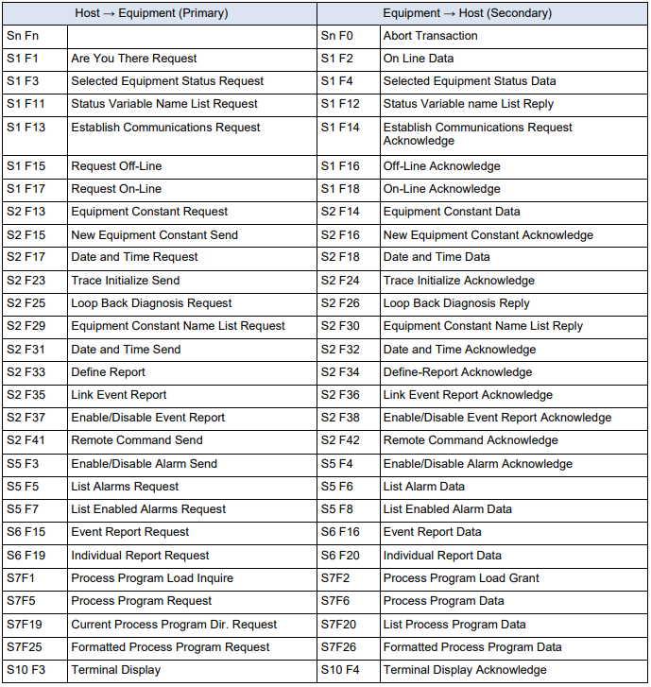

SECS-II Message List (E -> H)

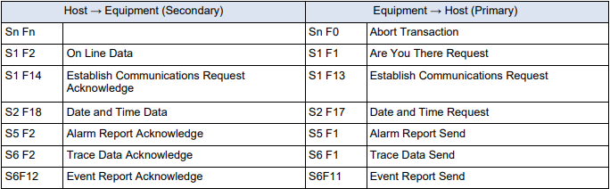

SECS-II Message Example

(Host perspective)

S1F1 : Are You There (H -> E)

Description :
The host may send this message to the EQ at any time. EQ sends this message periodically as a “heartbeat” to determine if the SECS link is alive.

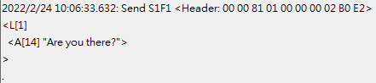

S1F2 : On-Line Data (E -> H)

Description :
EQ reports its Model Number and Software Revision to Host

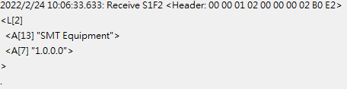

S1F3 : Selected Status Request (H -> E)

Description :
A request to EQ to report selected values of its status.

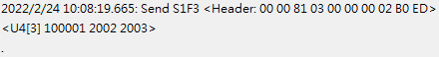

S1F4 : Selected Status Data (E -> H)

Description :
The equipment reports the value of each SVID requested in the order requested.

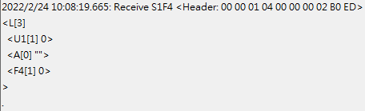

S1F11 : Status Variable NamelistRequest (H -> E)

Description :
A request to the equipment to identify certain status variables.

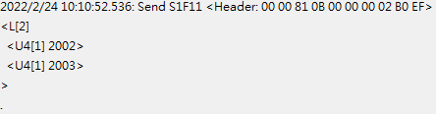

S1F12 : Status Variable Namelist Reply (E -> H)

Description :
EQ reports to the Host the name and units of the requested SVs.

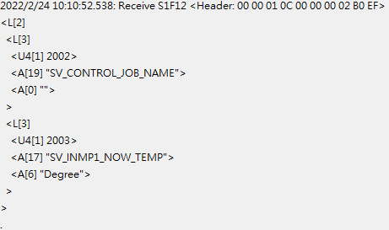

S1F13 : Establish Communication Request (H -> E)

Description:
Either end of the link may send S1F13 as the first message to establish connection of the link. Under EQ’s initialization logic, EQ will always attempt to establish the link. If no Host acceptance reply is received. EQ sends this message periodically.

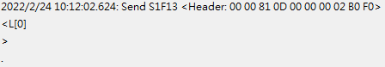

S1F14 : Establish Communication Request Acknowledge (E -> H)

Description:
Accept or deny Establish Communication Request.

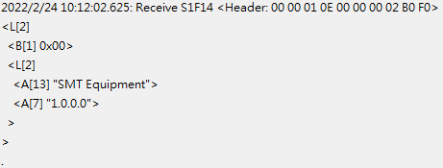

S1F15 : Request Off-Line (H -> E)

Description:
Host requests EQ to go Off-Line

S1F16 : Off-Line Acknowledge (E -> H)

Description:
EQ control state transits to Host Off-Line and sends this message in response to S1F15 primary.

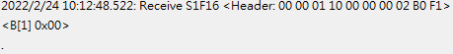
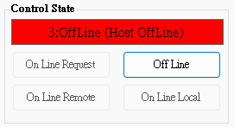

S1F17 : Request On-Line (H -> E)

Description:
Host requests EQ to go On-Line

S1F18 : On-Line Acknowledge (E -> H)

Description:
EQ responds to S1F17 primary in an attempt to go On-Line. Data item ONLACK indicates the success of failure of the attempt.

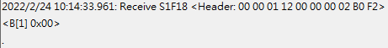
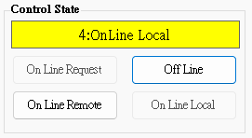

S2F13 : Equipment Constant Request (H -> E)

Description:
Constants and other values that are changed infrequently can be obtained using this message.

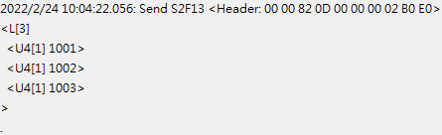

S2F14 : Equipment Constant Data (E -> H)

Description:
EQ returns constant data in the order requested in S2F13.

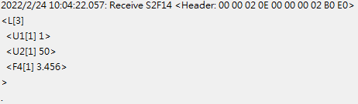

S2F15 : New Equipment Constant Send (H -> E)

Description:
Change one or more equipment constants.

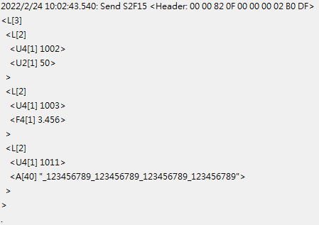

S2F16 : Equipment Constant Send Acknowledge (E -> H)

Description:
Change one or more equipment constants.

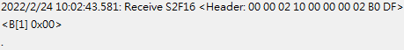

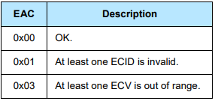

S2F17 : Date and Time Request (H -> E)

Description:
Host sends this message at any time to determine the date and time base EQ is currently using.

S2F18 : Date and Time Data (E -> H)

Description:
Host sends this message at any time to determine the date and time base EQ is currently using.

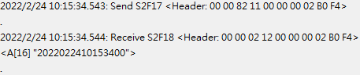

S2F23 : Trace Initialize Send (H -> E)

Description:
Trace initial send to device to enable/disable trace initial data. The trace data is returned on (S6F1) and is related to the original request by the TRID.

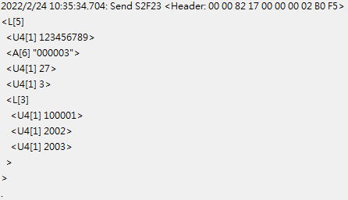

S2F24 : Trace Initialize Acknowledge (E -> H)

Description:
Acknowledge or error for Trace Initialize Send(S2F23)

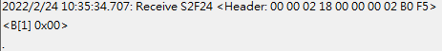

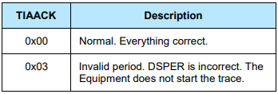

S2F25 : Diagnostic Loopback Request (H -> E)

Description:
Host sends an arbitrary binary string to test operation of the link.

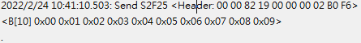

S2F26 Diagnostic Loopback Data (E -> H)

Description:
EQ “echoes” back the binary data from Host’s S2F25.

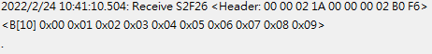

S2F29 Equipment Constant Namelist Request (H -> E)

Description:
This function allows the host to retrieve basic information about what equipment constants are available in the equipment.

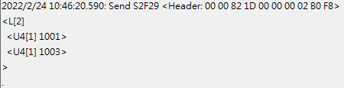

S2F30 : Equipment Constant Namelist Reply (E -> H)

Description:
Data Response for Equipment Constant Namelist Request(S2F29).

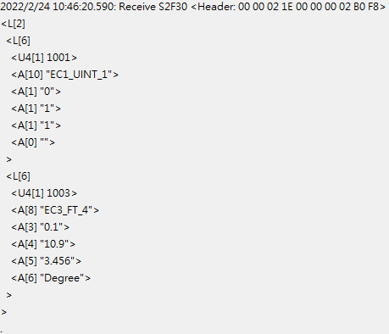

S2F31 : Date and Time Send (H -> E)

Description:
Useful to synchronize the equipment time with the host time base.

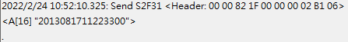

S2F32 Date and Time Acknowledge (E -> H)

Description:
Acknowledge the receipt of time and date.

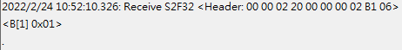

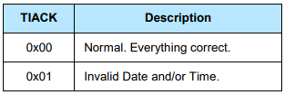

S2F33 Define Report (H -> E)

Description:
The purpose of this message is for the host to define a group of reports for the equipment. The event report will be sent via S6F11 when the event occurred.

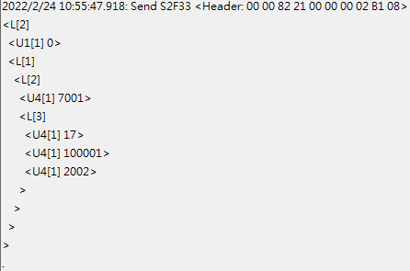

S2F34 Define Report Acknowledge (E -> H)

Description:
Acknowledge or error if an error condition is detected the entire message is rejected(i.e., partial changes are not allowed)

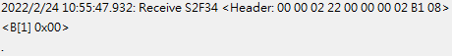

S2F35 : Link Event Report (H -> E)

Description:
The purpose of this message is for the host to link n reports to an event(CEID). These linked event reports will default to ‘disabled’ upon linking. That is, the occurrence of an event would not cause the report to be sent until enabled. See S2F37 for enabling reports.

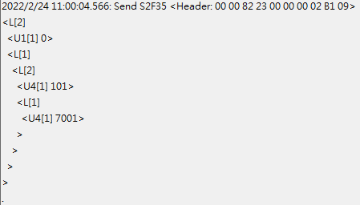

S2F36 Link Event Report Acknowledge (E -> H)

Description:
Acknowledge or error if an error condition is detected the entire message is rejected(i.e., partial changes are not allowed).

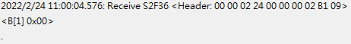

S2F37 : Enable/Disable Event Report (H -> E)

Description:
The purpose of this message is for the host to enable or disable reporting for a group of events(CEIDs).

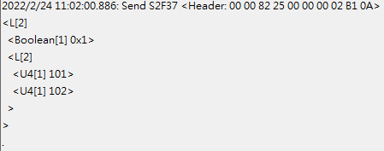

S2F38 : Enable/Disable Event Report Acknowledge (E -> H)

Description:
Acknowledge or error if an error condition is detected the entire message is rejected(i.e., partial changes are not allowed).

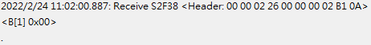

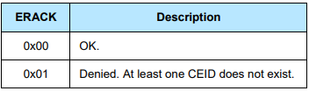

S2F41 : Remote Command Send (H -> E)

Description:
The host requests the equipment perform the specified remote command with the associated parameters.

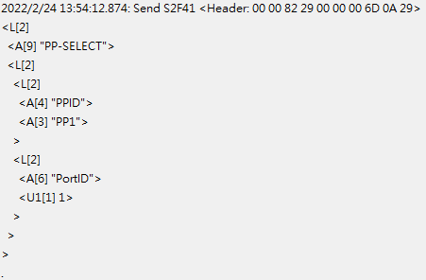

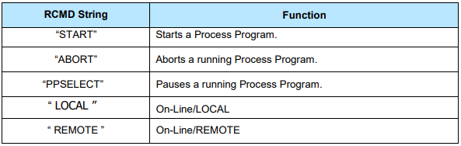

S2F42 : Remote Command Acknowledge (E -> H)

Description:
Acknowledge host’s command or error. If command is not accepted due to one or more invalid parameters, then a list of invalid parameters will be returned containing the parameter name and reason for being invalid.

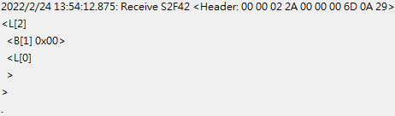

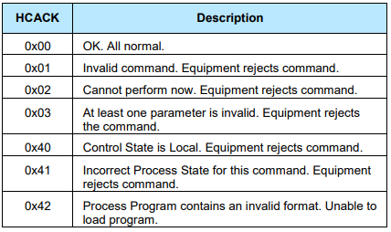

S5F1 : Alarm Report (E -> H)

Description:
This message reports a change in or presence of an alarm condition. One message will be issued when the alam is set and one message will be issued when the alarm is cleared. Irrecoverable errors and attention flags may not have a corresponding clear message.

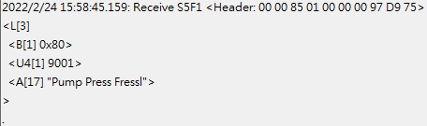

S5F2 : Alarm Acknowledge (H -> E)

Description:
The host acknowledges the alarm report. This equipment ignores the ACKC5.

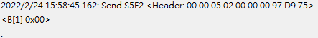

S5F3 Enable/Disable Alarm Send (H -> E)

Description:
This message will change the state of the enable bit in the equipment. The enable bit determines if the alarm will be sent to the host. Alarms which are not controllable in this way are unaffected by this message.

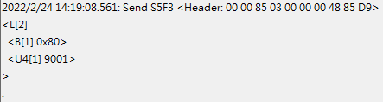

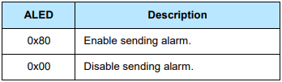

S5F4 Enable/Disable Alarm Acknowledge (E -> H)

Description:
The host acknowledges the alarm report. This equipment ignores the ACKC5.

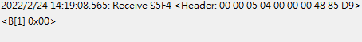

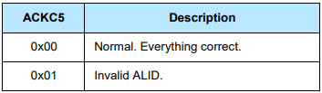

S5F5 : List Alarms Request (H -> E)

Description:
This message requests the equipment to send binary and analog alarm information to the host.

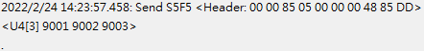

S5F6 : List Alarm Data (E -> H)

Description:
This message contains the alarm data known to the equipment.

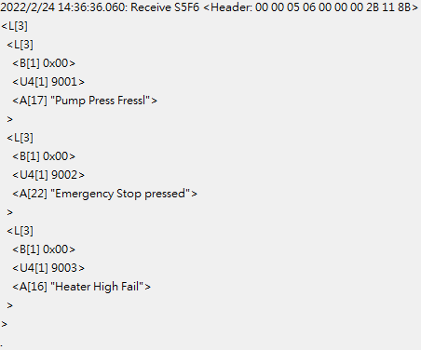

S5F7 : List Enabled Alarms Request (H -> E)

Description:
List all alarms which are enabled .

S5F8 : List Enabled Alarm Data (E -> H)

Description:
This message is similar to S5F6 except that it lists only alarms which are enabled.

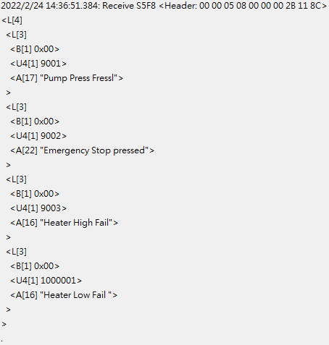

S6F1 : Trace Data Send (E -> H)

Description:
This function sends samples to the host according to the trace setup done by S2F23. Trace is a time-driven form of equipment status.

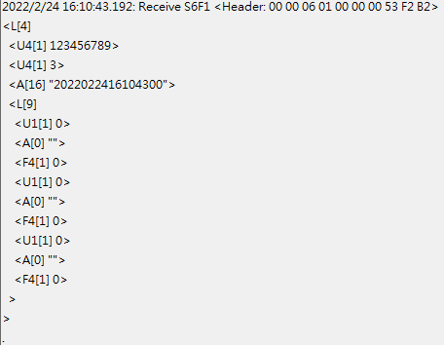

S6F2 : Trace Data Acknowledge (H -> E)

Description:
List all alarms which are enabled .

S6F11 : Event Report Send (E -> H)

Description:
The purpose of this message is for the equipment to send a defined, linked, and enabled group of reports to the host upon the occurrence of an event(CEID).

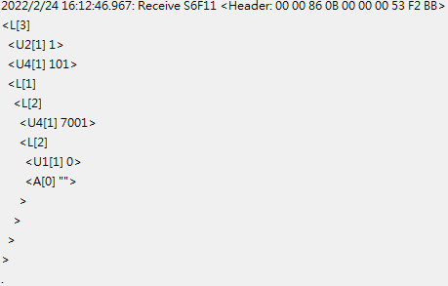

S6F12 : Event Report Acknowledge (H -> E)

Description:
Acknowledge or error for Event Report Send(S6F11).

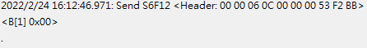

S6F15 : Event Report Request (H -> E)

Description:
The purpose of this message is for the host to demand a given report group form the equipment.

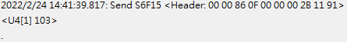

S6F16 : Event Report Data (E -> H)

Description:
EQ sends reports linked to given CEID to host.

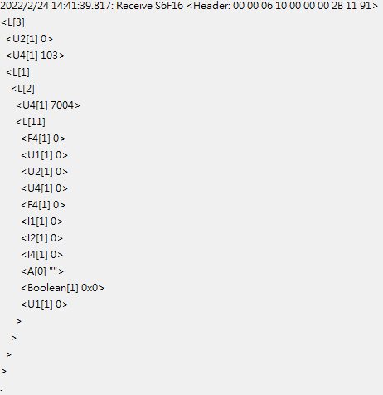

S6F19 : Individual Report Request (H -> E)

Description:
Host requests a Report for the specified RPTID.

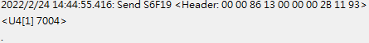

S6F20 : Individual Report Data Event Report Data (E -> H)

Description:
EQ sends variable data defined for the given to the host.

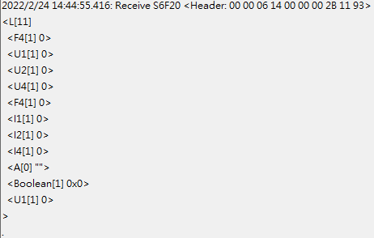

S7F1 : Process Program Load Inquire (H -> E)

Description:
The sender requests permission to send a process program.

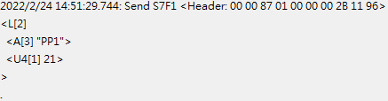

S7F2 : Process Program Load Grant (E -> H)

Description:
The receiver grants permission to send a process program.

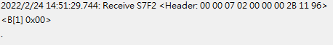

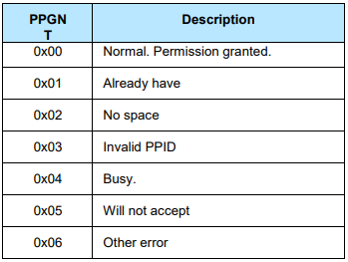

S7F5 : Process Program Request (H -> E)

Description:
Request the other end of the link to send a specified process program from its library.

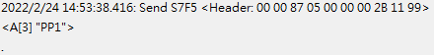

S7F6 : Process Program Data (E -> H)

Description:
Send the requested process program.

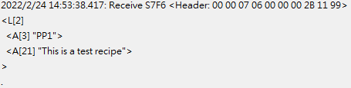

S7F19 : Process Program Dir. Request (H -> E)

Description:
The host requests a directory of the process program currently in the EQ’s library.

S7F20 : Current Process Program Data (E -> H)

Description:
The EQ sends a directory of its process program library. If the library is empty, the list will be zero length.

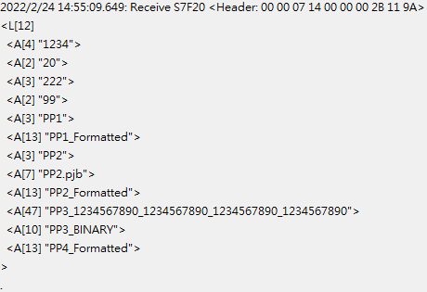

S7F25 : Formatted Process Program Request (H -> E)

Description:
The host requests a process program currently in the EQ’s library.

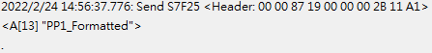

S7F26 : Formatted Process Program Data (E -> H)

Description:
The EQ sends a formatted process program data to the host.

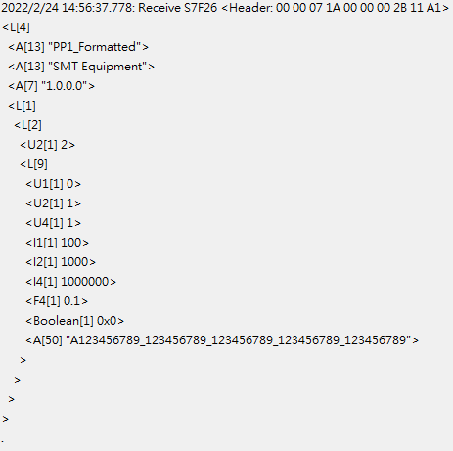

S9F7 : Invalid Data

Description:
This message indicates that the stream and function were recognized, but the associated data format could not be interpreted.

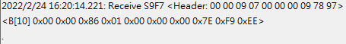

S9F9 : Transaction Timer Timeout

Description:
This message indicates that a transaction (receive) timer has timed out and that the corresponding transaction has been aborted. It is up to the host to respond to this error in an appropriate manner to keep the system operational.

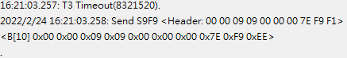

S10F1 : Terminal Request

Description:
A terminal text message to the host.

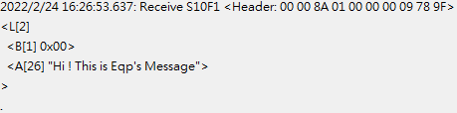

S10F2 : Terminal Request Acknowledge

Description:
Acknowledge or error for terminal request (S10F1).

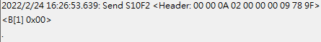

S10F3 : Terminal Display, Single (H -> E)

Description:
Data to be displayed.

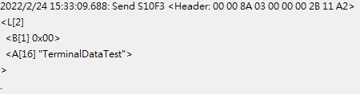

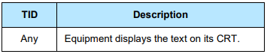
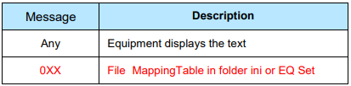

S10F4 : Terminal Request Acknowledge (E -> H)

Description:
Acknowledge or error for terminal request (S10F3).

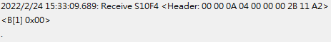

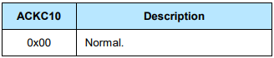

S2F41 Action Format And Simulate Log
★The send format all use ASCII.

GO-REMOTE
Description:
Send “GO-REMOTE” to change gem control status.
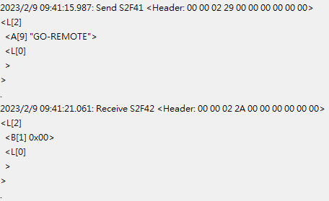
Description:
Use S1F3 can check current control status. VID 4
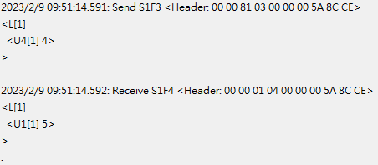
Response parameter :
1:OffLine (EQP OffLine)
2:OffLine (Attempt OnLine)
3:OffLine (Host OffLine)
4:OnLine Local
5:OnLine Remote

GO-LOCAL
Description:
Send “GO-LOCAL” to change gem control status.
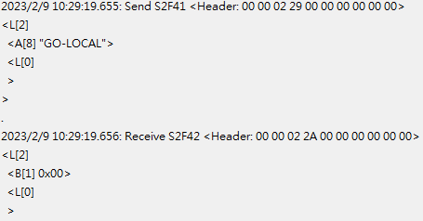

Description:
Use S1F3 can check current control status. VID 4
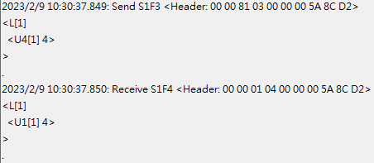
Response parameter :
1:OffLine (EQP OffLine)
2:OffLine (Attempt OnLine)
3:OffLine (Host OffLine)
4:OnLine Local
5:OnLine Remote

ACCESSMODE-ASK
Description:
Send “ACCESSMODE-ASK” with “LOADPORT-ID” attach loadport number(1or2) to ask loadport current control status(0=Manual, 1=Auto).
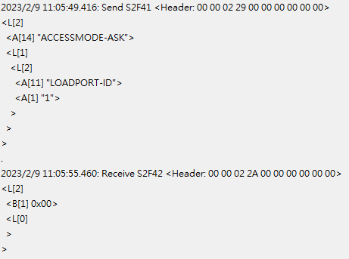
Description:
Equipment will response CEID 1008 with loadport number(1or2) and status(0=Manual, 1=Auto), or use S1F3 to ask VID2006(Loadport1 accessmode), VID2007(Loadport2 accessmode).

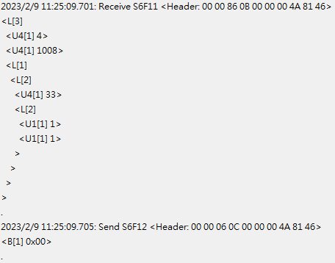

PORT-TRANSFERSTATUS-ASK
Description:
Send “PORT-ASK” with “LOADPORT-ID” attach loadport number(1or2) to ask loadport transfer status.
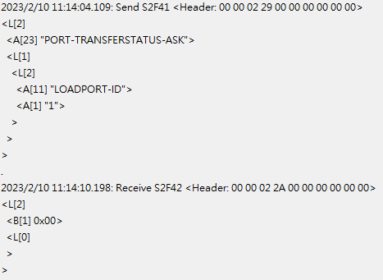

Description:
Equipment will response CEID 1016 with loadport number(1or2) and status, or use S1F3 to ask VID2008(Loadport1 transfer status), VID2009(Loadport2 transfer status).
0 = OUT OF SERVICE
1 = TRANSFER BLOCKED
2 = READY TO LOAD
3 = READY TO UNLOAD
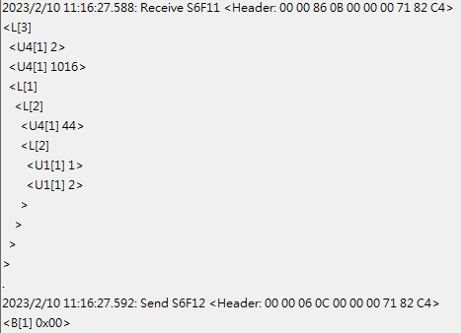

PP-SELECT
Description:
Send “PP-SELECT” with “RECIPE-ID” attach recipe name to change recipe.
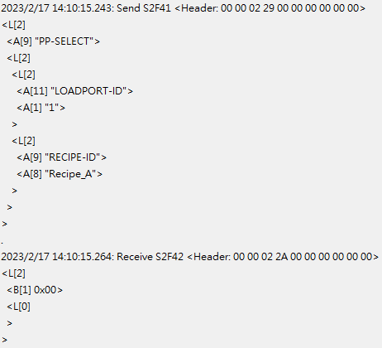

Description:
Use S1F3 can check current recipe name.
VID 2014(Loadport1), VID 2015(Loadport2)
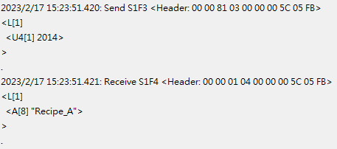

ACCESSMODE-CHANGE(Manual)
Description:
Send “ACCESSMODE-ASK” with “LOADPORT-ID” attach loadport number(1or2) and “ACCESS-MODE” attach change status(0=Manual).

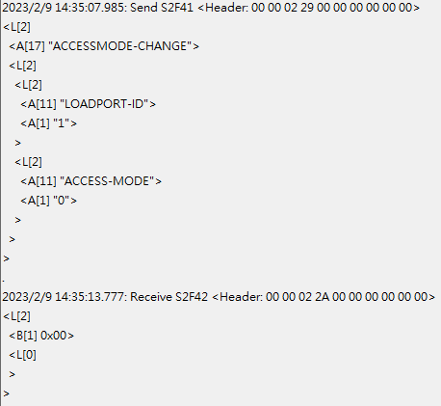

Description:
Equipment will response CEID 1003 with loadport number(1or2) and status(0=Manual)

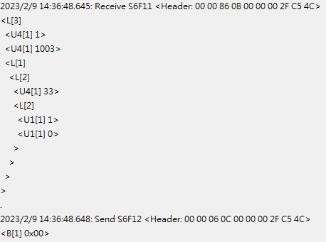

ACCESSMODE-CHANGE(Auto)
Description:
Send “ACCESSMODE-ASK” with “LOADPORT-ID” attach loadport number(1or2) and “ACCESS-MODE” attach change status(1=Auto).
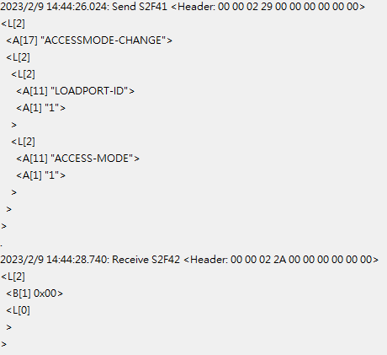

Description:
Equipment will response CEID 1002 with loadport number(1or2) and status(1=Auto)
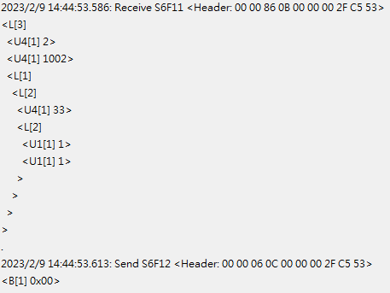

SLOTMAP-L&C
Description:
Send “SLOTMAP-L&C” with “LOADPORT-ID” attach loadport number(1or2) and “CARRIER-ID” attach CarrierID.

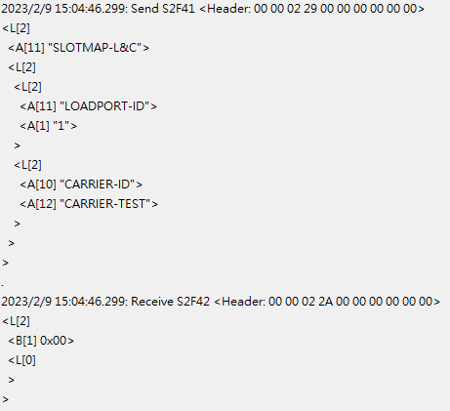

Description:
Equipment will response CEID 5115 with loadport number(1or2) and CarrierID.
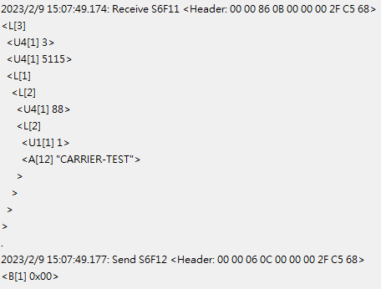

Description:
Equipment will response CEID 1013 with carrierID, loadport number(1or2), reason, slotmap status, slotmap.

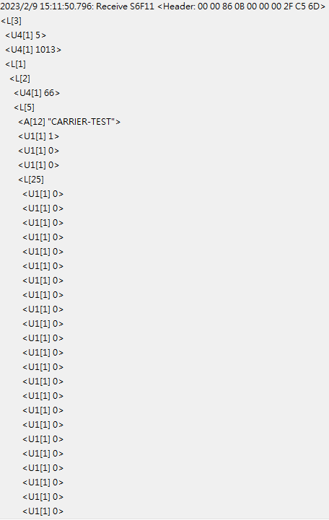
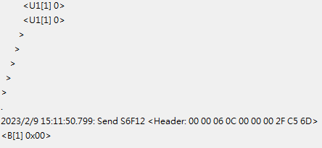

SLOTMAP-L
Description:
Send “SLOTMAP-L” with “LOADPORT-ID” attach loadport number(1or2).
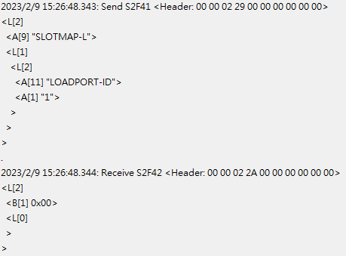

Description:
Equipment will response CEID 5115 with loadport number(1or2) and CarrierID.
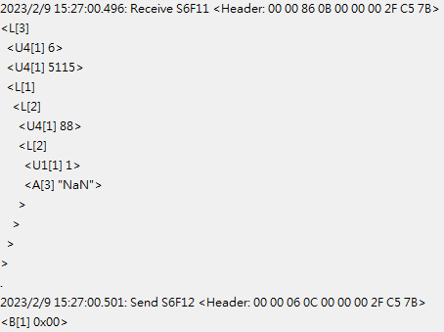

Description:
Equipment will response CEID 1013 with carrierID, loadport number(1or2), reason, slotmap status, slotmap.

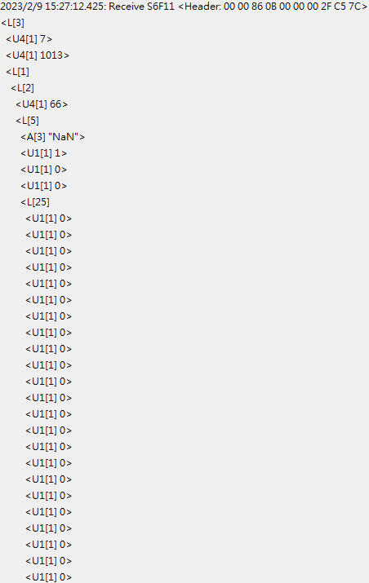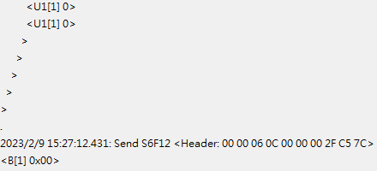

MEASURE-L&C
Description:
Send “MEASURE-L&C” with “LOADPORT-ID” attach loadport number(1or2) and “CARRIER-ID” attach CarrierID.
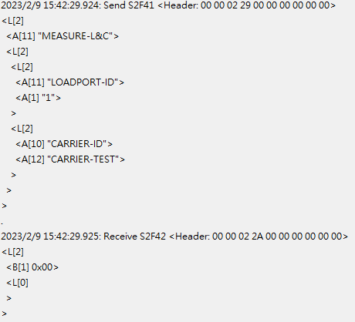

Description:
Equipment will response CEID 5999(Process Start event).
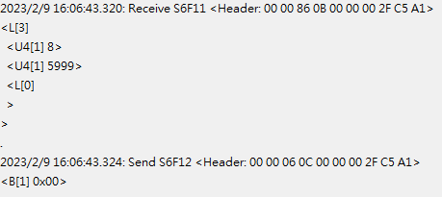

Description:
Equipment will response CEID 6000 with carrierID, loadport number(1or2), measure info.
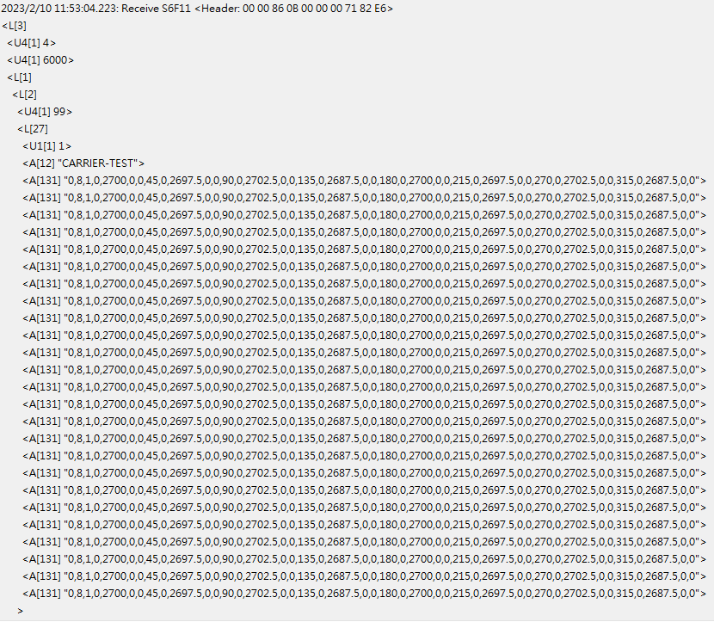

MEASURE format information:
- The first number represent the measure type(0=Blue tape, 1=Trim 1 step, 2=Trim 2 step)
- The second number represent the number of measure points(4 or 8 points)
- Follow by the number of measure points, the 5 fields are a group, the order is :
Angle, H1, W1, H2(If one step only, it will set 0), W2(If one step only, it will set 0)

★If measre type is blue tape, only W1 have value, other parameter will set 0.

MEASURE-L
Description:
Send “MEASURE-L” with “LOADPORT-ID” attach loadport number(1or2).
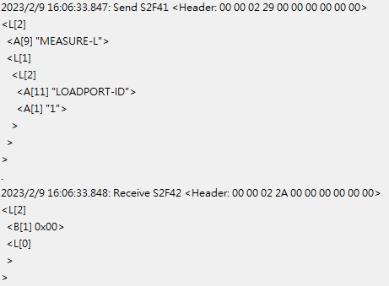

Description:
Equipment will response CEID 5999(Process Start event).


Description:
Equipment will response CEID 6000 with carrierID, loadport number(1or2), measure info.
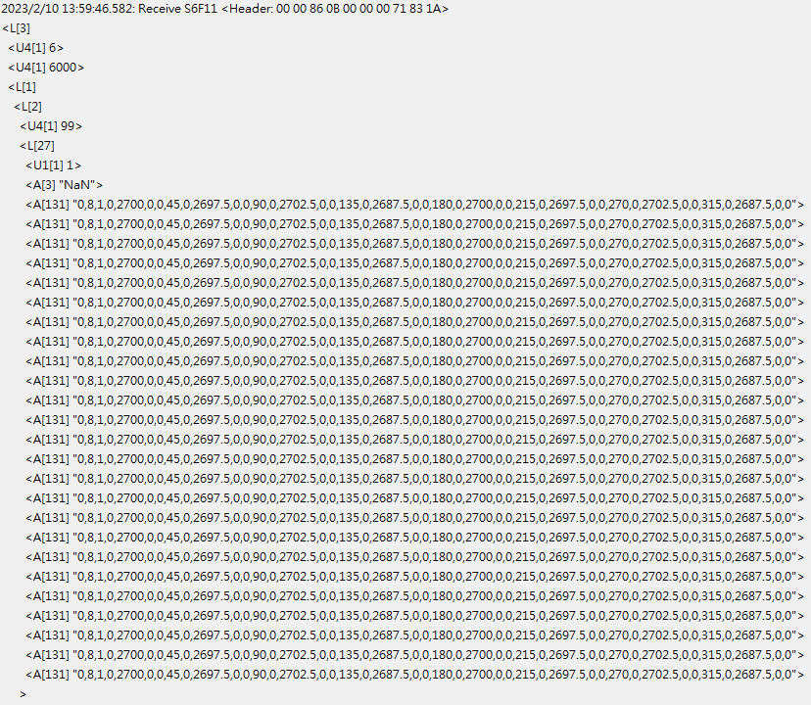

MEASURE format information:
- The first number represent the measure type(0=Blue tape, 1=Trim 1 step, 2=Trim 2 step)
- The second number represent the number of measure points(4 or 8 points)
- Follow by the number of measure points, the 5 fields are a group, the order is :
Angle, H1, W1, H2(If one step only, it will set 0), W2(If one step only, it will set 0)

★If measre type is blue tape, only W1 have value, other parameter will set 0.

RELEASE-L&C
Description:
Send “RELEASE-L&C” with “LOADPORT-ID” attach loadport number(1or2) and “CARRIER-ID” attach CarrierID.
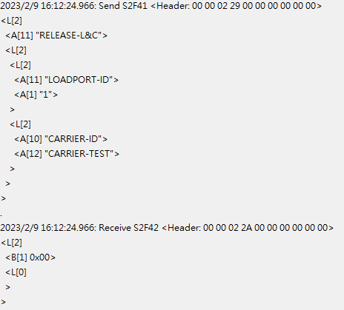

Description:
Equipment will response CEID 5116(Carrier undock event) with loadport number(1or2) and CarrierID.
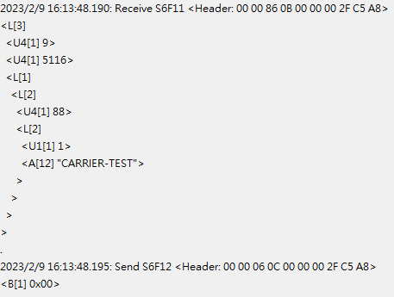

Description:
Then equipment will response CEID 1005(Ready to unload event) with loadport number(1or2) and PortTransferState.
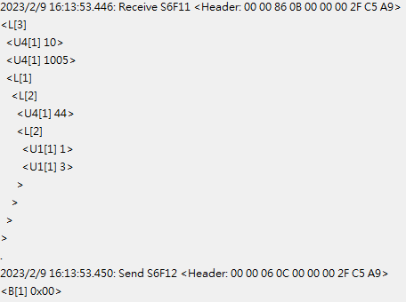

Description:
Then equipment will response CEID 101(Material Remove event) with loadport number(1or2) and CarrierID..
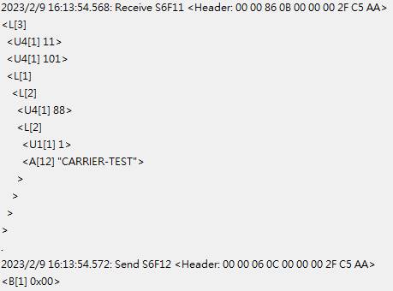

RELEASE-L
Description:
Send “RELEASE-L” with “LOADPORT-ID” attach loadport number(1or2) and “CARRIER-ID” attach CarrierID.
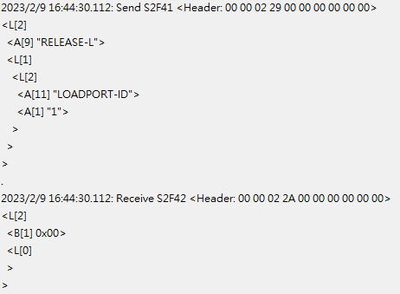

Description:
Equipment will response CEID 5116(Carrier undock event) with loadport number(1or2) and CarrierID.
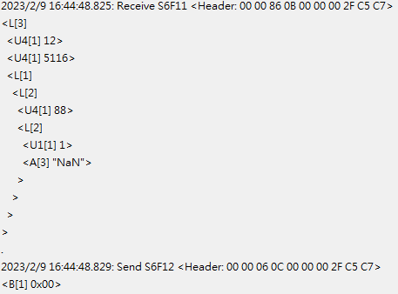

Description:
Then equipment will response CEID 1005(Ready to unload event) with loadport number(1or2) and PortTransferState.
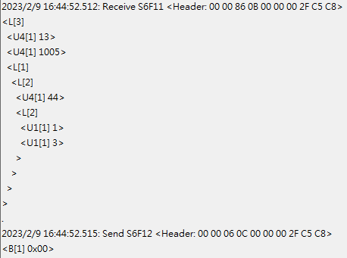

Description:
Then equipment will response CEID 101(Material Remove event) with loadport number(1or2) and CarrierID.
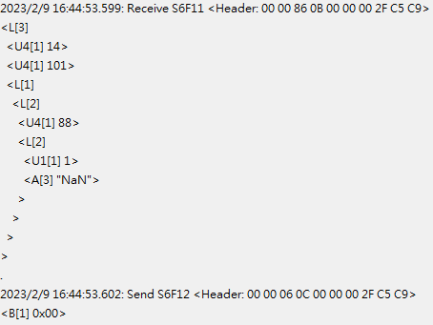

CANCEL-L&C
Description:
Send “CANCEL-L&C” with “LOADPORT-ID” attach loadport number(1or2) and “CARRIER-ID” attach CarrierID.
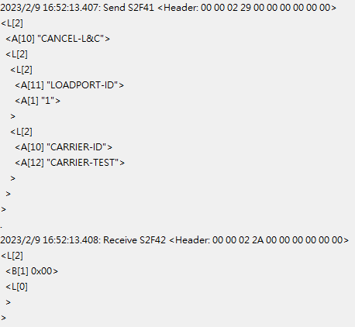

Description:
Equipment will response CEID 5116(Carrier undock event) with loadport number(1or2) and CarrierID.

Description:
Then equipment will response CEID 1005(Ready to unload event) with loadport number(1or2) and PortTransferState.


Description:
Then equipment will response CEID 101(Material Remove event) with loadport number(1or2) and CarrierID..


CANCEL-L
Description:
Send “CANCEL-L” with “LOADPORT-ID” attach loadport number(1or2) and “CARRIER-ID” attach CarrierID.
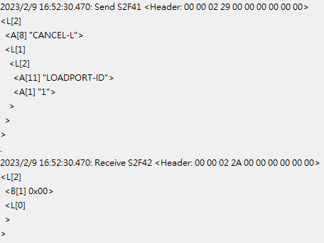

Description:
Equipment will response CEID 5116(Carrier undock event) with loadport number(1or2) and CarrierID.

Description:
Then equipment will response CEID 1005(Ready to unload event) with loadport number(1or2) and PortTransferState.


Description:
Then equipment will response CEID 101(Material Remove event) with loadport number(1or2) and CarrierID.


MACHINE START

Description:
Send “START” to set equipment into run.
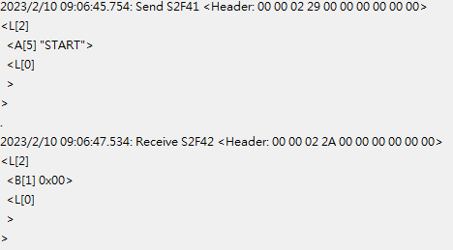

Description:
Then equipment will response CEID 1014(Machine running event) with.
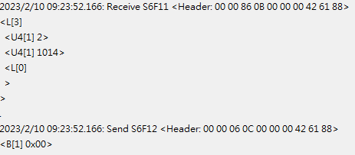

Description:
Use S1F3 can check equipment status.
VID 1998(0=Running, 1=Alarm, 2=Idle)
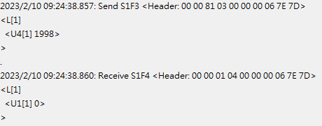

MACHINE STOP
Description:
Send “STOP” to set equipment into stop.
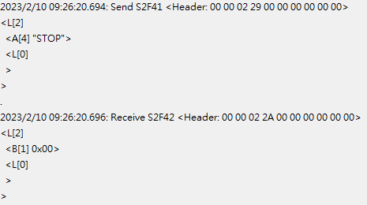

Description:
Then equipment will response CEID 1015(Machine stop event) with.
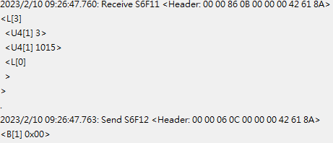

Description:
Use S1F3 can check equipment status.
VID 1998(0=Running, 1=Alarm, 2=Idle)
